PHP with Laravel for Beginners – Become a Master in Laravel

Section 1: The first steps

Table of Contents:

1.) Meet your professor Edwin Diaz … page 1

2.) Introduction to Laravel and MVC … page 3

3.) Reference files … page 4

1. Meet your professor Edwin

“Anyone can learn programming no matter who you are”

..you invest your time and your money for this course and take advantage over every single moment there

..you have to like what you're doing because if you came into this course thinking that you're just going to get that knowledge and leave without liking programming you're probably going to fail you probably not going to finish this course

..this course is going to be a really complete course

“Like what you're doing”

“You need to put in the time”

..I know some of you are super busy but if you go from work and you have your kids or your girlfriend whoever is you know doing stuff just tell them “Listen I need some time to study”

..Take 30 minutes will take one hour a day or whatever time you have and just focus on that thing only so if you are going to take to lectures they make sure that you take those two lectures but you really take advantage of that time

“Just focus on one thing at a time”

“Don't go and do many different things at the same time”

“Finish what you start”

..You know even if you get all the all that you want it by the by the middle of this course and you say “I'm done”

“Build the habit of finishing what you start”

..Make sure that you remember why you here

..Always write it down a piece of paper put it on the wall

..Ask for help if you are still stuck take some time and sleep and rest and then come fresh and try to look out if you can figure it out after two or three days

2. Introduction to Laravel and MVC

**What is Laravel?**

*Laravel is a PHP web framework who uses the MVC architecture

**What is a Framework?**

*is the underlying system, the methods, the classes or the files that makes up for that install

**What is an Architecture?**

*is the design pattern that a specific Framework has

**Model**

*are going to be the Classes

*deals with the Database

*it’s a Class

*example, if we have **Users** in our application, we can have **Users** model that deals with everything that has to do with Querying that database for that specific table of Users

*so that, we have **Users** model and **Users** table

*every time we have a Model, we always have a table for that specific model

**View**

*are going to be the methods

*are going to be have some classes depending on what we’re doing

*deals with the HTML

*representation of our Application

*everything you see in your application in the browser is going to be a View

**Controller**

*is actually our Classes as well

*the Middle-man

*deals with the Views and the Model

*the Controller talks to Model and say “Listen Model, I need you to pull all the lastname of the Users table, give me the lastname of the Users and then once you give it to me, I’ll give it to View to display it

3. Reference Files

See **web.php**

Section 2: Windows – Local Environment Setup

Table of Contents:

1.) Tools … page 4

2.) Using MySQL … page 5

3.) Installing Node.js … page 5

4.) Installing Laravel … page 6

1. Tools

XAMPP – [www.apachefriends.org/download.html](http://www.apachefriends.org/download.html)

Git – <https://www.git-scm.com>

PHP Storm – [www.jetbrains.com](http://www.jetbrains.com)

Visual Studio Code – [www.code.visualstudio.com](http://www.code.visualstudio.com)

Composer – [www.getcomposer.org](http://www.getcomposer.org)

@CLI:

php -v (to check the php version)

1. Using MySQL

How to access MySQL thru the command-line (CLI)

@CLI:

C:\>\xampp\mysql\bin\mysql -uroot -p (then enter password for MariaDB)

@MariaDB[(none)]>

show databases;

Add C:\xampp\mysql\bin in Environment variables in PATH

@CLI:

mysql -uroot -p (then enter password for MariaDB)

@MariaDB[(none)]>

show databases; (display all database)

create database my_db; (create a database)

use my_db; (to get in here the database)

show tables; (to display all tables in database)

1. Installing Node.js

Node – [www.nodejs.org/en/](http://www.nodejs.org/en/)

Add in Environment Variables in PATH (C:\Users\Faculty\AppData\Roaming\npm)

@CLI:

node -v (check the version of node.js)

npm -v (check the version of npm)

1. Installing Laravel

Laravel – [www.laravel.com/docs/7.x/installation](http://www.laravel.com/docs/7.x/installation)

@CLI:

composer create-project –prefer-dist laravel/Laravel blog (installing the latest version of Laravel)

composer global require laravel/installer (download Laravel installer)

laravel new new-blog (crafting the Laravel application via installer)

npm run install (install the node package in Laravel package)

php artisan serve (it gives a link to view Laravel application)

Section 3: MAC – Local Environment Setup

Table of Contents:

1.) PHP Upgrade … page

2.) Installing and Using MySQL on MAC OS X … page

3.) Installing Node.js … page

4.) Tools and Installing Laravel … page

5.) Using Valet in your Laravel projects – Optional … page

Section 4: Laravel Fundamentals – Routes

Table of Contents:

1.) Serving Our App … page 7

2.) Additional info … page 7

3.) Laravel Structure Overview … page 7

4.) Route Introduction … page 8

5.) Routes part 1 … page 8

6.) Routes part 2 … page 9

7.) Naming Routes … page 10

1. Serving our App

@CLI:

php artisan serve (serving the Laravel application)

1. Additional info

blog>routes>web.php (new location of routes.php)

1. Laravel Structure Overview

**app(folder) –** this is where we keep the Models and Controllers

**Controllers(folder)** – controller classes

**Middleware(folder)** – which is the security

**Kernel.php** – where you register your security classes

**routes/web.php** – we control the routes in our application here

**app.php** – is where we register the other classes that we want to use from other provided, this is where we register the package

**database.php** – setting up the database connection

**.env** – our environment/global variables setup here, sensitive information here

**.gitignore** – files added here are just been ignore when pushing in Git

**mail.php** – we setup here our email

**migrations(folder)** – executing our own commands to create a table

**seeds(folder)** – we create a list of code if we want to create a lot of content for a website in our application

**public(folder)** – having the CSS, JavaScript, images

**resources(folder)** – having the assets, language, views folder

**vendor(folder)** – this is where package is compiled and installed via npm run install

**.env.example** – copy this to .env

**composer.json** – this is where you use composer and requiring the packages

**artisan** – used to generate controllers, models, tables, and directory

**webpack.mix.js** – is the wrapper used in mix

1. Route Introduction

**routes** – are super important in Laravel, the URL in the address bar

1. Routes part 1

Create a new Laravel project: **cms**

@CLI:

laravel new cms (create a new Laravel application named “cms”)

composer create-project laravel/laravel new-cms (create a **new-cms** app)

npm run install (installing the package package.json)

**@web.php:**

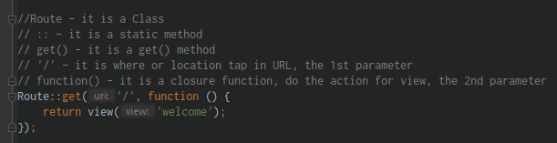

1. Routes part 2

Creating more routes

Passing single parameter

Passing multiple parameter

@CLI:

php artisan route:list (check the available routes)

**@web.php:**

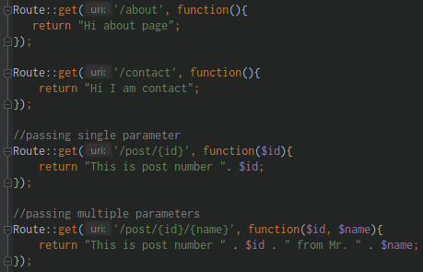

1. Naming Routes

@CLI:

php artisan route:list (check the available routes)

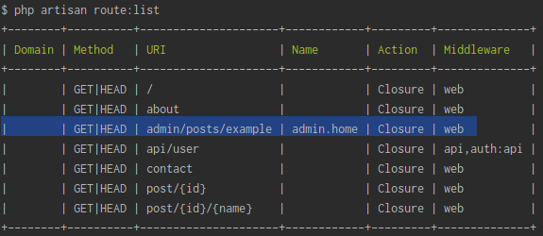

**@web.php:**

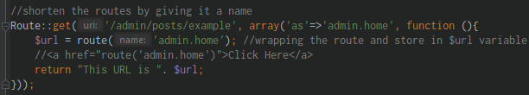

Section 5: Laravel Fundamentals – Controllers

Table of Contents:

1.) Intro to Chapter with Edwin Diaz … page 11

2.) Creating Controllers … page

3.) Laravel 8 – Important Update … page

4.) Routing Controllers … page

5.) Passing Data … page

6.) Resources and Controllers … page

1. Intro to Chapter with Edwin Diaz

**Controllers** – this classes that deals information with the Database and relate that information and display and passing information a View or a representation of our application, controlling the information in the View and taking it to Database

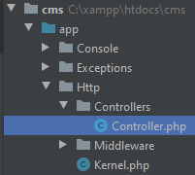



**namespace** – it does for functions and classes, it allows us to use the same function name or Class Name in different part of the same application that we have

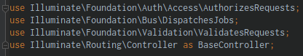

**use** – is used to import the specific class from a namespace from the scope of the file

1. Creating Controllers

@CLI:

php artisan make:controller PostsController (create a Controller)

php artisan make:controller –resource PostsController (create a Controller with CRUD)

1. Routing Controllers

@CLI:

php artisan (view available artisan commands)

**@web.php:**

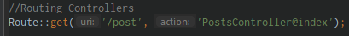

**@PostsController.php:**

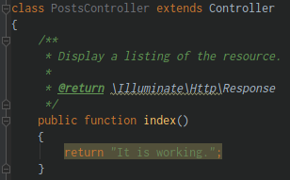

1. Passing Data

**@web.php:**



**@PostsController.php:**

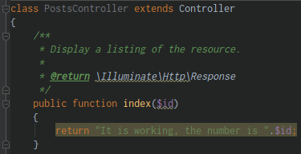

1. Resources and Controllers

**Route resource** - it is a special static function like get() that will give us access to different types of routes, that we can use in Controllers

**@web.php:**



@CLI:

php artisan route:list (display the available routes in application)

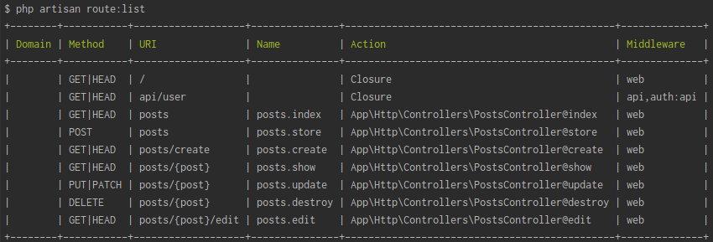

*it automatically gives us a name for our route

*http://127.0.0.1:8000/posts/create

*http://127.0.0.1:8000/posts/{post} -> http://127.0.0.1:8000/posts/1

**@PostsController.php:**

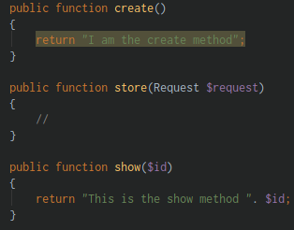

Section 6: Laravel Fundamentals – Views

Table of Contents:

1.) Intro to Chapter with Edwin Diaz … page

2.) Creating Views and Custom Method … page

3.) Passing Data to Views … page

1. Intro to chapter with Edwin Diaz

@CLI:

php artisan serve (serving our app)

1. Creating views and custom method

Views located at: **cms/resources/views/welcome.blade.php**

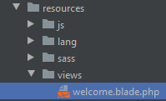

Create a **contact.blade.php** file inside resources/views folder

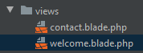

**@web.php**: *get the **contact()** method created in PostsController



**@PostsController.php:** (create a custom function to view the contact page)

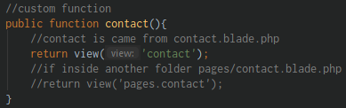

1. Passing data to views

Passing data into views

**@web.php:**

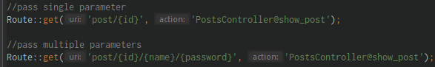

**@PostsController.php:**

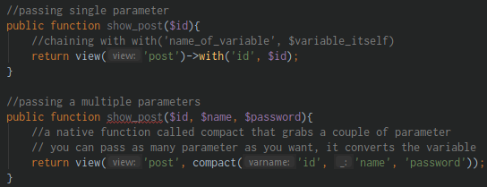

**@post.blade.php:**

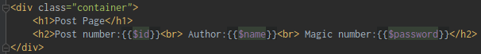

Section 7: Laravel Fundamentals – Laravel Blade templating engine

Table of Contents:

1.) Intro to Chapter with Edwin Diaz … page

2.) Master Layout Setup … page

3.) Some More Blade Features … page

1. Intro to Chapter with Edwin Diaz

**Blade** – is a php Laravel Blade Templating engine, it grabs a php code to make us to easy write an HTML, makes php code simpler and cleaner

1. Master Layout Setup

Create a Master Template

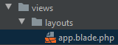

**@app.blade.php:**

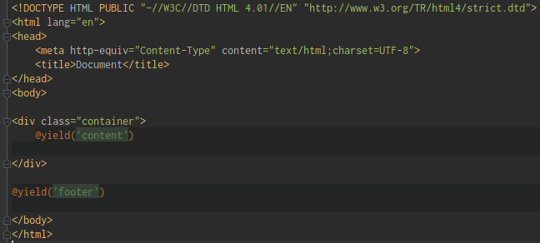

**@contact.blade.php:**

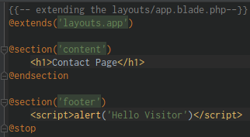

**@post.blade.php:**

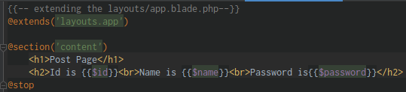

1. Some more blade features

Pass data to blade and processing it

**compact** – takes a variable number of parameters, each parameter can be either a string containing the name of the variable names

**@web.php:**



**@PostsController.php:**

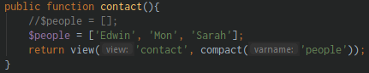

**@contact.blade.php:**

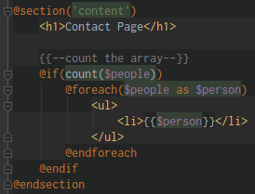

Section 8: Laravel Fundamentals – Database – Laravel Migrations

Table of Contents:

1.) Intro to Chapter with Edwin Diaz … page

2.) Environment Configurations … page

3.) Windows OS – Migrations … page

4.) MAC OS – Migrations … page

5.) Creating Migrations and Dropping … page

6.) Adding Columns to Existing Tables using Migrations … page

7.) Some more Migration Commands … page

1. Intro to Chapter with Edwin Diaz

**Migrations –** the coolest thing that Laravel has, table and column generators, we define the table inside the Laravel app

@CLI:

php artisan serve (serving our app)

1. Environment Configurations

Environment configuration files:

**.env** – this is not push in the server file, it has sensitive information

**.gitignore –** put the files and folder that you want to ignore upon pushing the Git

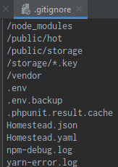

**@config>database.php** – configuration of database connections

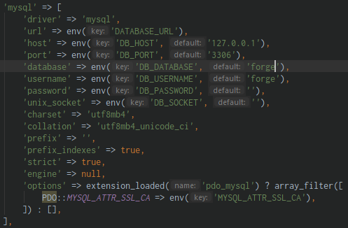

**forge** – is the same thing with the .env and pulling info from it,

1. Windows OS – Migrations

Accessing MySQL thru CMD

@CLI:

mysql -uroot -p (connecting to database)

@MariaDB[(none)]>

show databases;

create database new_cms;

**.env:** *configure the DB_DATABASE variable replace the value in **new_cms**

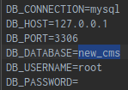

@CLI:

php artisan migrate (migrating the database inside Laravel app)

php artisan

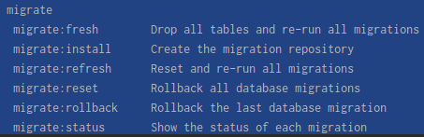

**@database>migrations>file.php:**

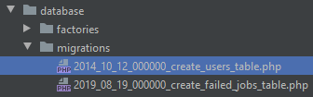

**@_create_users_table.php:**

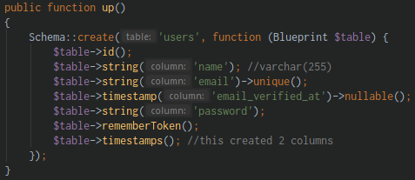

1. Mac OS – Migrations

**\*MAC OS**

1. Creating Migrations and Dropping them

Create a migration from a scratch



@CLI:

node -v (check the version of node.js)

php artisan make:migration create_posts_table -–create=”posts”

*all **lower_case** , use flag(--create=”posts”)

*you can customize the up method

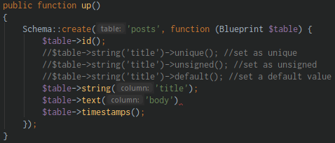

@CLI:

php artisan migrate (migrate the customized and update migration files)

**@localhost/phpmyadmin:**

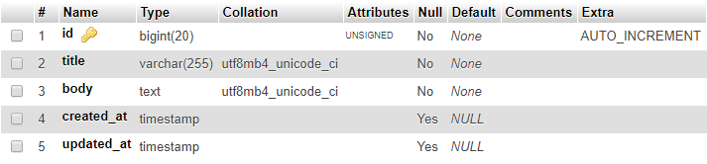

php artisan migrate:rollback (rollback the last database migration, delete the last one you did)

1. Adding Columns to existing tables using Migrations

We don’t have to delete the existing table because it already has a data on it

@CLI:

php artisan make:migration add_is_admin_column_to_posts_tables -–table=”posts” (create a new file of migration that update the posts table column)

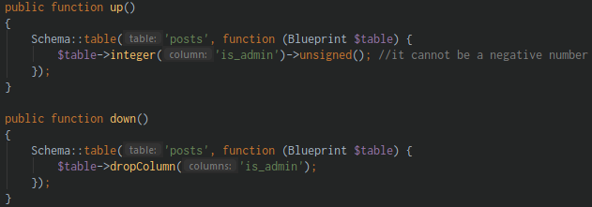

php artisan migrate (do the migration)

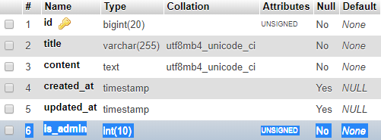

\***is_admin** – is added in the table

1. Some more Migrations Commands

Reset everything

@CLI:

php artisan migrate:reset (rollback all database migrations)

*it deleted all of the migrated tables and remain the migrations table for history

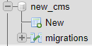

php artisan migrate (run the migration)

php artisan migrate:refresh (drop all tables and re-run the migrations)

php artisan migrate:status (show the status of each migrations)

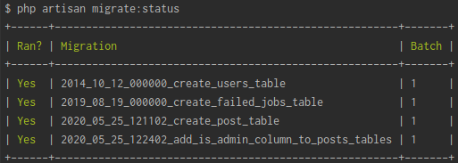

Section 9: Laravel Fundamentals – Raw SQL Queries

Table of Contents:

1.) Section Intro with Edwin Diaz … page

2.) Inserting Data … page

3.) Reading Data … page

4.) Updating Data … page

5.) Deleting Data … page

1. Section Intro with Edwin Diaz

Dealing with database

Laravel has a classes and methods when dealing with the database

1. Inserting Data

Learn the hard way first by using **Raw SQL Queries**

**@web.php:**

*import the **use Illuminate\Support\Facades\DB** class

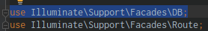

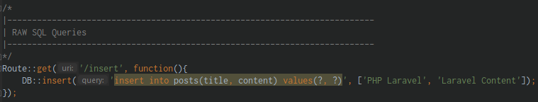

Run in the url:

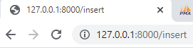

*it will add data in posts table



1. Reading Data

**@web.php:**

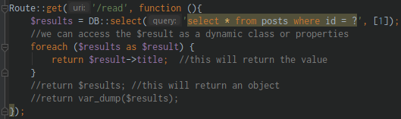

*Run in the url:

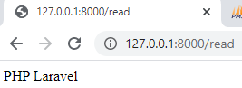

Updating Data

**@web.php:**

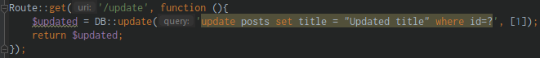

Run in the url:

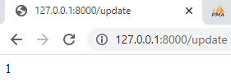

*the **title** is updated

1. Deleting Data

**@web.php:**

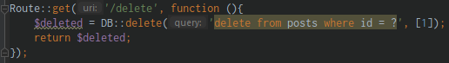

Run in the url:

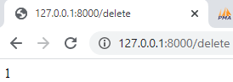

*the data is deleted in the database

Section 10: Laravel Fundamentals – Database – Eloquent ORM

Table of Contents:

1.) Section Intro with Edwin Diaz … page

2.) Reading Data … page

3.) Reading/Finding with Constraints … page

4.) More ways to Retrieve Data … page

5.) Inserting/Saving Data … page

6.) Creating Data and Configuring Mass Assignment … page

7.) Updating with Eloquent … page

8.) Deleting Data … page

9.) Soft Deleting/Trashing … page

10.) Retrieving Deleted/Trashed Records … page

11.) Restoring Deleted/Trashed Records … page

12.) Deleting a Record Permanently … page

1. Section Intro with Edwin Diaz

Learn the amazing feature of Laravel the Eloquent

It deals with active records, how to do with database stuff in such an easy way

1. Reading Data

Eloquent allows us to do a lot of database queries in a very easy format

In order to access information in database in Eloquent

@CLI:

php artisan make:model Post (this will create a Post model)

php artisan make:model Post -m (this will create a Post model and a Migration)

**@Post.php:**

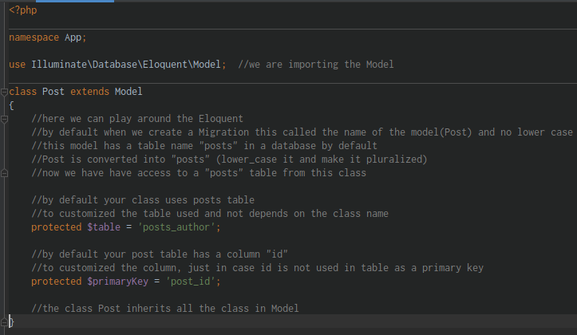

**@web.php:**

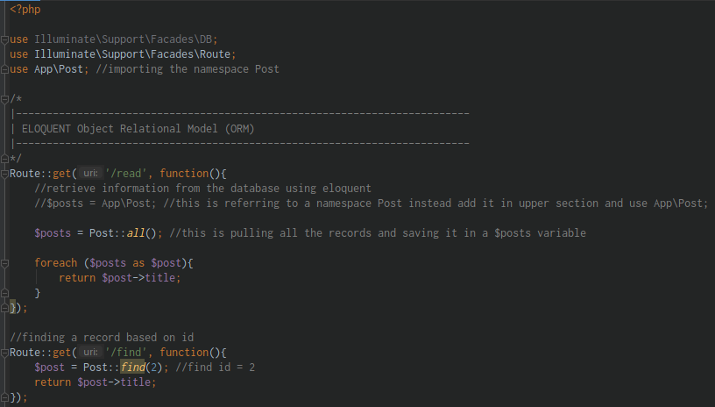

1. Reading Finding with Constraints

Retrieving records based on condition

**@web.php:**

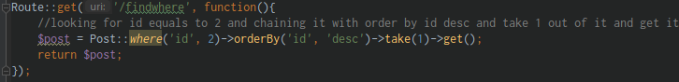

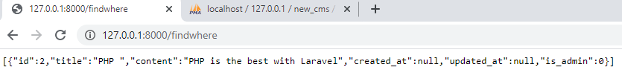

1. More ways to Retrieve Data

**@web.php:**

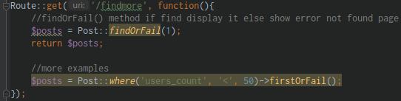

1. Insert Saving Data

**@web.php:**

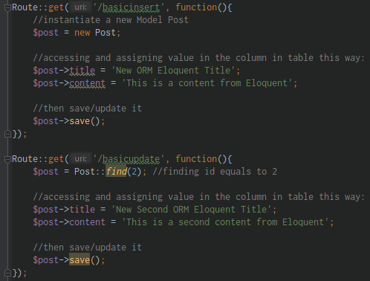

1. Creating Data and Configuring Mass Assignment

When you are creating a data something called a Mass Assignment, Laravel prevents a multiple records to be created at the same time unless you specify in the Model

**@web.php:**

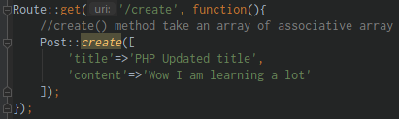

*then expect this error to allow mass assignment in fillable property:

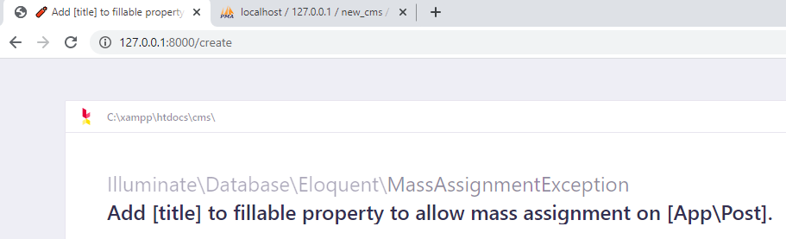

**@app/Post.php:**

*overrides the **$fillable** property

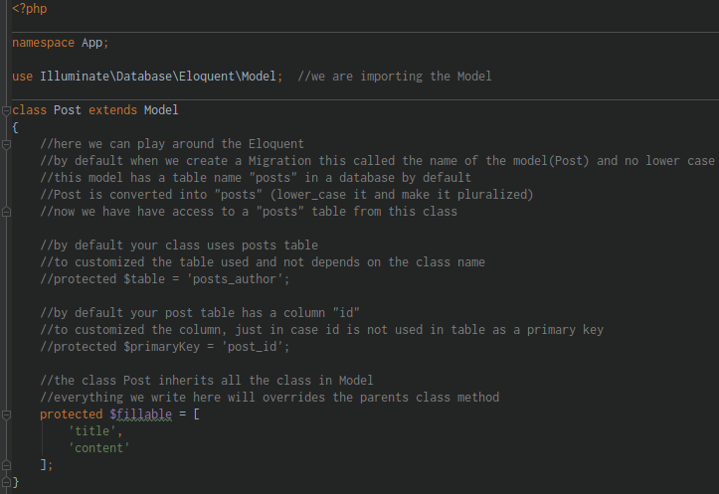

1. Updating with Eloquent

**@web.php:**

*updating the content with a condition

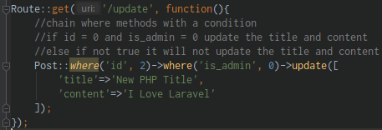

1. Deleting Data

Deleting Data using Eloquent

**@web.php:**

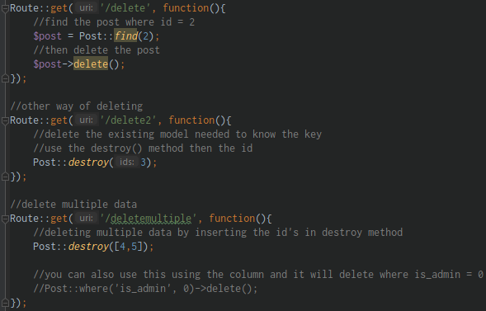

1. Soft Deleting Data

Delete data in a different way, put in a trash and not deleted it at all, it will not deleted the item unless you force deleted it

**@app/Post.php:**

*import/use the **SoftDeletes** class

*use it inside the class

*create a protected **$dates** //customized

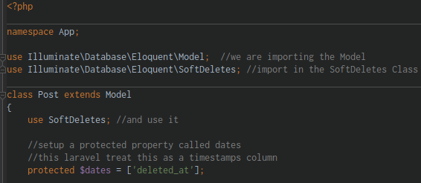

*then create a Migration

@CLI:

php artisan make:migration add_deleted_at_column_to_posts_tables -–table=posts (create migration and flag it into posts table)

php artisan migration:reset (reset the migration if you experience error)

php artisan migrate (create migration and flag it into posts table)

**@date_add_deleted_at_column_to_posts_tables.php:**

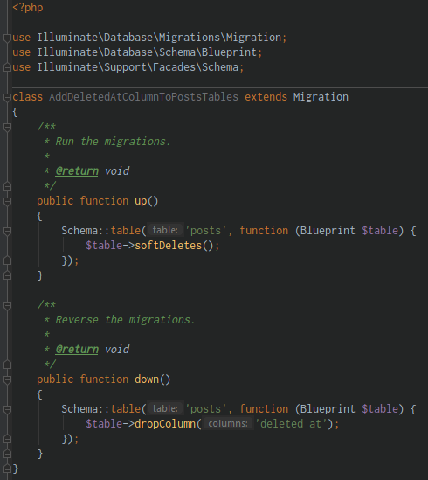

**@web.php:**

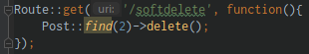

Run in the URL

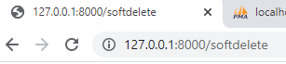

*deleted_at column now has a timestamp



1. Retrieving Deleted Trashed Records

Pulling the deleted_at or trashed item

**@web.php:**

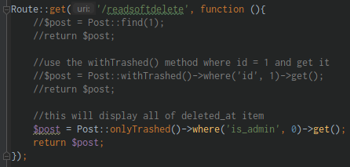

*it will display all of the **deleted_at** items

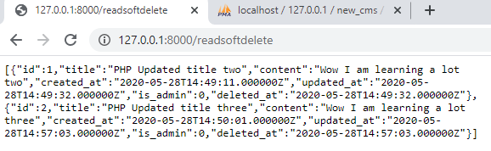

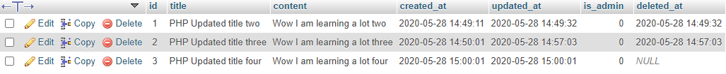

1. Restoring Deleted Trashed Records

Restoring the deleted | trashed records

**@web.php:**

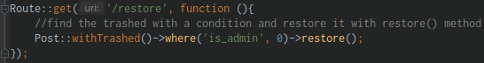

Run in the URL:

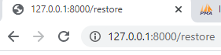

*deleted_at value becomes NULL

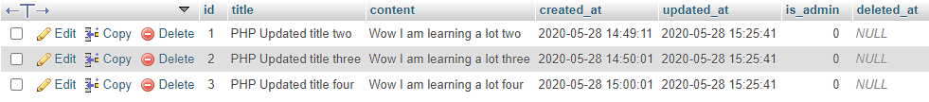

1. Deleting a Record Permanently

*be careful to read the comment part

**@web.php:**

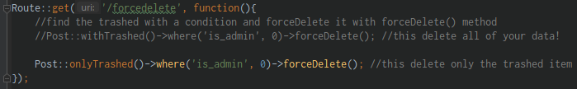

Section 11: Laravel Fundamentals – Database – Eloquent Relationships

Table of Contents:

1.) Section Intro with Edwin Diaz … page

1. Section Intro with Edwin Diaz

Eloquent Relationship a way to deal with database in a very easy format, they are going to allow us to relate tables in a very easy way format basically a function

Example is give me all categories in one post in just one function

Once we create a function, Laravel know what we want to pull a data

1. One to One Relationship

We are dealing with Relationship

**One to One** let’s say the User has one post

**One to Many** let’s say the User has many post

**User.php** is the parent

**Post.php** is the child

@database\migrations\dated_create_posts_table.php:

*add the new column “user_id”

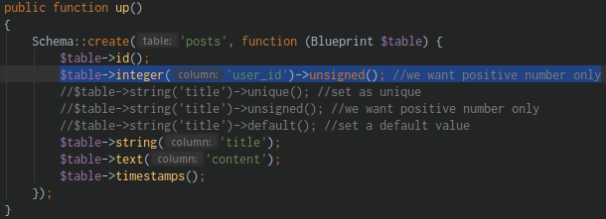

*then migrate

@CLI:

php artisan migrate:refresh (refresh to migrate again and because we’re adding new column in table, now the user_id or custom_column will now added to the table)

**@app\User.php:**

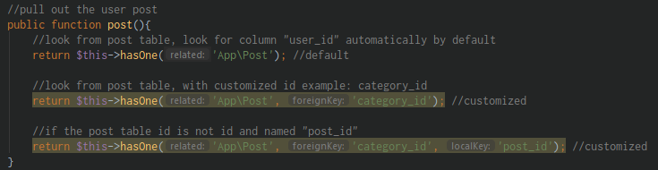

**@web.php:**

*import the app\User

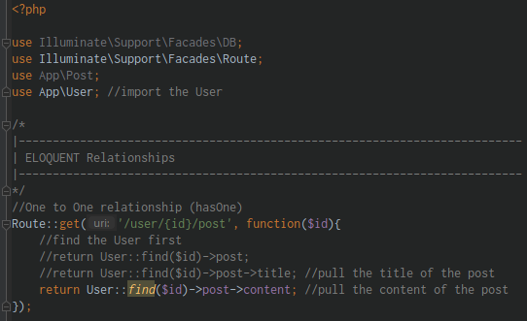

Run in the URL:

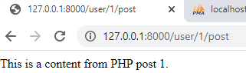

1. The Inverse relation

The Inverse of the One to One relationship or the opposite of One to One relationship

Pulling the User that **belongs to** that post

**@app\Post.php:**

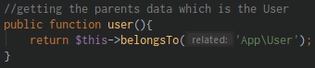

**@routes\web.php:**

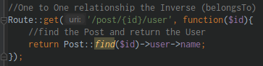

**@posts** table: (child table of users table)



**@users** table: (parent table of posts table)



Run in the URL:

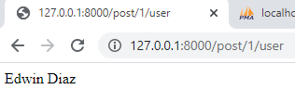

1. One to Many relationship

Pulling out all of the User posts

**@app\User.php:**

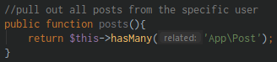

**@routes\web.php:**

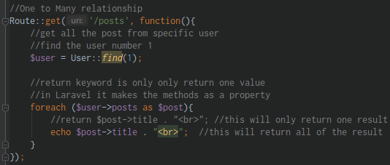

Run in the URL:

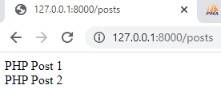

1. Some random Tips

If the PHP artisan **migrate:refresh** is not working

It is not advisable to delete the migration files in the Laravel, you must **delete all of the table in the localhost/phpmyadmin**

Then re-run the:

@CLI:

php artisan migrate (re migrate all the migration files)

1. Many to Many relations part 1

We create a Pivot table with a Many to Many relationship

**Pivot table** is a lookup table, table used to relate to other tables

Laravel has a specific instruction on how to construct a Pivot table

Create a Roles for a User to have different Roles for a User

Create 3 tables:

1. **users** table
2. **roles** table
3. **role_user** table (*pivot table* or *lookup table* that has user_id and roles_id)

@CLI:

php artisan make:model Role -m (create a Role model and a migration)

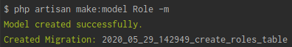

php artisan make:migration create_users_roles_table –create=role_user

(create a role_user migration)



*rename it as **role_user** because Laravel always look for unique name of table

**@dated_create_roles_table.php:**

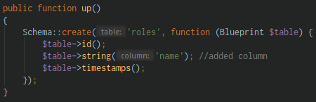

@dated_create_users_roles_table.php:

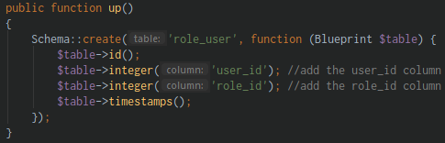

1. Many to Many relations part 2

Migrate the created migration files

@CLI:

php artisan migrate (migrate the migration files)

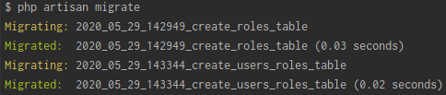

Setup data in localhost/phpMyAdmin

**@users** table:

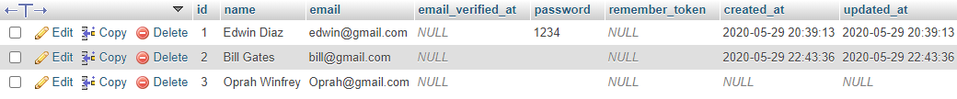

**@roles** table:

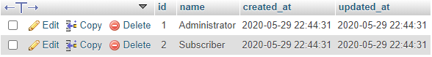

**@role_user** table:

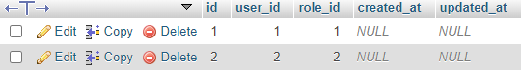

**@app/User.php:**

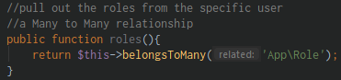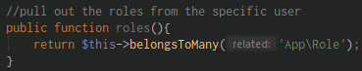

**@routes/web.php:**

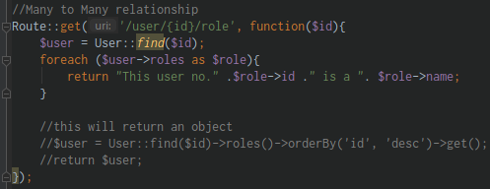

Run in the URL:

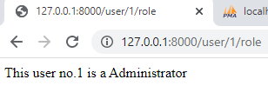 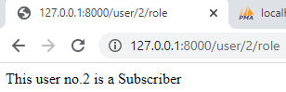

1. Querying Intermediate table

**@app/User.php:**

*customizing the Many to Many relationship

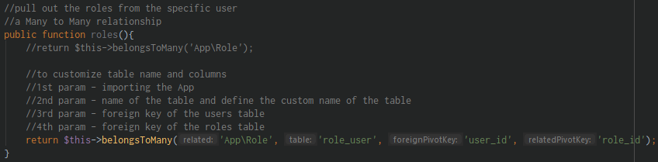

**@app/Role.php:**

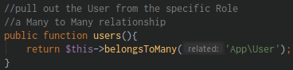

If you want to access the Intermediate table or the Pivot table

**@app/User.php:**

*let the Model know that you want to access the pivot table

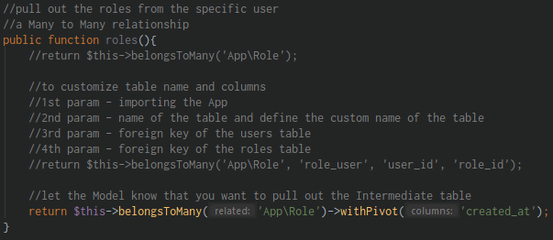

**@routes/web.php:**

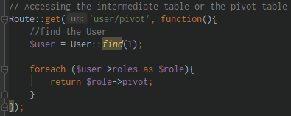

Run in the URL:

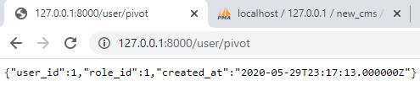

1. Has Many Through relation part 1

A Has Many Through relationship allow us to provide a convenient for accessing relationship via intermediate relations

@CLI:

php artisan make:model Country -m (make Country model and a migration)

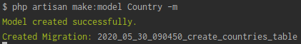

php artisan make:migration add_country_id_column_to_users --table=users (add country_id to users table)



**@dated_add_country_id_column_to_users.php:**

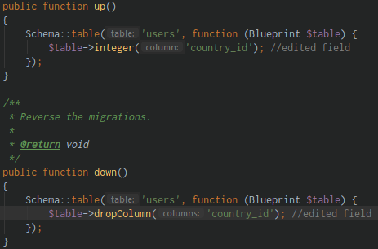

**@dated_create_countries_table.php:**

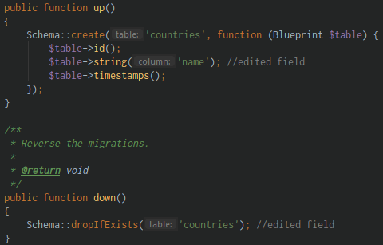

@CLI:

php artisan migrate (do the migration)

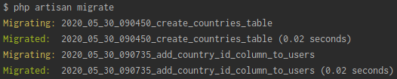

*add data in countries table:

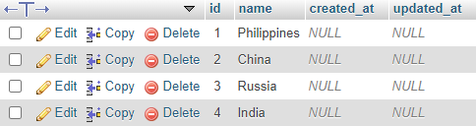

*add country_id to users table:



1. Has Many Through relation part 2

Start writing a relationship to our Model

**@app/Country.php:**

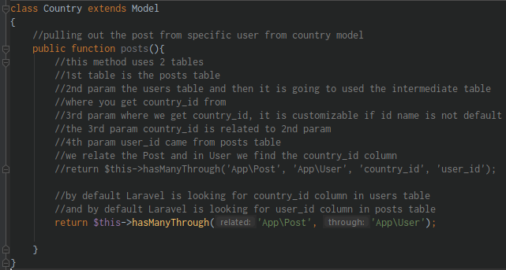

**@routes/web.php:**

*import the Country model

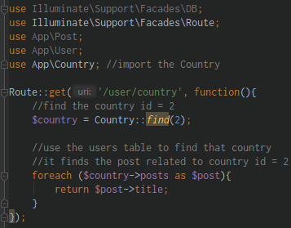

1. Polymorphic relation part 1

Polymorphic relation allow a model to be load to more than one model with a single association

@CLI:

php artisan make:model Photo -m (create a Photo model and a migration)

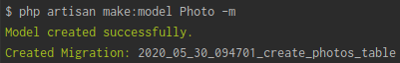

**@dated_create_photos_table.php:**

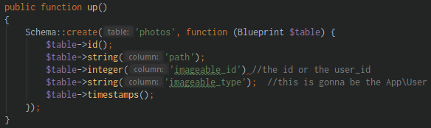

php artisan migrate (do the migration)

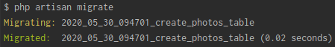

1. Polymorphic relation part 2

**@dated_create_posts_table.php:**

*remove the **user_id** column in posts table because we user polymorphic relations

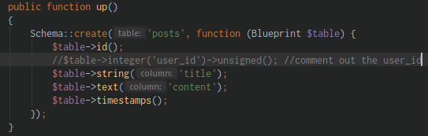

@CLI:

php artisan migrate:refresh (to rolling back the migration and migrate it again)



\***user_id** column is removed in posts table:



*add some data in photos table:

**path** – put photo file

**imageable_id** – is going to be the user_id for the specific photo

**imageable_type** – the address, the namespace, the Model

*if imageable_type is App\User -> imageable_id is the user_id

*if imageable_type is App\Post -> imageable_id is the post_id

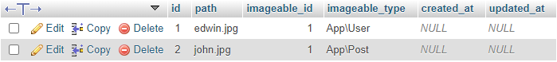

**@app\Photo.php:**

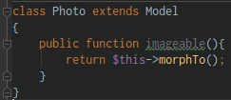

**@app\User.php:**

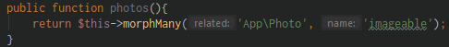

**@app\Post.php:**

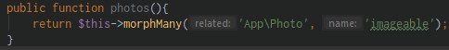

**@routes\web.php:**

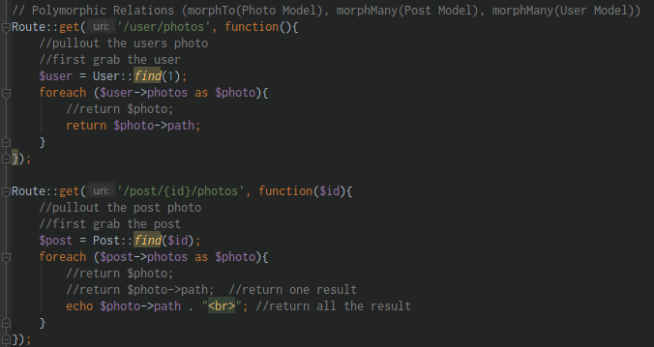

1. Polymorphic relation the Inverse

How to pull the owner of the image

**@routes/web.php:**

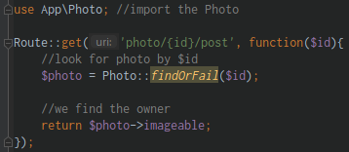

Run in the URL:

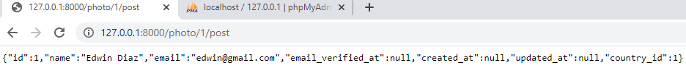

1. Polymorphic relation Many to Many part 1

Many to Many Polymorphic relations are they share a single list of unique records those records are among those tables

@CLI:

php artisan make:model Video -m (create a Video model and a migration)

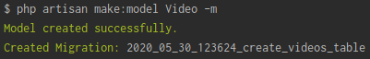

php artisan make:model Tag -m (create a Tag model and a migration)

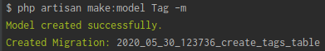

php artisan make:model Taggable -m (create a Taggable model and a migration)

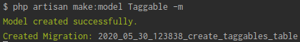

php artisan migrate (do the migration)



**@dated_create_videos_table.php:**

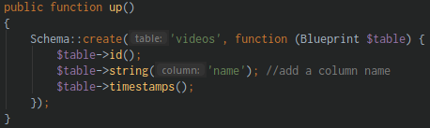

**@dated_create_tags_table.php:**

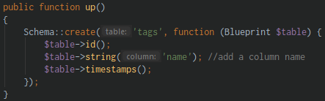

**@dated_create_taggables_table.php:**

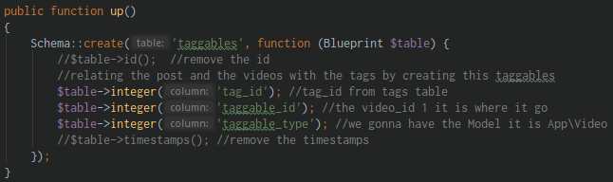

1. Polymorphic relation Many to Many part 2

Define the relationship to a Model

**@app\Post.php:**

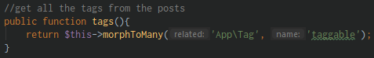

**@app\Tag.php:**

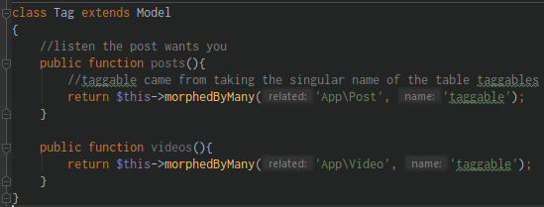

1. Polymorphic relation Many to Many – retrieving

Start putting data in the tables and start retrieving

@CLI:

php artisan migrate:rollback (rolling back the migration)



**@dated_create_taggables_table.php:**

*from integer change to string



php artisan migrate (do the migration)



**@videos** table:

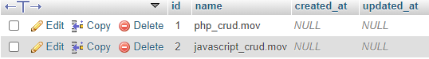

**@tags** table:

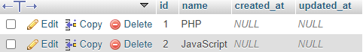

**@posts** table:



**@taggables** table:

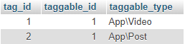

**@routes\web.php:**

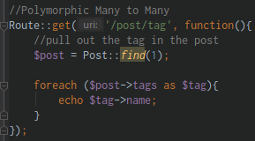

Run in the URL:

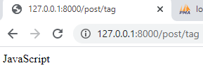

1. Polymorphic relation Many to Many – retrieving owner

Retrieving the owner of polymorphic relation

**@taggables** table:

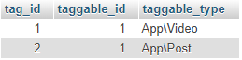

*tag_id = 1 is for App\Video

*tag_id = 2 is for App\Post

**@routes/web.php:**

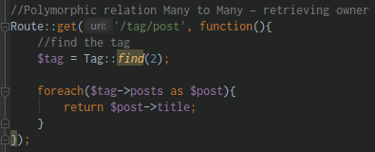

Run in the URL:

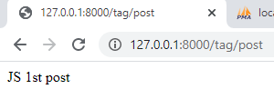

Section 12: Laravel Fundamentals – Database - Tinker

1. Section Intro with Edwin Diaz

A very handy tool called Tinker

Tinker help us to interact with Database a lot better using Eloquent we don’t have to go to routes to create a record

We use the command line in CRUD

1. Creating Data with Tinker

Create object, data using Tinker

@CLI:

php artisan tinker (opening the line in Tinker)

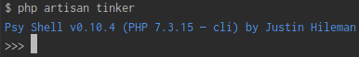

*insert some data into our table using Tinker:

$post = App\Post::create([

‘title’=>’PHP post from Tinker’,

‘content’=>’PHP post from Tinker’

]); (somehow like what you did in Routes, data must be in array)

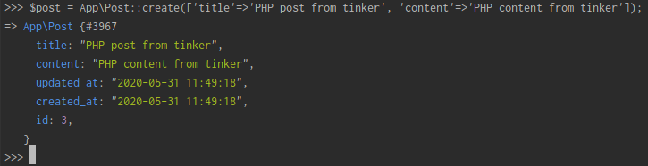

*if you want to access it again:

$post (type $post then hit Enter)

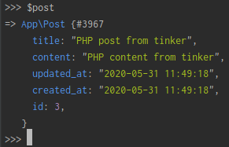

*create a New Object:

$post = new App\Post; (creating a new object)

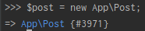

*accessing the properties and assigning a new value:

$post->title = “New Title from this object” (access the properties and assign new value to it)

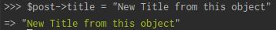

*to check the value:

$post (then hit Enter, check the value of the created object)

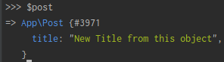

*add a content, view the object database:

$post->content = “New content from the object” (add content to object)

$post (then hit Enter, view the object)

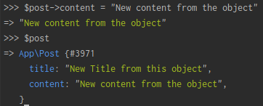

*save the object into the database

$post->save(); (then hit Enter, save the object)

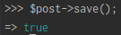

*view the saved object:

$post (then hit Enter, view the save object)

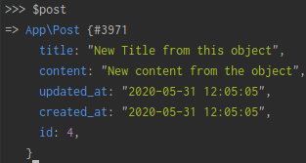

*to exit in Tinker:

exit (then hit Enter)

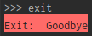

1. Finding record and using Constraints in Tinker

Reading information using Tinker from Database

@CLI:

php artisan tinker (opening the line in Tinker)

*accessing the Post table and look for id = 4

$post = App\Post::find(4) (create a post variable and accessing post table and look for id = 4)

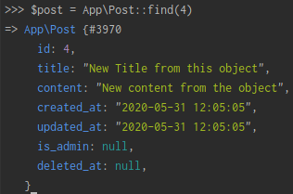

*you can also do a where statement:

$post = App\Post::where(‘id’, 4)->first(); (use a where condition to find data)

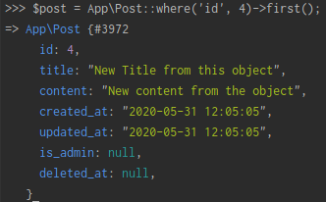

*another example:

$post = App\Post::whereId(4)->first();

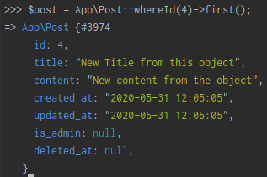

1. Updating and Deleting with Tinker

Update and Delete data using Tinker

@CLI:

php artisan tinker (opening the line in Tinker)

$post = App\Post::find(3) (create a variable post and look for post id = 3)

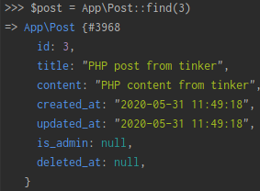

*create a new value for the column in post table:

$post->title = “Updated the record”; (add new value in post table)

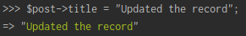

*then save it:

$post->save() (then hit Enter, then save it)

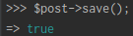

*when we update record the updated_at field is updated

*to delete record in post table:

$post->delete() (then hit Enter, it will SoftDelete unless you force deleted it)

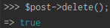

*SoftDelete is on the Delete method:



*Deleted it permanently:

$post = App\Post::onlyTrashed() (look for has a value in deleted_at)

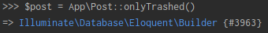

*the force deletes it:

$post->forceDelete() (then hit Enter, it will delete data in post table, display how many data is deleted)

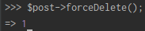

*to exit in Tinker:

exit (then hit Enter)



1. Playing around with Relations in Tinker

Find out the Relations using Tinker

Find out if the relationship is working go to Tinker and pullout the object and find out the relationship

@CLI:

php artisan tinker (opening the line in Tinker)

*use the app\User.php (User Model):

$user = App\User::find(1) (use the User Model and find id = 1)

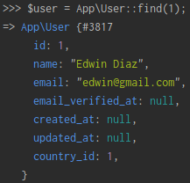

*find the user_id in the post (User Model):

$user->posts (check if has the post)



*look how helpful it is, it tells you the error, as you remember we deleted the user_id column in posts table:



$user->roles (check if has the roles)

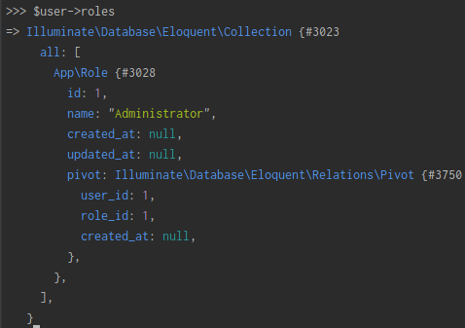

*you can play with your relationship, update or delete it

Section 13: Database – Eloquent One to One Relationship CRUD

1. Section intro with Edwin Diaz

Create a new Laravel project with migrations

Let’s learn One to One Relationships

1. Create a new Laravel installation called **onetoone**
2. Create a database with the same name **onetoone**
3. Make sure your database setting is in your **.env** file so that you may connect to it of course

@CLI:

node -v (check the version of node.js)

1. Database Configuration and Migration

Create a new folder/project named “**onetoone**”

@CLI:

composer global require laravel/installer (install globally the Laravel installer in xampp\htdocs folder)

laravel new onetoone (create a new Laravel project)

*modify the variables in .env file:

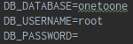

*create a new database “onetoone” in localhost/phpmyadmin:



php artisan make:model Address -m (create an Address model and a migration)

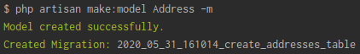

@dated_create_addresses_table.php:

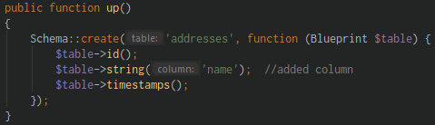

php artisan migrate (do the migration)

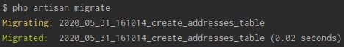

*the **addresses** table is added in onetoone database:

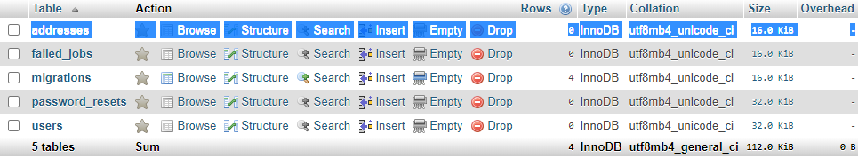

1. Setting up Relations

Setting up the relations and use it in CRUD

@dated_create_addresses_table.php:

*add new column “**user_id**”

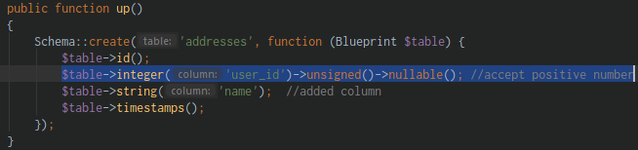

@CLI:

php artisan migrate:refresh (rolling back the migration)

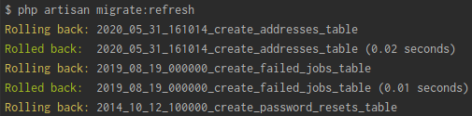

1. Creating data for User

You may user php artisan tinker

@routes/web.php:

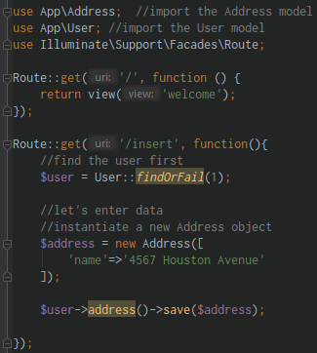

@app/Address.php:

*allow the input in “**name**” column

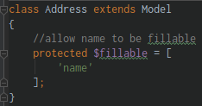

@app/User.php:

*create a relationship with address table:

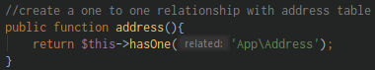

*run in the URL:

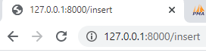

@localhost/phpMyAdmin (addresses table):

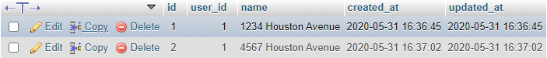

1. Updating data

Find the address of the User and update it

@route/web.php:

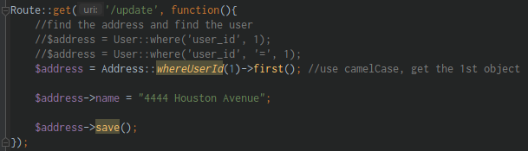

*run in the URL:

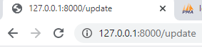

@localhost/phpmyadmin addresses table:

*the first record where user_id = 1 is updated

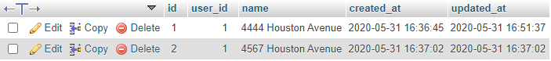

1. Reading and Deleting data

Reading the data

@routes/web.php:

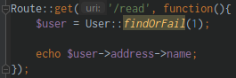

*run in the URL:

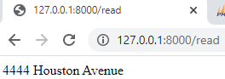

Deleting the data

@routes/web.php:

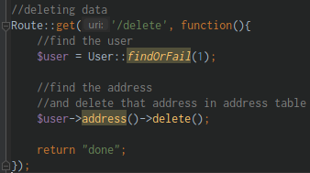

*run in the URL:

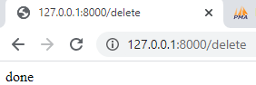

@localhost/phpmyadmin (addresses table):

*the address where user_id = 1 is deleted

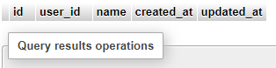

Section 14: Database – Eloquent One to Many Relationship CRUD

1. Database migrations

Create a new Laravel Project

Let’s learn One to Many Relationships

1. Create a new Laravel installation called **onetomany**
2. Create a database with the same name **onetomany**
3. Make sure your database setting is in your **.env** file so that you may connect to it of course

Older Laravel versions will have the **$table->increments(‘id’)** by default when you create a migration but the **new versions have $table->id(),** don’t worry about, this are basically the same thing.

Create a new folder/project named “**onetomany**”

@CLI:

composer global require laravel/installer (install globally the Laravel installer in xampp\htdocs folder)

laravel new onetomany (create a new Laravel project)

@.env file: (modify the database variable)

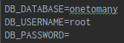

@localhost/phpmyadmin (create a onetomany database)

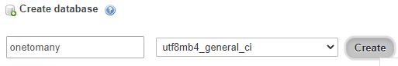

*create a Migration for Post, let’s say the User has many post

@CLI:

php artisan make:model Post -m (create a Post model and a migration)

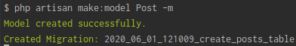

@dated_create_posts_table:

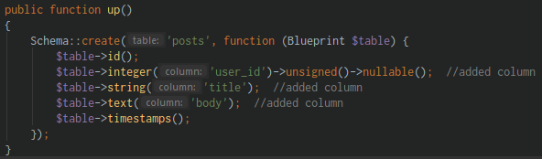

php artisan migrate (do the migration)

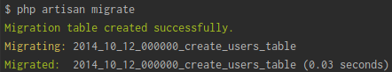

1. Relationships and mass assignment

We are going to create a relationship

@app/User.php:

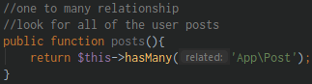

@app/Post.php:

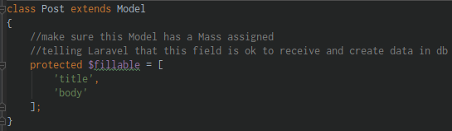

1. Inserting data

Let’s start with the CRUD

*create a user using the php Tinker

@CLI:

php artisan tinker (opening the line for tinker)

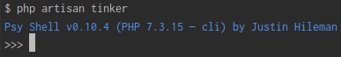

App\User::create([‘name’=>’John Doe’, ‘email’=>’john@gmail.com’, ‘password’=>bcrypt(“123”)]); (create a record using php artisan tinker and use a function bcrypt())

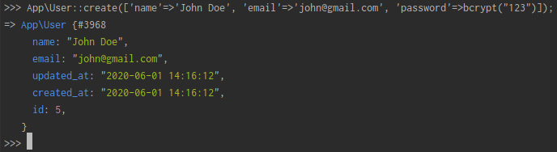

*then exit:

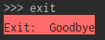

@localhost/phpmyadmin (users table):

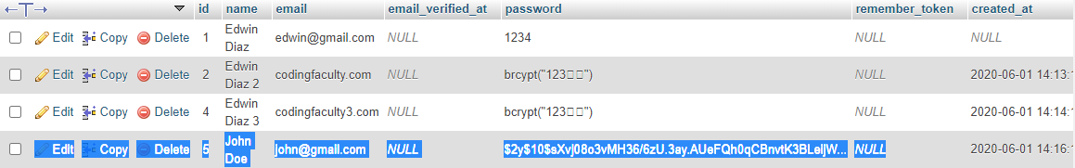

@routes/web.php:

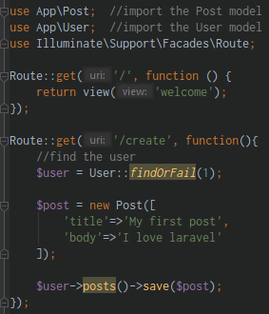

@localhost/phpmyadmin (posts table):



1. Reading data

Start reading our data

@routes/web.php: (this return an object)

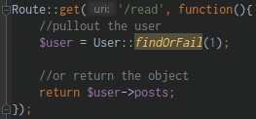

*run in the URL:



@routes/web.php: (diedump or dd() to check if it is a collection)

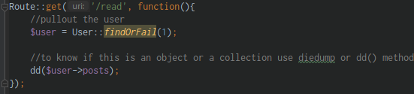

*run in the URL:

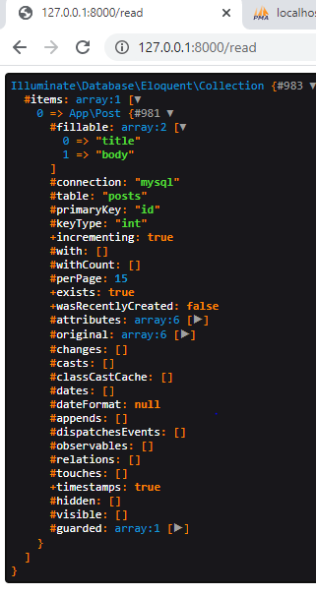

@routes/web.php: (now this return an object, because user has a relationship of hasMany, then it’s a Collection)

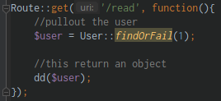

*run in the URL:

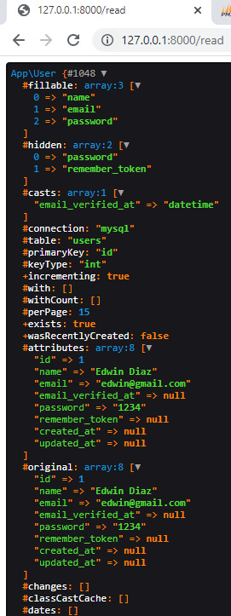

@routes/web.php: (view all of the users posts)

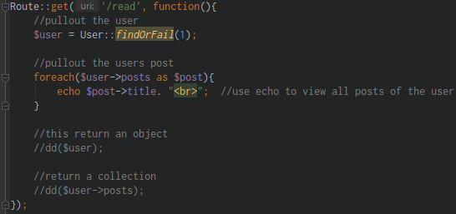

*run in the URL:

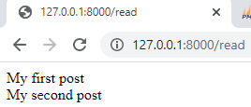

1. Updating data

Start updating our data

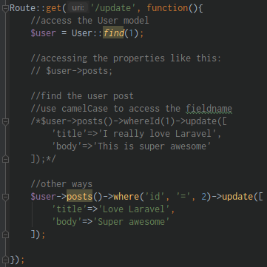

1. Deleting data

Deleting the record, as long as we can find that specific users relationship and delete it

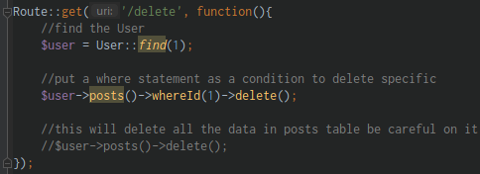

Section 15: Database – Eloquent Many to Many Relations CRUD

1. Database Migrations

Let’s learn Many to Many Relationships

1. Create a new Laravel installation called **manytomany**
2. Create a database with the same name **manytomany**
3. Make sure your database setting is in your .env file so that you may connect to it of course

We create here a Many to Many relationship

Create the **manytomany** project using cmd

@CLI:

laravel new manytomany (creating a Laravel new project)

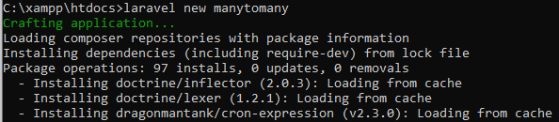

@localhost/phpmyadmin (create a **manytomany** database)

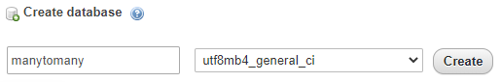

@.env file: (modify the environment variable)

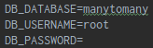

*then Run the project in server:



@CLI:

php artisan make:model Role -m (create a Role model and a migration)

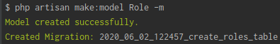

@dated_create_roles_table.php: (add new column)

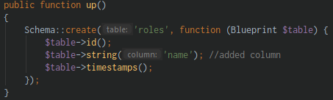

php artisan make:migration create_role_user_table (create pivot/lookup table)



@dated_create_role_user_table.php: (add new column)

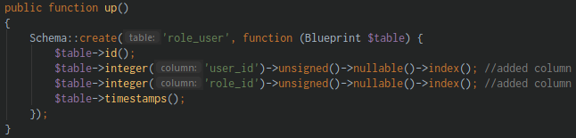

*then run the migrate

php artisan migrate (run the migration)

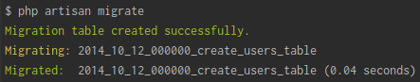

1. Relationships and Mass assignment

Setting up the relationship and the mass assignment

@app/User.php:

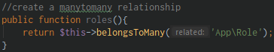

@app/Role.php:

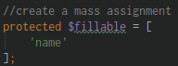

1. Inserting Data

Create data using many to many relationship

@routes/web.php:

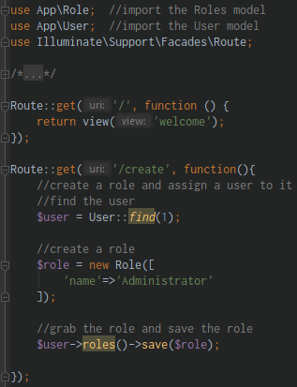

@localhost/phpmyadmin: (roles table)



@localhost/phpmyadmin: (role_user table)



1. Reading Data

Reading data using a ManytoMany relationship

Use diedump **dd()** method to inspect what value you’ve got, it’s ok to investigate, do the in-depth learning

@routes/web.php:

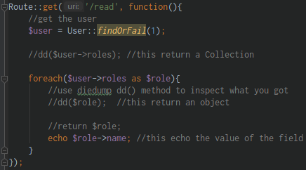

1. Updating Data

Learn how to Update using Many to Many Relationship

@routes/web.php:

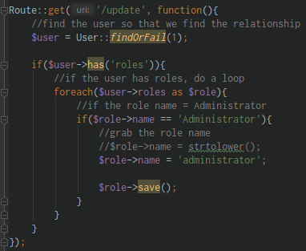

1. Deleting Data

Delete with a ManytoMany relationship

@routes/web.php:

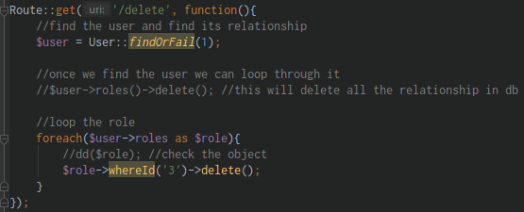

1. Attaching, Detaching and Syncing

Some other methods, built-in functionalities from Laravel that allows us to attach roles, detach roles and sync roles

@routes/web.php:

*attaching

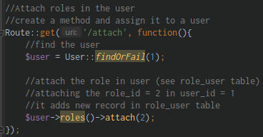

*detaching

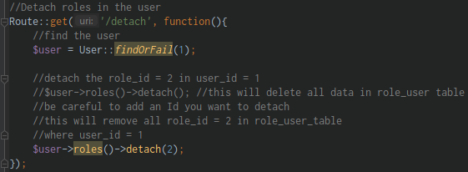

*syncing

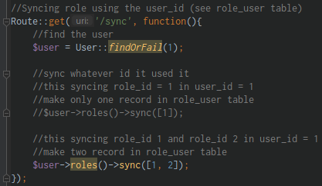

Section 16: Database - Eloquent Polymorphic Relationship CRUD

1. Relationships and Mass Assignment

Let’s learn about Polymorphic relationships

Summary:

**We creating a Laravel Project with the database, 3 models and 3 migrations**

**Note:** There is no need to add increment ids on pivot tables unless you plan to access them directly

1. Create a new Laravel installation called **polymorphic**
2. Create a database with the same name **polymorphic**
3. Create **3** models,
   1. **Staff**,
   2. **Product** and
   3. **Photo**;

and here is a reminder of how we do that below

php artisan make:model Staff -m

php artisan make:model Product -m

php artisan make:model Photo-m

1. Edit your migrations
2. By default, we know the migrations will have $table->id()
3. The Migration for **create_staff_table.php** of the Staff model needs to have the below data.

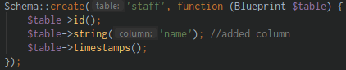

1. The Migration for **create_photos_table.php** of the Photo model

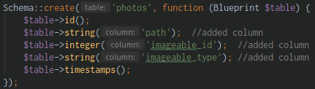

1. The Migration for **create_products_table.php** of the Product model

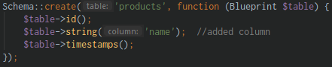

1. Then run the Migration

php artisan migrate

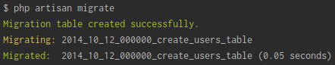

Create a **polymorphic** project

@CLI:

laravel new polymorphic (create a new Laravel app named polymorphic)

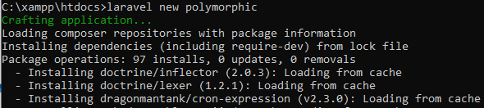

*always click the Run ‘npm install’

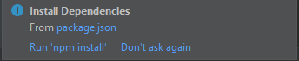

@.env file (modify the environment variables)

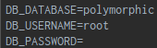

@localhost/phpmyadmin (create a polymorphic database)

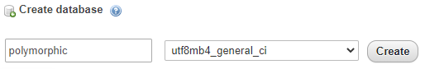

php artisan serve (serving your application)

php artisan make:model Staff -m (create a Staff model and a migration)

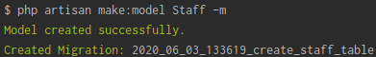

@dated_create_staff_table.php: (add new column)



php artisan make:model Product -m (create a Product model and a migration)

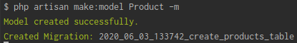

@dated_create_products_table.php: (add new column)



php artisan make:model Photo -m (create a Photo model and a migration)

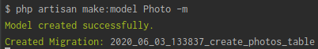

@dated_create_photos_table.php: (add new column)



Setting up the main relationship in **Photo** model

@app/Photo.php:

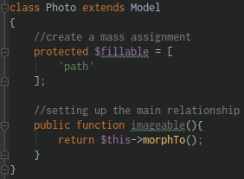

@app/Staff.php:

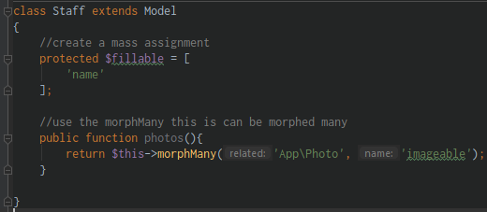

@app/Product.php:

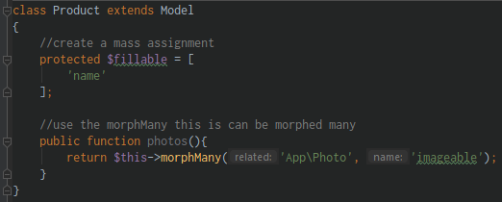

1. Inserting Data

Start retrieving some data

@routes/web.php:

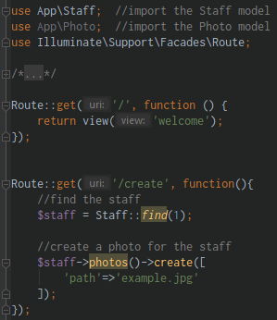

*run in the URL:

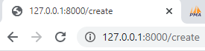

@localhost/phpmyadmin: (photos table)



1. Reading Data

Start reading informations

@routes/web.php:

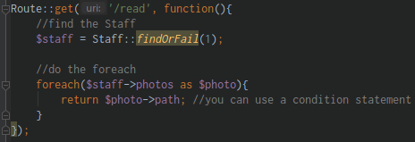

*run in the URL:

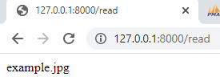

1. Updating Data

Start how to update using the Polymorphic relationships

@routes/web.php:

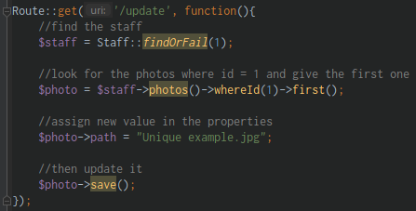

*run in the URL:

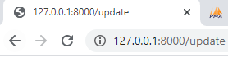

@localhost/phpmyadmin: (photos table)



1. Deleting Data

Delete using the Polymorphic relationship

@routes/web.php: (delete photos where id = 1)

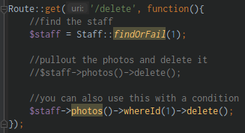

1. Extra Techniques

Showing a couple of tricks just in case you want to take a relationship of a polypmorphic relationship or a just relate it in a different way

@localhost/phpmyadmin: (**photos** table)

*add a path only

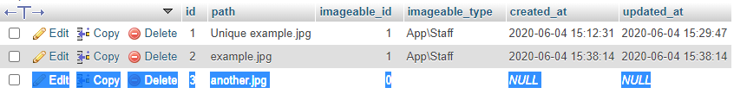

@routes/web.php:

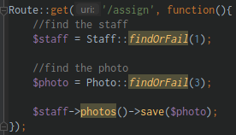

*run in the URL:

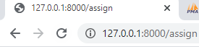

@localhost/phpmyadmin: (**photos** table)

*the imageable_id and imageable_type is updated with a new records

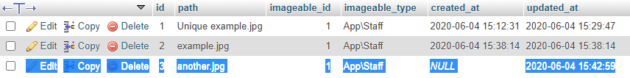

@routes/web.php:

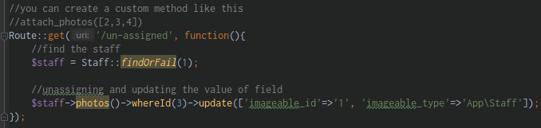

Section 17: Database – Eloquent Polymorphic Many to Many Relationship CRUD

1. Relationships and Mass Assignment

Creating a New Project with some Migrations – Classwork

Let’s learn so more about **Polymorphic relationships** but this one will be the Many to Many

**NOTE:** There is no need to add increment ids on pivot tables unless you plan to access them directly

Summary:

We creating a Laravel Project with **4 database**, **4 models** and **4 migrations**

1. Post
2. Video
3. Tag
4. Taggable

Let’s get started:

1. Create a new Laravel installation called **polymorphicmanytomany** 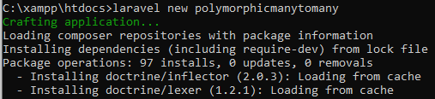
2. Create a database with the same name

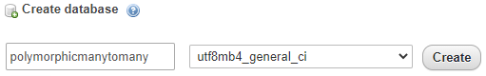

1. Create 4 models: **Post**, **Video**, **Tag** and **Taggable**

php artisan make:model Post -m (create a Post model and a migration)

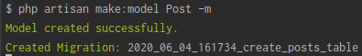

php artisan make:model Video -m (create a Video model and a migration)

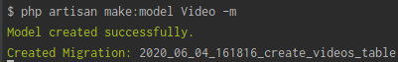

php artisan make:model Tag -m (create a Tag model and a migration)

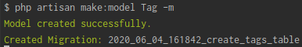

php artisan make:model Taggable -m (create a Taggable model and a migration)

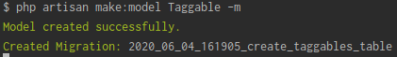

1. Edit the Migrations
   1. **create_posts_table.php**

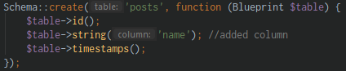

* 1. **create_videos_table.php**

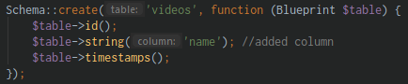

* 1. **create_tags_table.php**

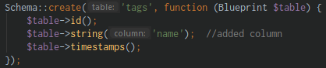

* 1. **create_taggables_table.php**

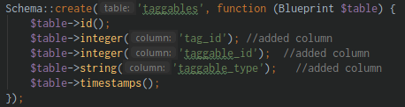

1. Then run the migration

php artisan migrate (run the migration)

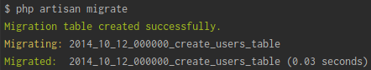

@PHP Storm IDE:

*click Run ‘npm install’

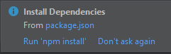

@.env file: (modify the environment variables)

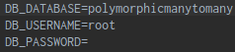

@CLI:

php artisan serve (serving the Laravel application)

@app\Post.php:

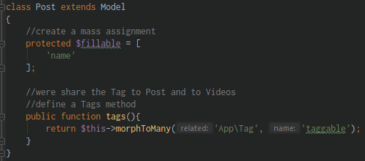

@app\Video.php:

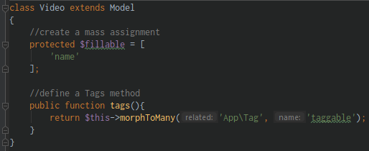

@app\Tag.php:

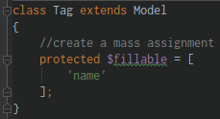

1. Inserting Data

Insert data in **tags** table

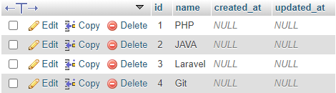

@routes/web.php: (2 save instances in one route)

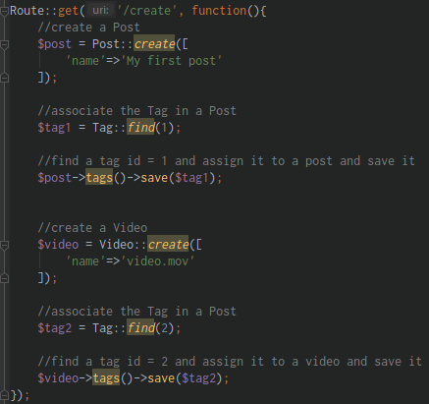

*run in the URL:

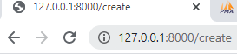

@localhost/phpmyadmin: (it added data to **posts** table)



@localhost/phpmyadmin: (it added data to **videos** table)



@localhost/phpmyadmin: (it added data to **taggables** table)

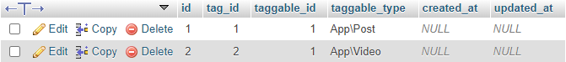

1. Reading and Updating Data

Reading information in the database

@routes/web.php:

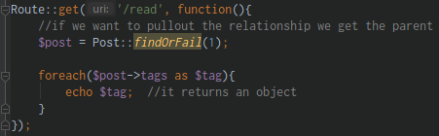

*run in the URL:

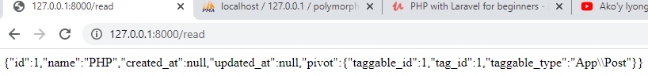

@routes/web.php:

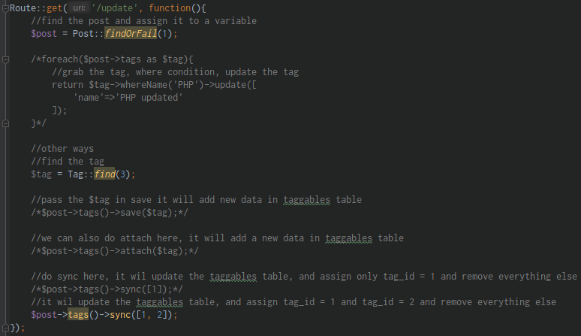

1. Deleting Data

Start deleting some of this relationship

@routes/web.php:

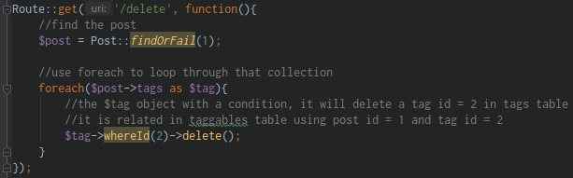

Section 18: Forms and Validation

1. Section Intro with Edwin Diaz

Learn about forms and validation, forms are used to entering information in website

1. Setting up migration and relations

Back at **cms** folder

Create a CRUD in **posts** table

@CLI:

php artisan serve (serving the application)

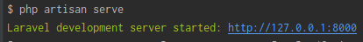

@create_post_table.php: (uncomment the user_id field)

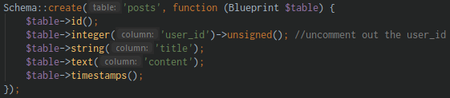

php artisan migrate:refresh (re run the migration)

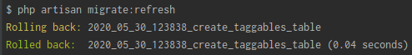

@app/User.php: (review the hasMany relationship)

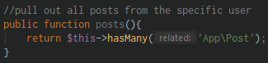

1. Setting up views and routes

Setting up the routes in views

@routes/web.php:



@CLI:

php artisan config:cache (clearing the cached)

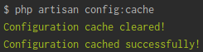

php artisan route:list (check all the available routes in application)

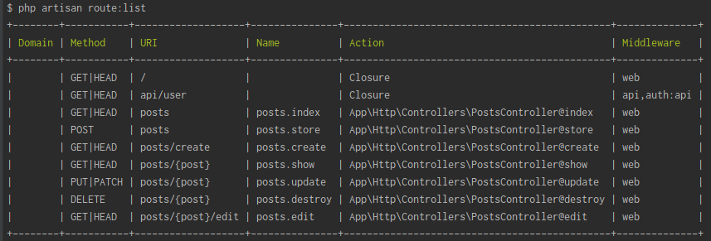

@PostsController.php:

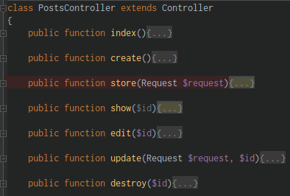

*setting up a blade page for blade.php file:

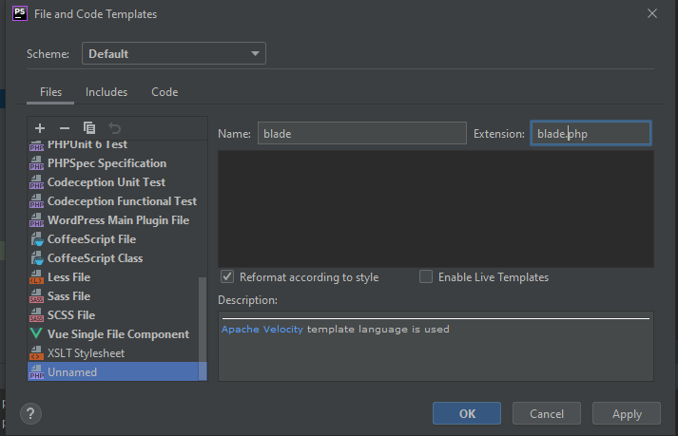

@resources/views folder (add a new folder **posts** and 4 CRUD blade.php file)

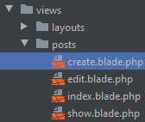

1. 4-Setting the markup for create

Creating the markup for the page

@posts/create.blade.php: (create a form)

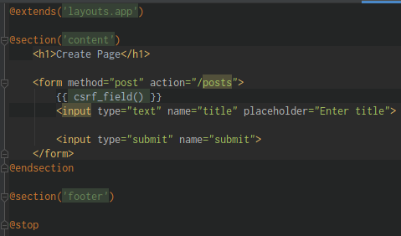

1. Setting up the controller and view

Start creating a controller

@PostsController.php:

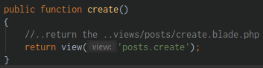

run in the URL:

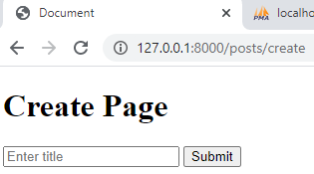

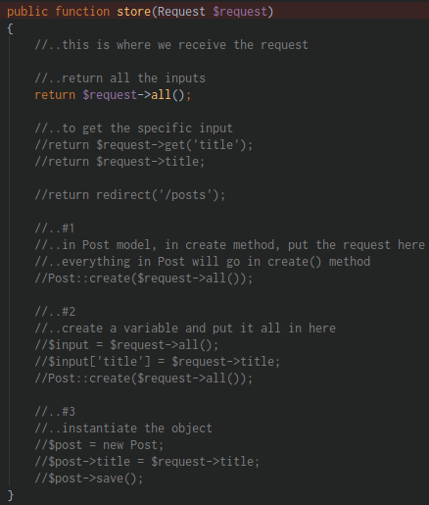

1. Persisting data to database

Returning the persist data into our table to database

@PostsController.php:

way #1:

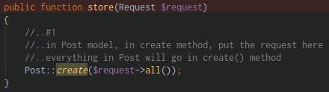

way #2:

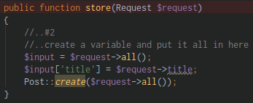

way #3:

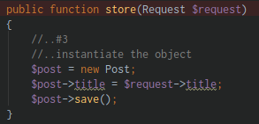

1. Reading data

Reading the information

@PostsController.php:

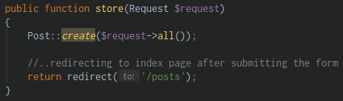

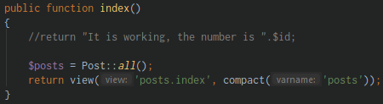

@views/posts/index.blade.php:

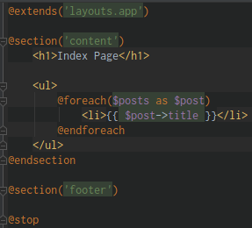

1. Showing individual posts and updating

Learn to show record

@PostsController.php:

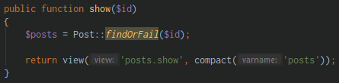

@views/posts/show.blade.php:

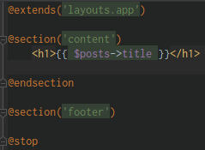

1. Preparing the edit view and setting up the token

Let’s update the record

@views/posts/edit.blade.php:

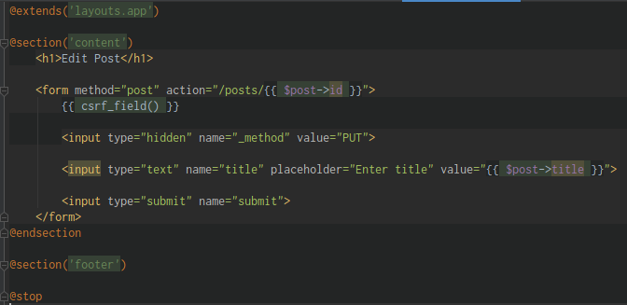

@PostsController.php:

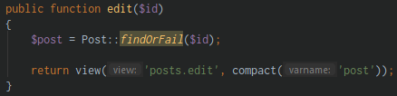

1. 10- Editing records and redirecting

Let’s continue to update our records

@PostsController.php:

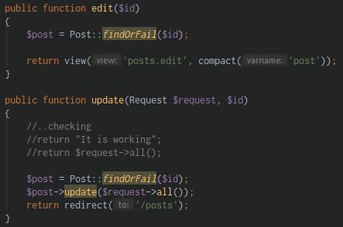

1. 11- Deleting

Let’s delete a record or data

@views/posts/edit.blade.php: (where the delete form is being placed)

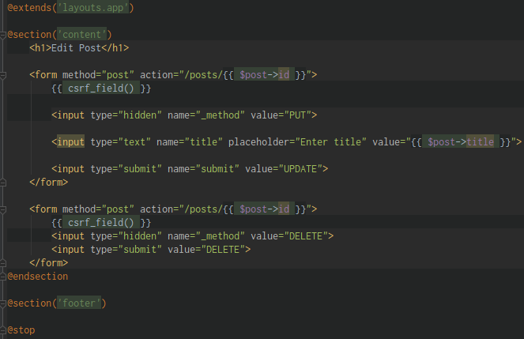

@PostsController.php:

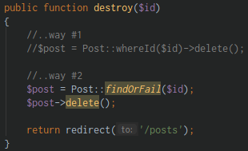

Section 19: Forms – Package and validation

1. Section intro with Edwin Diaz

Learn how to use package in forms and we are using Advanced Validation

1. Installing package and testing

Installing the package and use it functionality

Check these pages for the Forms & HTML we’re going to be used:

* <https://github.com/illuminate/html>
* <https://laravelcollective.com/docs/6.0/html>

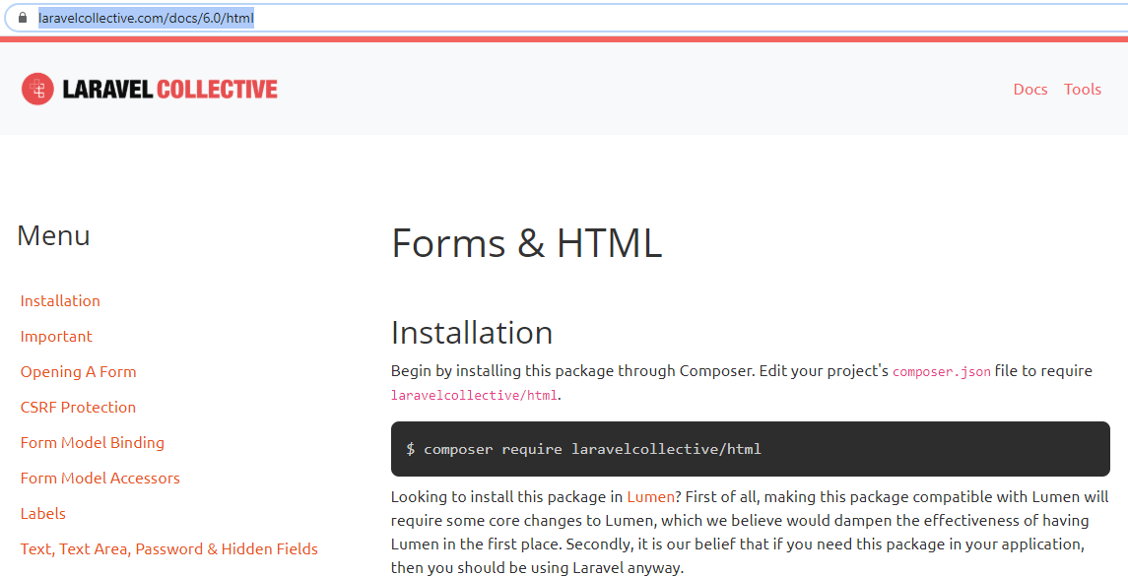

@CLI:

composer update (updating the composer)

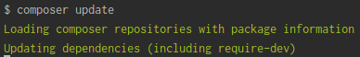

composer require laravelcollective/html (adding the laravelcollective in composer.json)

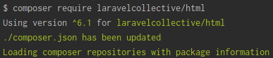

@composer.json: (laravelcollective/html is added)

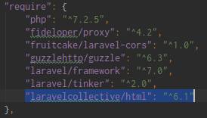

@config/app.php: (in providers, add a service provider)

* this is where we install the plugins
* Add this new line:
* 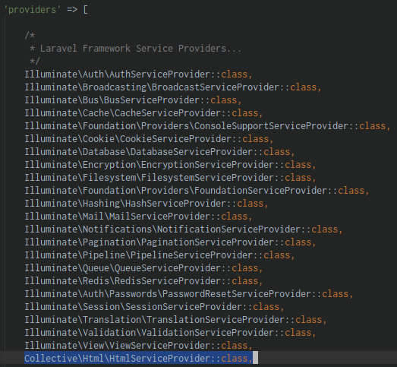



* now Add the ‘aliases’
* this is where you use a Classes with another name:
* add the two new line:
* 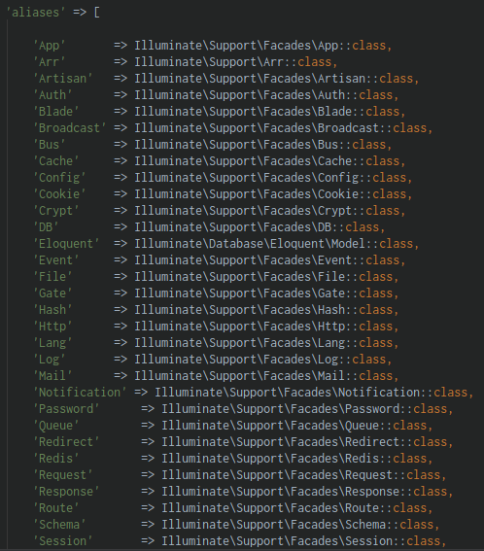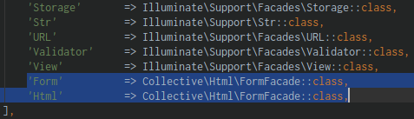

@views/posts/create.blade.php (apply the laravelcollective plugins)

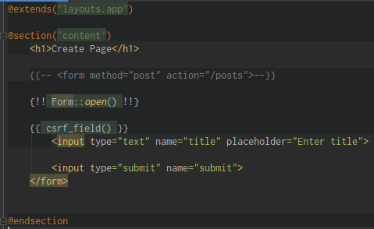

1. Modifying our create form with the form package

Create an input and pass a parameter in installed plugins(laravelcollective)

@views/posts/create.blade.php:

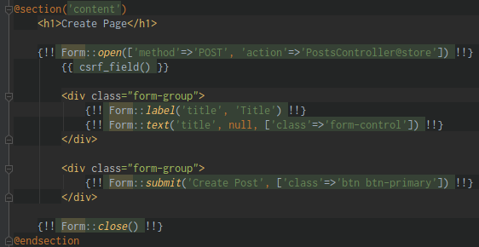

LaravelCollective/Html more samples:

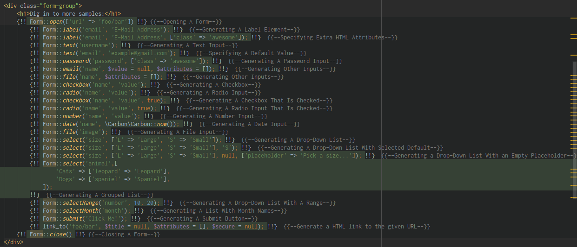

1. Modifying our edit and delete forms with the form package

Let’s start editing and deleting in our form

@views/posts/edit.blade.php:

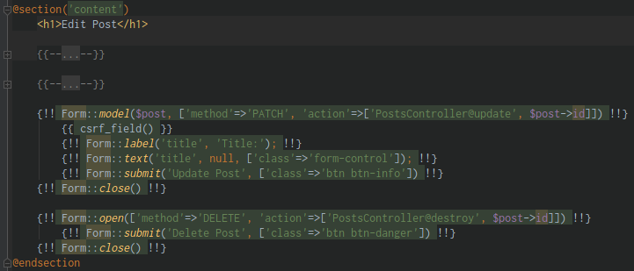

1. Basic Validation

@PostsController.php: (add a validation)

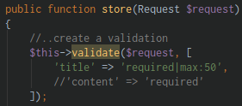

1. Displaying errors

Displaying the errors message

In this line of code:

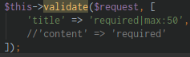

* when this line of code fails it is store in a variable name **$errors**
* **$errors –** this is available to all application

Modify the routes/web.php:

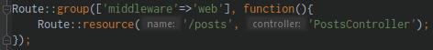

Display the error in views/posts/create.blade.php:

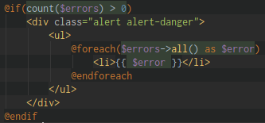

Run in the URL:

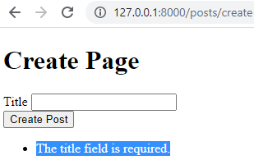

1. Advance validation

Create an Advanced Validation

Create a custom class for a Validation

@CLI:

php artisan make:request CreatePostRequest (Create a request)

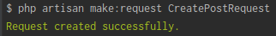

* location: (app/Http/Requests/CreatePostRequest.php)

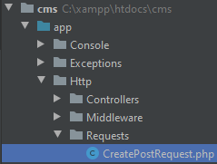

@CreatePostRequest.php:

* in authorize() method - change false into true
* in rules() method – add your rules

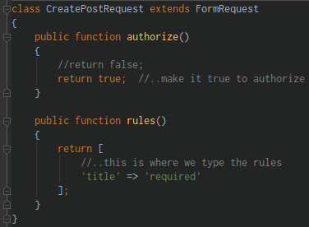

@PostsController.php:

* Add the CreatePostRequest namespace
* change the Request into CreatePostRequest
* remove/comment out the validation

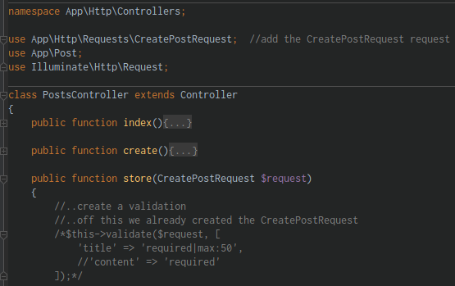



1. Creating snippets with PHPStorm

Creating the Snippets like Emmets in PHPStorm IDE

Click **Search >** type **Live Templates** >

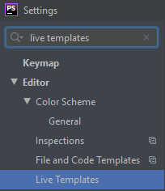

Click the **1. Live Template** >

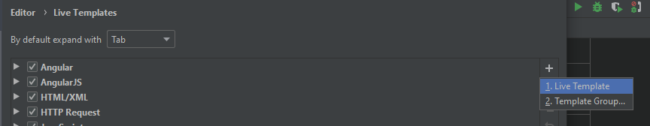

Click the **Abbreviation**

* Define the Abbreviation
* Define the Description
* Define Template Text
* Define it in PHP

> click **Apply** > **OK**

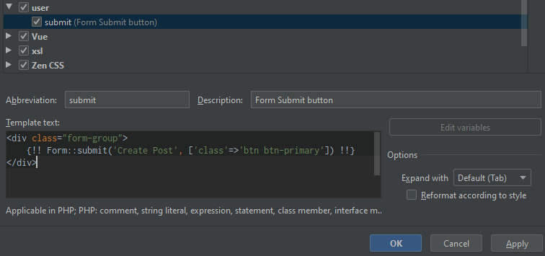

to test: Type **submit**

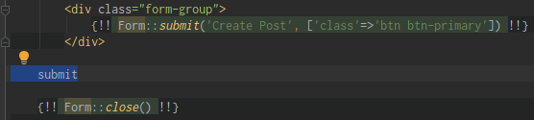

then hit **Tab**

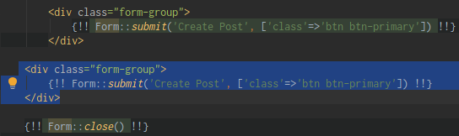

Section 20: Database – Some more model manipulation

1. Section Intro with Edwin Diaz

Learn about Dates, Accessors, Mutators and Query Scope

1. Dates

@routes/web.php:

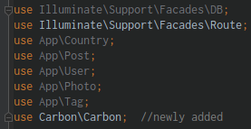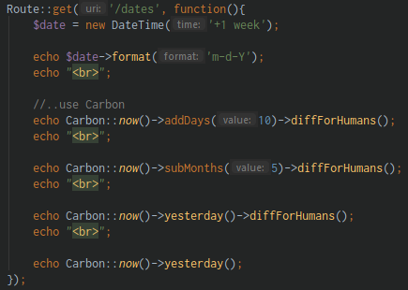

Run in the URL:

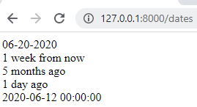

1. Accessors

**Accessors** do the functionality that pulls data out of the database without doing and then being able to manipulate it before we get it out

@routes/web.php:

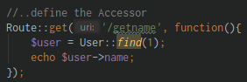

@app/User.php:

* this is where we manipulate the data
* getNameAttribute (explains: **get** the **name** column and keyword **attribute** and passing a value, **get attributes,** the accessors get the data)

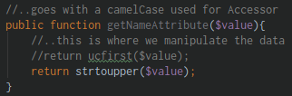

Run in the URL:

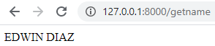

1. Mutators

**Mutators** are the functionality where we can actually set a value before we go to the database and manipulate the value and set it in the database

@app/User.php:

* this is where we manipulate the data
* setNameAttribute (explains: **set** the **name** column and keyword **attribute** and passing a value, **set attributes,** the mutators set the data)

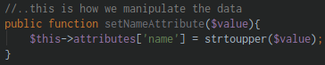

@routes/web.php:

* this will set the name into strtoupper (ALL UPPERCASE) with the predefined value
* in database, the new value of name is “WILLIAM”

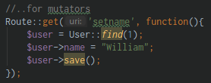

1. Query Scope

Query Scope’s allow us to kind of create shortcuts for really complex operations

Query Scope will minimize this long line of code:

* $posts = Post::latest()->get();

@app/Post.php:

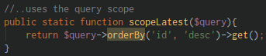

@PostsController.php:

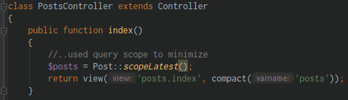

!! review it !!

Section 21: Forms – Uploading files

1. Section intro with Edwin Diaz

This section we’ll be learning about uploading files using form

1. Modifying our create view for File input

Add the **enctype** in form

From:



To add: (add in [] array the **‘files’=>true**)





@views/posts/create.blade.php: (add the input file in the form)

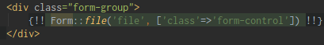

1. Retrieving file data

Retrieve the file from the store method

@PostsController.php:

* inside the store() method
* play around how to file will be displayed

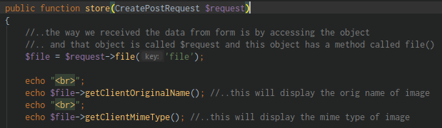

Run in URL: (this will display after you select an image and hit enter)

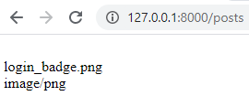

1. Persisting file data into the database

Learn how to persist it the data so it goes in the database/server

Create a migration to **add a column** for the **image** in **posts** table

@CLI:

php artisan make:migration add_path_column_to_posts –table=posts (add path column to posts table)



@dated_add_path_column_to_posts.php

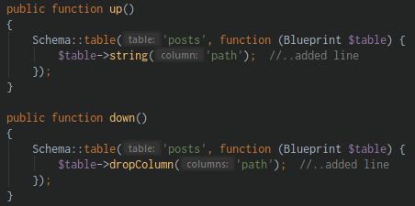

php artisan make:migrate (do the migration)

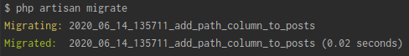

@app/Post.php

* Add the ‘path’ in fillable to allow it to be mass assigned

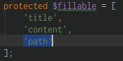

@PostsController.php:

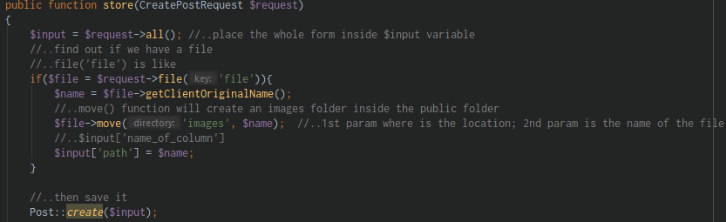

Run in the URL:

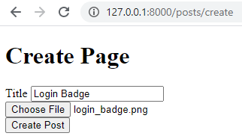

@public (folder)

* it created a new folder named “images” and inside of it is the file

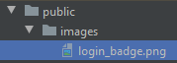

1. Displaying images and using accessors to make it easy

Make the image name uploaded unique in case same name

@views/posts/index.blade.php:

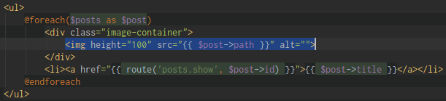

@app/Post.php:

* create an Accessor and a mutators for the image file path
* instead of using “/images/{{ $post->path }}” make it {{ $post->path }}

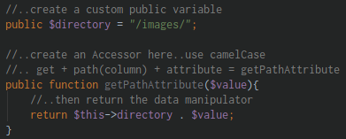

Section 22: Form - Login

1. Section intro with Edwin Diaz

Learn about login

1. New Laravel installation

Create an installation for **Login** application

Create a new installation of Laravel project/application

@CLI:

laravel new login (creating a new Laravel project named **login**)

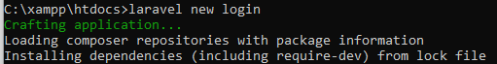

>Open **PHPStormIDE** > **run npm install**

php artisan serve (serving your application)

1. Database connection and migrations

Create a **laravel_login** database:

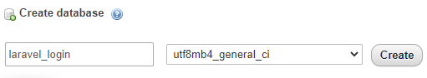

Modify the **DB_DATABASE** in **.env** file:



@CLI:

php artisan migrate (run the migration)

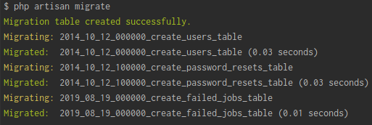

1. Creating the login system under 1 minute

Create the Login system

Check this website: <https://hdtuto.com/article/laravel-6-make-auth-command-tutorial>

@CLI:

composer require laravel/ui (first install the laravel/ui package)

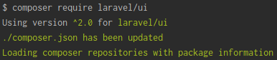

php artisan ui --help (check the ui commands info)

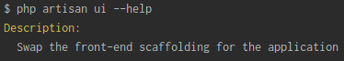

You can use the following commands for creating auth:

php artisan ui vue --auth (using Vue)

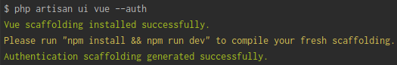

php artisan ui react --auth (using React)

Now you need to run npm command, otherwise you can’t see the layout of login and register page

npm install (install NPM)

npm run dev (run NPM)



Refresh the URL: (**LOGIN** and **REGISTER**)

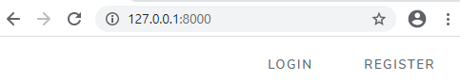

Run this command every time you have made changes in **.env** file 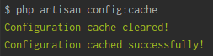

1. Login creation overview

Reviewing the auth folder in **Http/Controllers/Auth** folder

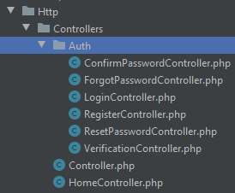

Reviewing the auth folder in **resources** folder

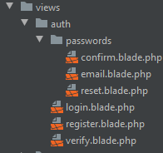

1. Retrieving authenticated user data

How to authenticating the users information

@HomeController.php: (display the authenticated user)

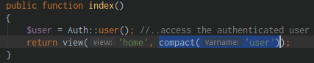

@views/home.blade.php:



Playing around the routes/web.php:

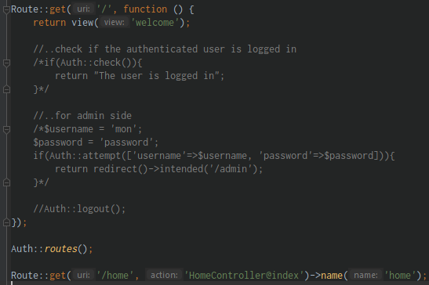

Section 23: Middleware – Security Protection

1. Section intro with Edwin Diaz

Middleware acts as a bridge between a request and a response

It’s a type of filtering mechanism

Laravel includes a **middleware** that verifies whether the user of the application is authenticated or not

Middleware protecting your application

Create a new project/application named: **middleware**

@CLI:

laravel new middleware (creating a new Laravel project named **middleware**)

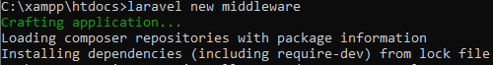

Open the project **middleware** in PHPStorm IDE

Click the Run **npm install**

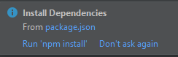

Create **middleware** database in localhost/phpmyadmin

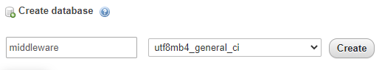

**@.env** file: (update the DB_DATABASE variable)



@CLI:

php artisan serve (serving your application)

php artisan migrate (run the migration)

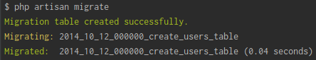

Create the Login system

Check this website: <https://hdtuto.com/article/laravel-6-make-auth-command-tutorial>

@CLI:

composer require laravel/ui (first install the laravel/ui package)



php artisan ui --help (check the ui commands info)



You can use the following commands for creating auth:

php artisan ui vue --auth (using Vue)



php artisan ui react --auth (using React)

Now you need to run npm command, otherwise you can’t see the layout of login and register page

npm install (install NPM)

npm run dev (run NPM)



Refresh the URL: (**LOGIN** and **REGISTER**)



Run this command every time you have made changes in **.env** file 

1. Create a new Laravel installation (challenge)

Create a RoleMiddleware

@CLI:

php artisan make:middleware RoleMiddleware (create a middleware)

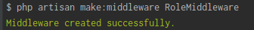

* it’s created a RoleMiddleware.php file inside Middleware folder

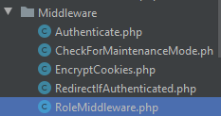

1. Registering a new middleware and using it

Start using the RoleMiddleware

Register the RoleMiddleware in **App\Http\Kernel.php**

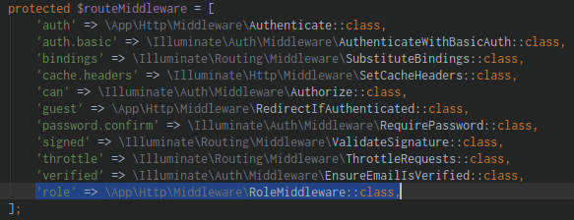

Applying the RoleMiddleware in the routes:

@routes/web.php:

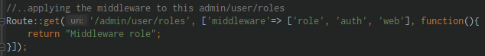

@app/Http/Middleware/RoleMiddleware.php:

* to check if this is working
* run in the URL: /admin/user/roles

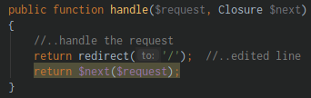

1. A more practical way to use middlewares 1 - roles, migration and relations setup

Let’s create a Role user, and that user will create a user, and it will check if that user is admin

Create a Role Model and a Migration

@CLI:

php artisan make:model Role -m (create a Role model and a migration)

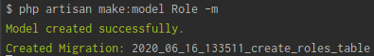

Next is create a Relationship

@database/migrations/create_users_table.php:

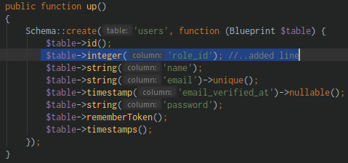

@database/migrations/create_roles_table.php:

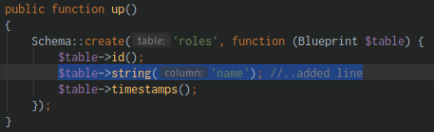

@CLI:

php artisan migrate:refresh (rerun the Migration)

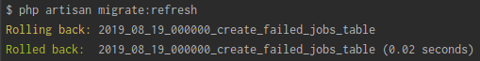

Then start creating the relationship:

@app/Role.php:

* Create a mass assignment
* 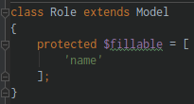

@app/User.php:

* Create a relationship with Role
* 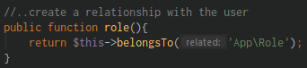

1. A more practical way to use middlewares 2 - Custom method

Start using our Middleware

Create another middleware named: I**sAdmin** (firstword is UpperCase)

@CLI:

php artisan make:middleware IsAdmin (create an IsAdmin middleware)

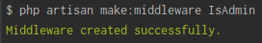

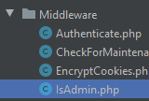

@app/Http/Kernel.php:

* register the IsAdmin middleware
* 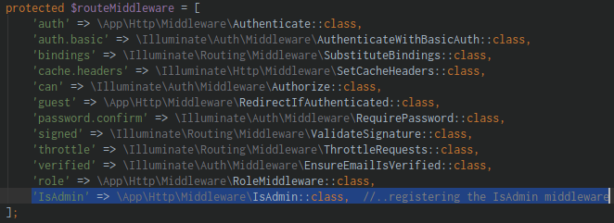

Register a User

@localhost/phpmyAdmin:

@roles table: (Create a 2 Role)

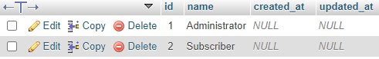

@app/User.php:

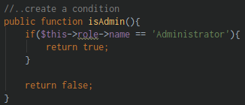

@routes/web.php:

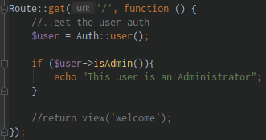

Run in the URL:

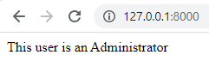

A Review:

Registering the **IsAdmin.php** middleware in **Kernel.php,** then we created a function/method in **app/User.php** named **isAdmin()** and use it in **web.php**

1. A more practical way to use middlewares 3 - Custom method

@app/Http/Middleware/IsAdmin.php:

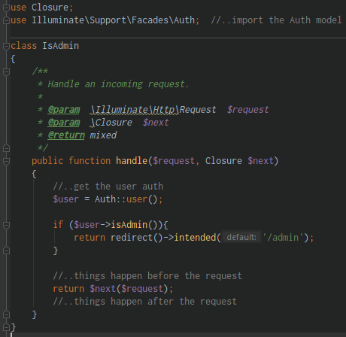 

Create an **AdminController**

@CLI:

php artisan make:controller AdminController (create an AdminController)

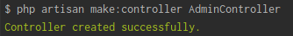

@routes/web.php:



@AdminController.php:

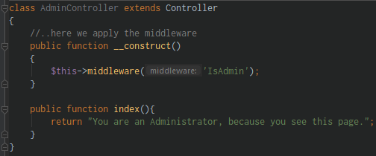

Run in the URL:

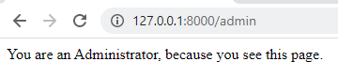

1. A more practical way to use middlewares 4 - Custom method

Testing this out the middleware

What if the user is not an Admin?

We direct him back to home page

@app/Http/Middleware/IsAdmin.php:

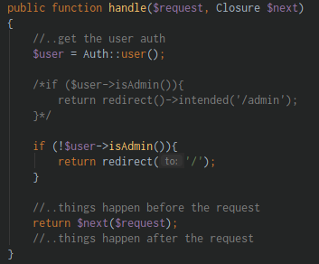

Section 24: Laravel Sessions

1. Section intro with Edwin Diaz

Learn SESSION, reading it, setting it

1. Setting and reading sessions

@HomeController.php:

* Insert the Request $request inside index() parameter

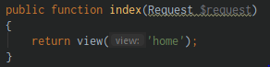

@HomeController.php:

* Creating/Setting and Reading the session()

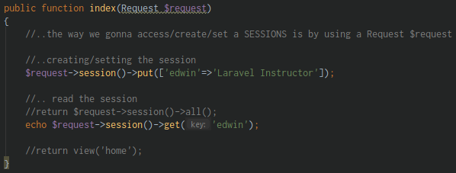

1. Global session function deleting

@HomeController.php:

* Using the Global function
* 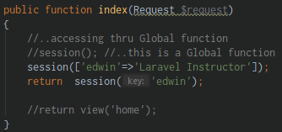

@HomeController.php:

* Deleting the session()
* 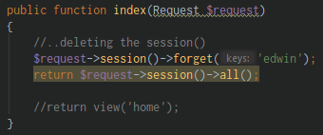

@HomeController.php:

* Delete all/everything in the session
* 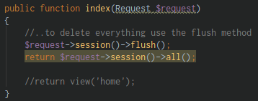

1. Flashing data

Learn how to flash data, flash data will only stay one request

@HomeController.php:

* Adding the flash data

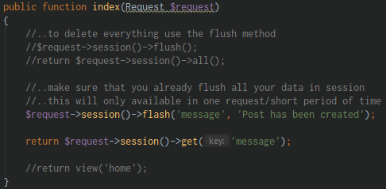

Run in the URL:

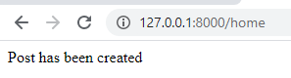

@HomeController.php:

* Comment the flash data

Once only because it’s only a flash data

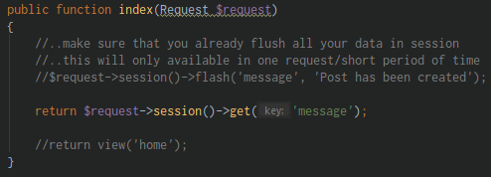

Run in the URL:

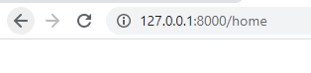

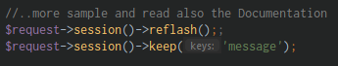

Section 25: Laravel – Sending Email API

1. Section intro with Edwin Diaz

Learn sending Email with Laravel is super easy

We use an **API**

We use **Mailgun**

Laravel provides a clean, simple API over the popular **SwiftMailer** library with drivers for **SMTP**, **Mailgun**, **Postmark**, **Amazon SES**, and **sendmail**, allowing you to quickly get started sending mail through a local or cloud based service of your choice

1. New Laravel installation

Lorem ipsum dolor sit amet

@CLI: (thru CMD ..xampp/htdocs/)

composer global require laravel/installer (downloading the Laravel installer)



laravel new mail (crafting the Laravel application via installer)

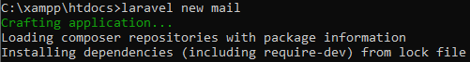

Open your project folder (mail) in PHPStorm IDE

Run npm install

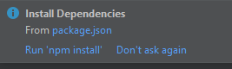

**@.env** file:

* modify the DB_DATABASE variable



@localhost/phpmyadmin

* create a new database: **mail**

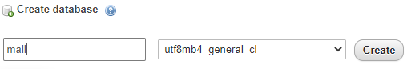

1. Overview on Mailgun

Signup with the Mailgun: <https://www.mailgun.com/>

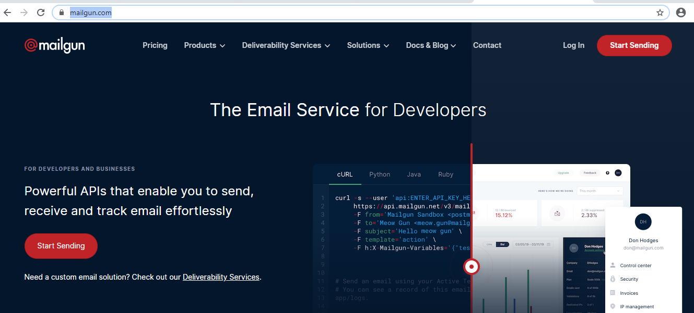

Create an Account here

1. Email verification

First make sure that you already verify your email and enter your phone number for 2FA protection

1. Configuration

**@.env** file:

* Update your MAIL_ variables

FROM:

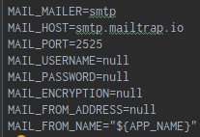

TO:

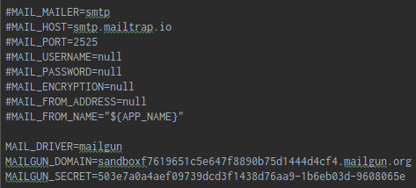

* Get the credentials from your created mailgun account

@config/mail.php:

* Customize this part

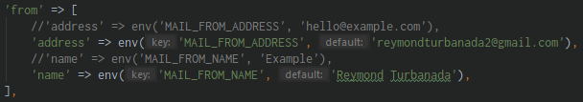

1. Sending email part 1 – route

@routes/web.php:

* Setting up your routes

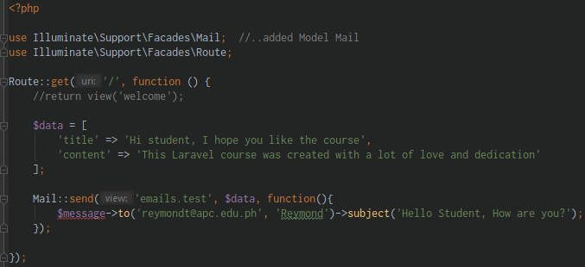

Create a new folder in **resources/views** folder:

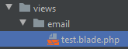

1. Sending email part 2 – Finished

Requiring the Laravel mail

@CLI:

composer require guzzlehttp/guzzle (requiring the guzzle)

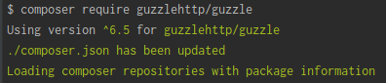

php artisan config:cache (cache everytime we have a changes in **.env** file)

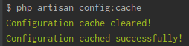

@vendor/guzzlehttp/guzzle/src/Client.php:

* Turn to false for the meantime the verification, then turned it back to True

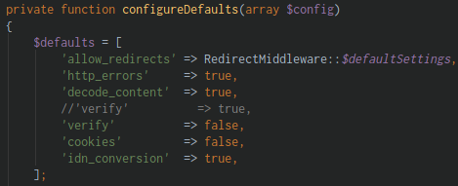

@views/email/test.blade.php:

* Those variables are came from the routes/web.php (mail part)

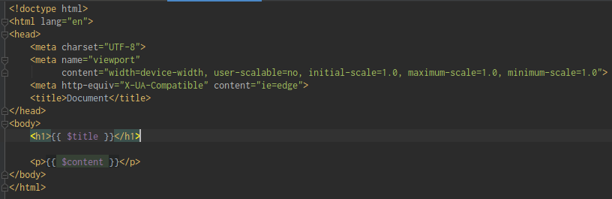

@routes/web.php:

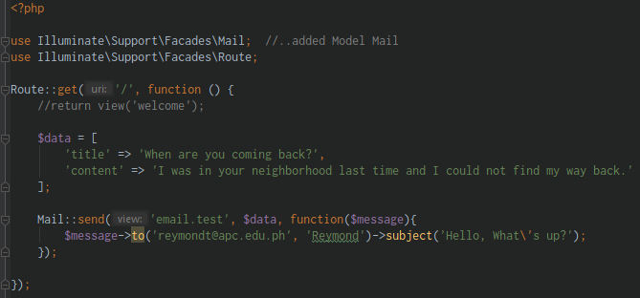

!! Expect some changes here.. expect some bugs also in swiftmailer.. because of the updated version !!

1. Custom domain

Add a Custom Domain to your Mailgun

!! Re-watch the Video and it involves the GoDaddy.com domain Invest to do research !!

Section 26: Git and Github – Version Control

1. Git Intro

Learn about Git

Git is a version control software

1. Git Installation

Let’s install Git

Visit this website: <https://git-scm.com/>

Download Git

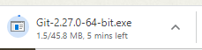

After you install go to CMD Terminal

@CLI:

git --version (check the version of your Git)

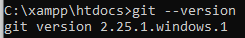

1. Git commands

Let’s start Using Git

Create a new folder in xampp/htdocs named: **learning-git**



Go to your folder

Then initialized git

@CLI:

git init (initializing git inside your folder)

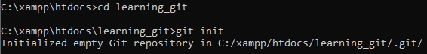

git (to see all git commands)

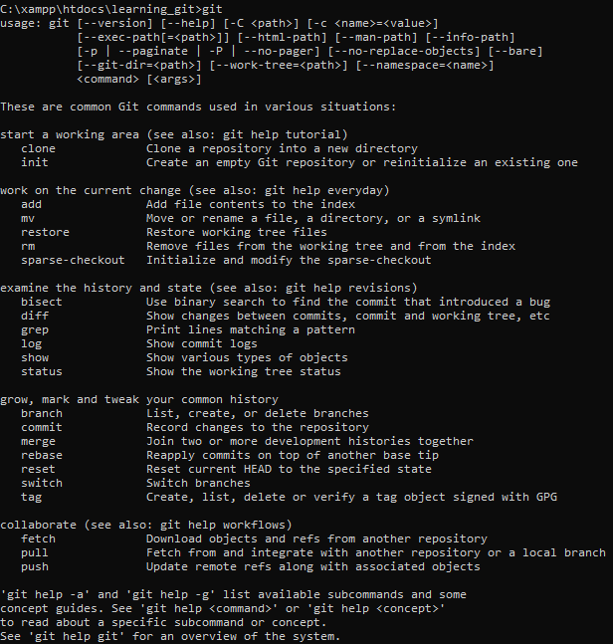

usage: **git** [--version] [--help] [-C <path>] [-c <name>=<value>]

[--exec-path[=<path>]] [--html-path] [--man-path] [--info-path]

[-p | --paginate | -P | --no-pager] [--no-replace-objects] [--bare]

[--git-dir=<path>] [--work-tree=<path>] [--namespace=<name>]

<command> [<args>]

These are common **Git commands** used in various situations:

Start a working area (see also: git help tutorial)

1. **clone** - Clone a repository into a new directory
2. **init -** Create an empty Git repository or reinitialize an existing one

Work on the current change (see also: git help everyday)

1. **add -** Add file contents to the index
2. **mv** - Move or rename a file, a directory, or a symlink
3. **restore** - Restore working tree files
4. **rm -** Remove files from the working tree and from the index
5. **sparse-checkout** - Initialize and modify the sparse-checkout

Examine the history and state (see also: git help revisions)

1. **bisect** - Use binary search to find the commit that introduced a bug
2. **diff -** Show changes between commits, commit and working tree, etc
3. **grep** - Print lines matching a pattern
4. **log** - Show commit logs
5. **show** - Show various types of objects
6. **status -** Show the working tree status

Grow, mark and tweak your common history

1. **branch -** List, create, or delete branches
2. **commit -** Record changes to the repository
3. **merge** - Join two or more development histories together
4. **rebase -** Reapply commits on top of another base tip
5. **reset** - Reset current HEAD to the specified state
6. **switch** - Switch branches
7. **tag** - Create, list, delete or verify a tag object signed with GPG

Collaborate (see also: git help workflows)

1. **fetch** - Download objects and refs from another repository
2. **pull -** Fetch from and integrate with another repository or a local branch
3. **push -** Update remote refs along with associated objects

'**git help -a**' and '**git help -g**' list available subcommands and some concept guides

See '**git help <command>**' or '**git help <concept>**' to read about a specific subcommand or concept

See '**git help git**' for an overview of the system

1. Git Crash Lecture

After we initialized Git let’s start using it

@CLI:

git status (show the working tree status)

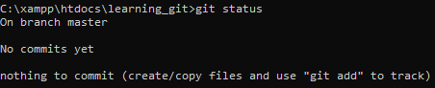

if **touch** is not working

npm install touch-cli -g (install touch in C:)

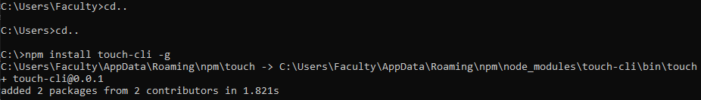

Add index.html

touch index.html (add index.html file in current folder)

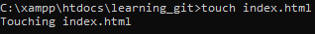

git status (show the working tree status)

* It tells us that there is an Untracked files

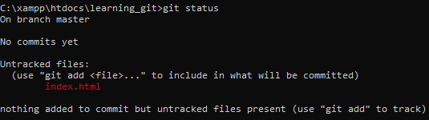

Add some content in index.html:

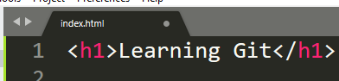

Then Add it in Git:

git add index.html (add the specific file)

git add . (add everything/all file use . “dot”)



git status (show the working tree status)

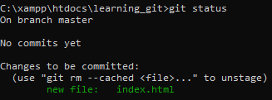

Then try to edit the content of your index.html file:

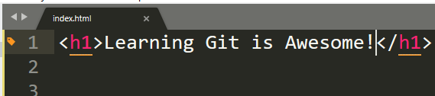

git status (show the working tree status)

* It tells you the index.html is modified

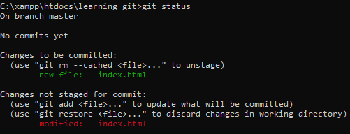

git commit -m “Added feature 1” (Record changes to the repository)

* It added the file and the commit message

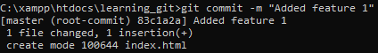

git log (Show commit logs)

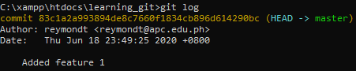

git status (show the working tree status)

* As you can see we didn’t add the file, we need to add it then commit

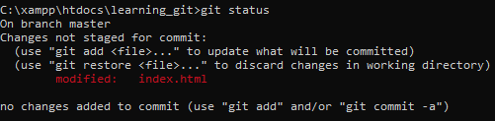

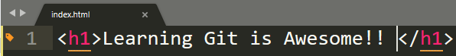

git add . (Add all files)

git commit -m “Added 2 Exclamatin Point” (commit it with a message)

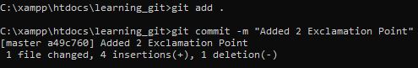

git status (show the working tree status)

* Now that we see that our git is clean

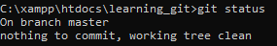

git log (Show commit logs)

* Now you can see that we have 2 commits now

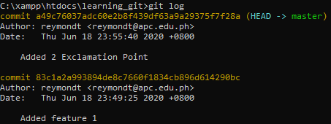

To go back in the first commit

git reset –hard a49c76037adc60e2b8f439df63a9a29375f7f28a (back to first commit)

* Now that we are back on that first commit we made



1. Git Workflow

@CLI:

dir (view the files inside your project folder)

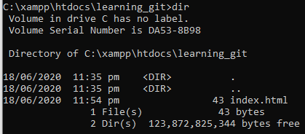

del -rf .git (delete the .git)

del -rf index.html (delete the index.html)

* Cleanstate your working file

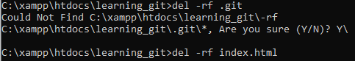

git init (initialized the git again)



touch index.html (create a file index.html)

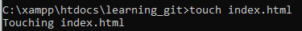

git status (Show the working tree status)

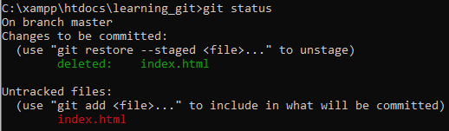

git add . (Add all the file)

git commit -m “Add an index.html file” (commit it with a commit message)

git status (Show the working tree status)

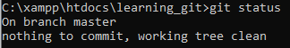

git log (Show commit logs)

1. Branches

Practical way to create a Branches

Using Git Bash and link into your working folder

1. Type **cd**
2. Then drag out your folder in Git Bash

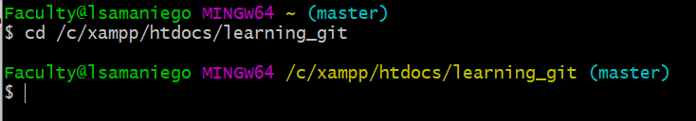

@CLI:

ls -la (to see all files)

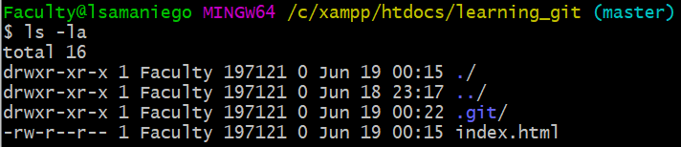

cd .git (go to .git directory)

ls (to see all files)

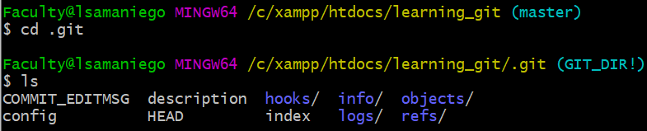

cd .. (to go outside from that directory)

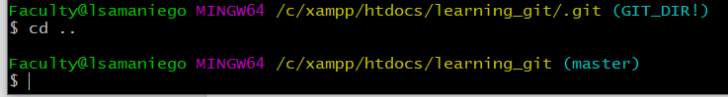

git status (Show the working tree status)

* We see that we are in a Master branch

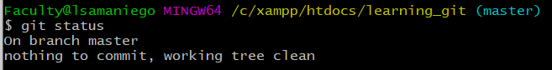

ls -la (see all the list file)

rm -rf .git (removing the .git file)

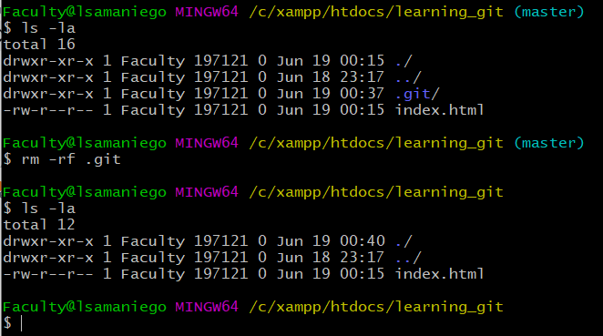

rm index.html (remove the ordinary file the index.html file)

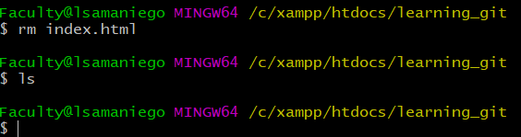

touch index.html (add index.html file)

ls (see list file inside the project)

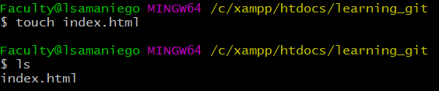

git init (initialized git inside the project)



git add . (add all files)

git commit -m “Initial commit working on index.html” (commit with message)

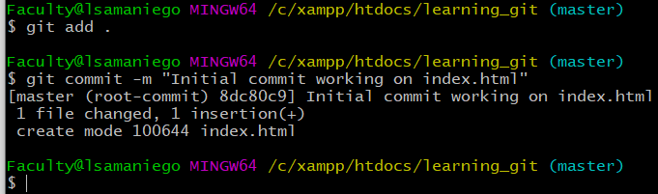

git log (Show commit logs)

* We are in the (HEAD->master) HEAD and in the master branch

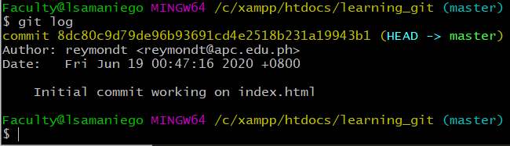

git status (Show the working tree status)

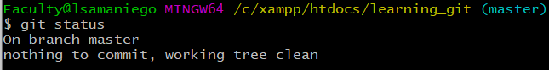

In order for us to Create a New Branch

git branch example (Create a new branch)



git branch (See all branch)

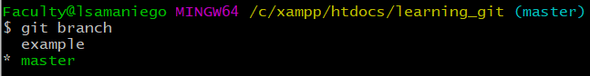

In order for us to go to **example** branch

git checkout example (type git + checkout + name of the branch)

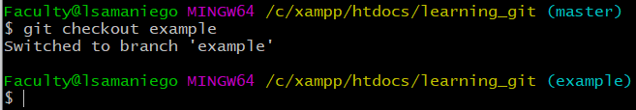

* Now that we are on **example branch**

git branch (to check branch)

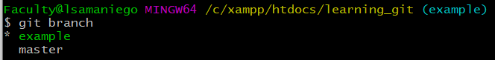

Get out and go to **master branch**

git checkout master (switch branch into **master branch**)

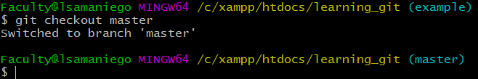

Let’s delete the **example branch**

git branch -d example (this will delete the **example branch**)

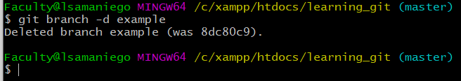

git branch (the **example branch** is now not in the list of branches)

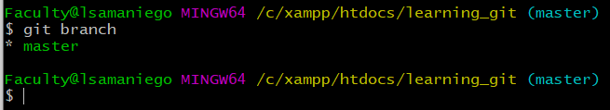

Created a new branch and switched into it (a shortcut)

git checkout -b newcategory (create a newcategory branch and switch into it)

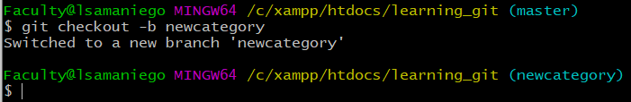

git branch (see all branch)

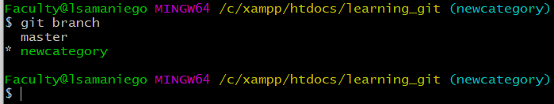

touch category.php (create a category.php)

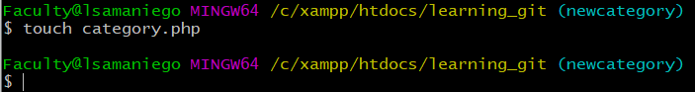

Team B is working on newcategory branch (category.php)

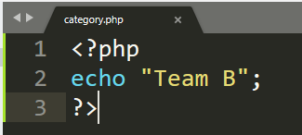

git checkout master (go to master branch)

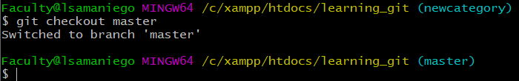

And get back to newcategory branch

git checkout newcategory (go back to newcategory branch)

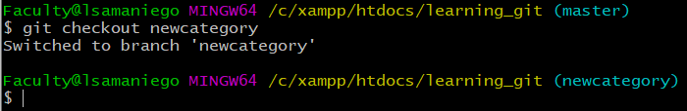

The TeamB(newcategory) is add the file and commit it

git add . (add all file)

git commit -m “New Categories Added” (commit with a message)

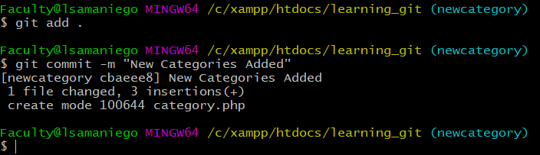

git status (check the Status)

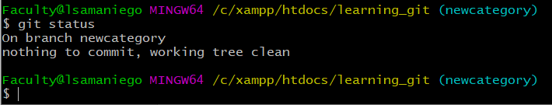

Go to master branch

git checkout master (go to **master branch**)

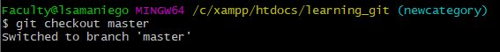

* The category.php disappear

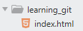(**master branch)** 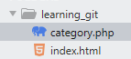(**newcategory branch**)

git checkout newcategory (go back to newcategory branch)

git log (Show commit logs)

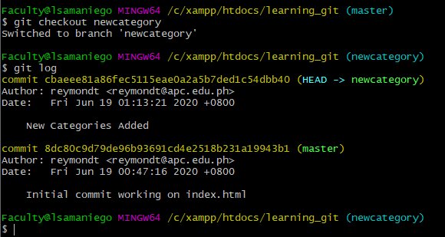

git checkout master (Go back to master branch)

git merge newcategory (Merge the **newcategory** into **master** branch)

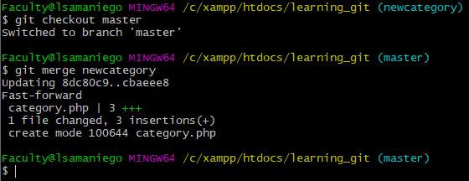

git log (Show commit logs and master, newcategory tells it was merge)

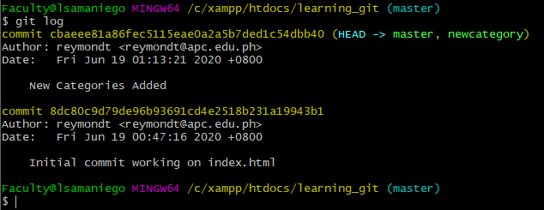

git branch -d newcategory (Delete the newcategory branch)

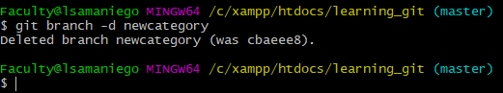

git log (Show commit logs and the newcategory branch is not there)

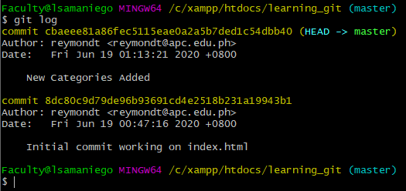

git branch (Show the list of branch)

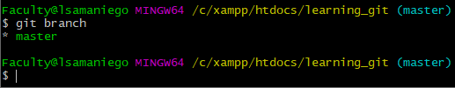

Branch is super useful when you are working with a Team, it doesn’t affect your original files.

1. Creating Repositories on Github

Github is an Online project hosting using Git

Add a new Repositories in your Github Account (**gitcourse**)

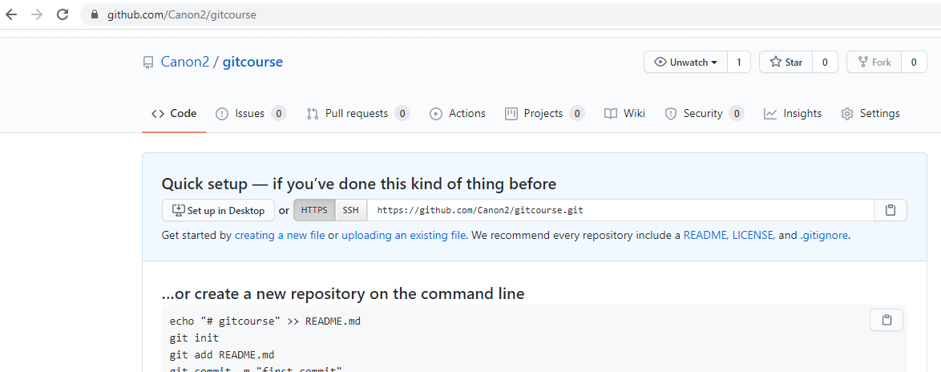

1. Git Settings

Setup our Git settings

@CLI:

git log (Show commit logs)

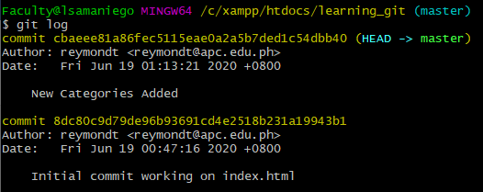

* You see the username and the email address use

Set this up with someone else

git config –global user.name “Canon2” (set up the user name)

git config –global user.email “reymondturbanada2@gmail.com” (set up the email)

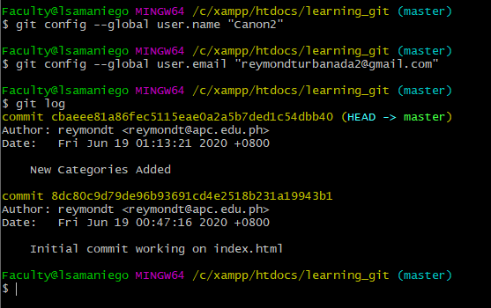

As you can see that in

git log (Show commit logs)

* Still shows the old user

touch newfile.html (add a newfile.html)

git add . (add all file)

git log (Show commit logs and you can see the setup user name and email)

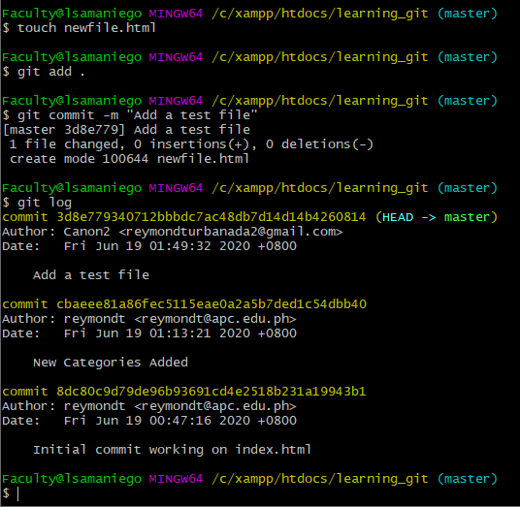

1. Cloning and Pushing to Github

Check the files inside learning_git folder

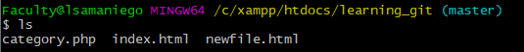

Go to your Github account:

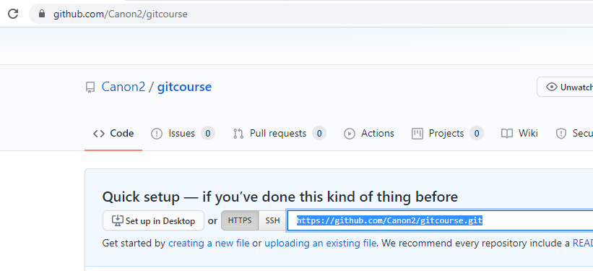

And Copy the HTTPS (URL)

@CLI:

git clone https://github.com/Canon2/gitcourse.git (clone your repositories in Github)

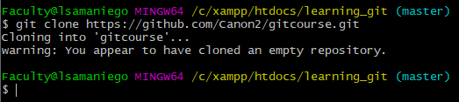

ls (see all files, and you see the **gitcourse)**

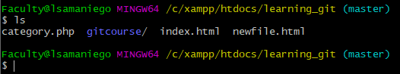

cd gitcourse (and we go to that directory)

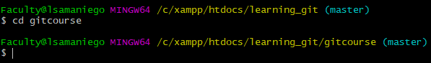

ls (see the list and you found its empty)

git status (Show the working tree status)

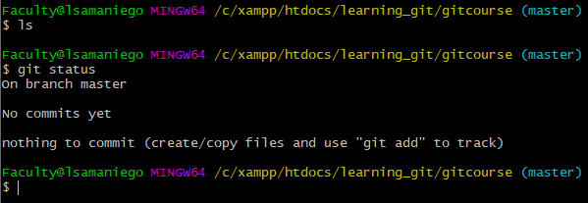

To see if the git is initialized

ls -la (check all files and hidden files, and you see the .git)

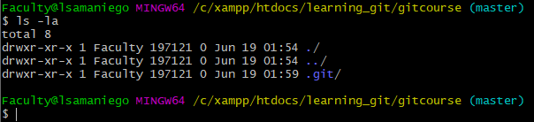

touch index.html (create an index.html file)

ls (see all files)

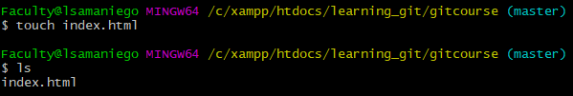

git add . (add all files)

git commit -m “Create a new index.html file” (commit with a message)

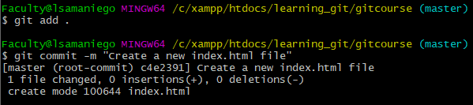

Now that we are ready to push it online to our repositories (Github)

git push origin master (Push to origin(Github) master branch)

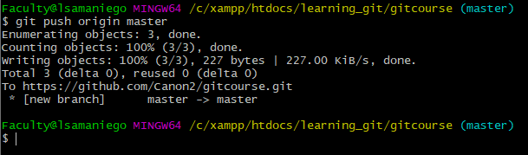

And now you can see your file and your commit message

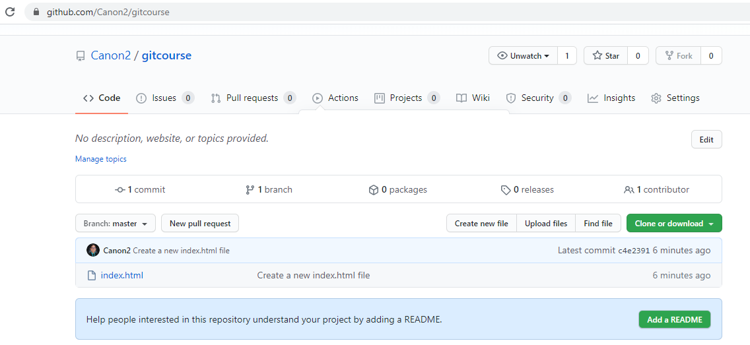

1. Pull Request and Pulling Changes

Learn how to Pull information data that has been updated from the repository into your computer

Edit your index.html in Github

Commit with message

@CLI:

ls (see all files inside that folder)

nano index.html (check the content of your index.html file)

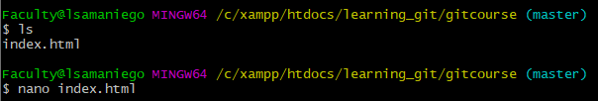

In here you see the content of index.html file

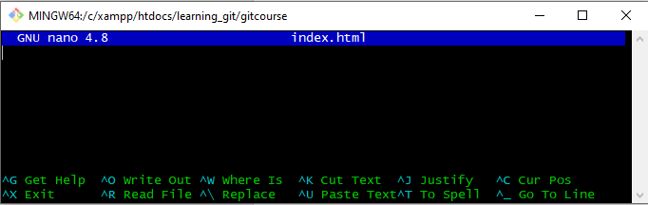

To exit Click **Ctrl + X**

git pull (Pulling the data)

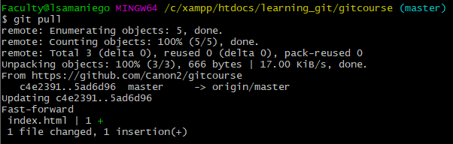

nano index.html (check the content of index.html file)



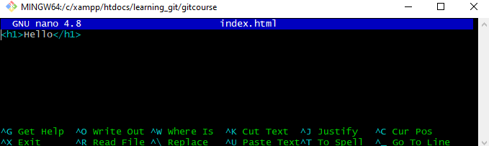

git log (Show commit logs)

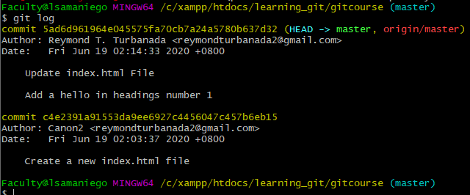

If there is someone who wants to contribute in your project

He/She must **fork** your project

**Fork** meaning is you create a copy in your own Github account and then you can clone it and copy it into your computer, you can not make any changes in the original or on the users you fork the project it only make changes in your account

1. Contribution to the Project

Message Edwin Diaz, and give your username and contribute in the project

**Fork** his project

Put in your local copy

!! You can re watch this videos as Soon as you want to contribute in Edwin Diaz laravel project !!

Section 27: New - Laravel 7 Front-End

1. New – Adding Bootstrap plus Login & Registration

Learn how to Scaffold an application

Add a Bootstrap, Add Vuejs and React or any application

Download a package that has all these things called ui (User Interface)

@CLI:

composer require laravel/ui (installing the ui)

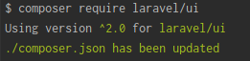

Now you can use ui

php artisan ui bootstrap (installing bootstrap ui)

php artisan ui vue (installing Vue js)

php artisan ui react (installing react)

php artisan ui scaffolding (installing scaffolding)

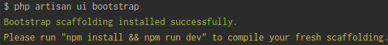

npm install && npm run dev (installing npm and compile package.json)

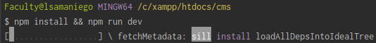

@composer.json

* We see all those installed packages

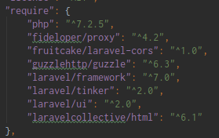

@resources/sass/app.scss

* You can see that we importing the fonts, variables and bootstrap

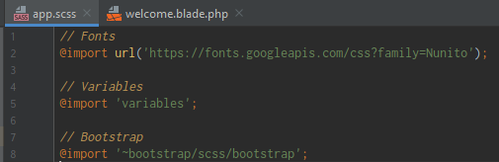

@welcome.blade.php

* Customizing the fonts source
* Adding a Bootstrap button to test if Bootstrap is working

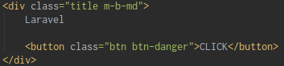

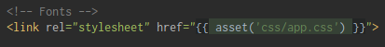

* asset() -> this method get all folders/file inside the public folder

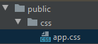

Run in the URL:

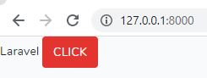

php artisan ui bootstrap --auth (installing bootstrap UI auth)

Installing the Bootstrap UI for auth

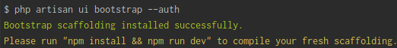

1. How to Add Templates to Laravel Projects

Installing the admin-template

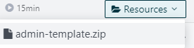 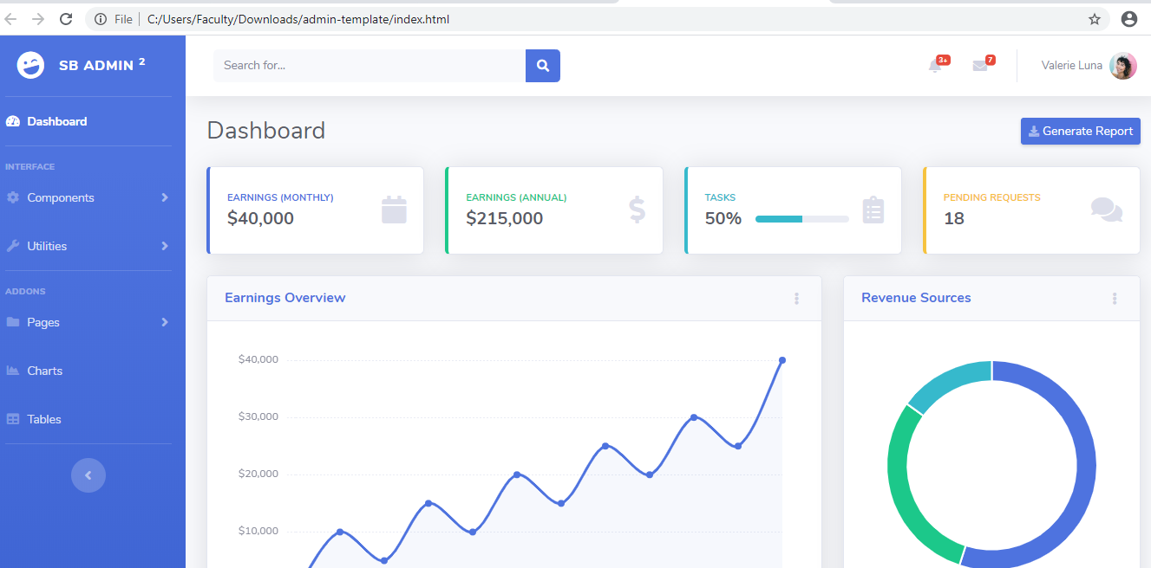

Let’s create a new Laravel project named (admin-project)

@CLI:

laravel new admin-project (create a new laravel application)

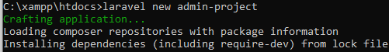

Create a database (admin-project)

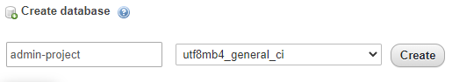

Click Run ‘npm install’

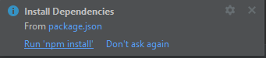

@.env file (Modify the DB_DATABASE variable)



Copy the **css** folder (admin-template) to **public** folder (admin-project)

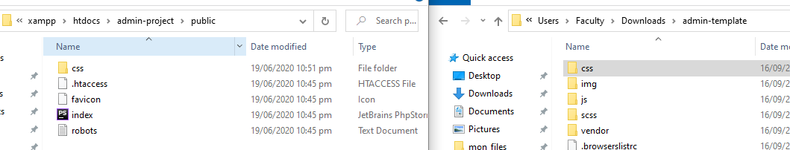

Copy the **js** folder (admin-template) to **public** folder (admin-project)

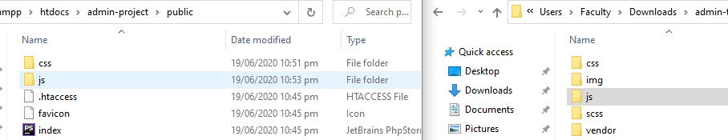

Copy the **vendor** folder (admin-template) to **public** folder (admin-project)

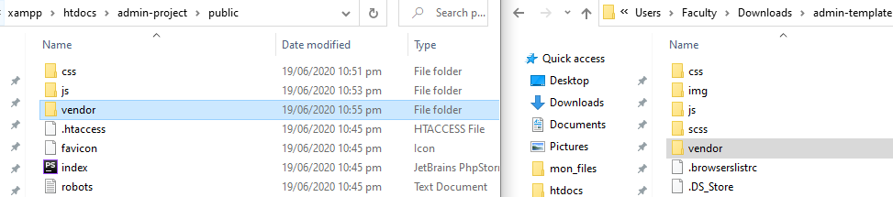

Copy the codes inside **blank.html**



Create a **layouts** folder inside **resources/views** folder

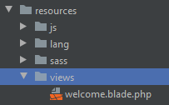 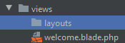

Create **admin.blade.php** inside **views/layouts** folder

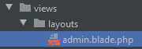

Then paste the code from **blank.html** into **admin.blade.php** file

Create a new folder inside **resources/views** folder **admin/index.blade.php**

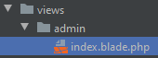

@CLI:

php artisan serve (run the application)



@routes/web.php:

* Create a new Route

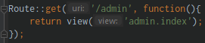

@resources/views/admin/**index.blade.php**:

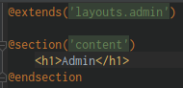

@resources/views/layouts/**admin.blade.php**:

* Do some modification on this page
* Use the **{{ asset(‘path’) }}** method on source and link

Create a new folder inside **views/admin** and named it **partials/_navbar.blade.php**

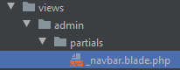

Include the file in resources/views/layouts/**admin.blade.php**

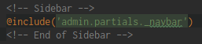

Section 28: Laravel Data Seeding

1. Creating a Simple Seeder

Learn a Laravel seeding about inserting dummy data into our applications

Laravel can create table, migrations

Create a new Laravel applications named **codehacking**

@CLI:

laravel new codehacking (create a laravel applications named **codehacking**)

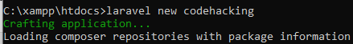

@localhost/phpmyadmin

* Create a new database named: **codehacking**

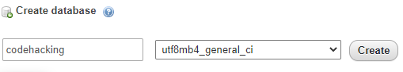

Click Run ‘npm install’

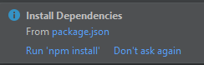

**@.env** file:

* Modify the **DB_DATABASE** variable value



php artisan migrate (do the first migration)

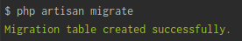

@dated_create_users_table.php:

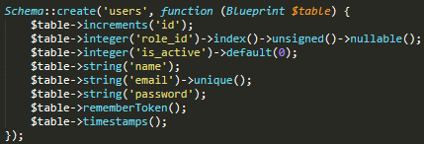

php artisan make:migration create_roles_table –-create=”roles” ()



@dated_create_roles_table.php:

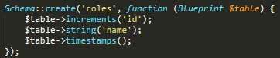

php artisan make:migration add_photo_id_to_users –-table=users ()

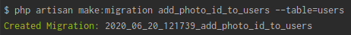

@dated_add_photo_id_to_users.php:

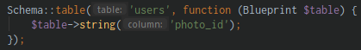

php artisan make:migration create_photos_table –-create=photos ()



@dated_create_photos_table.php:

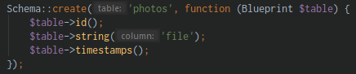

php artisan make:migration create_posts_table –-create=posts ()

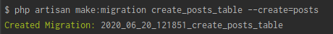

@dated_create_posts_table.php:

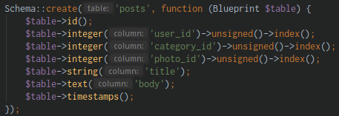

php artisan make:migration create_categories_table –-create=categories ()



@dated_create_categories_table.php:

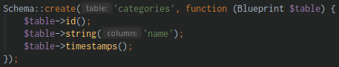

php artisan make:migration create_comments_table –create=comments ()



@dated_create_comments_table.php:

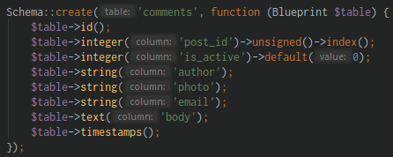

php artisan make:migration create_comment_replies_table -–create=comment_replies ()



@dated_create_comment_replies_table.php:

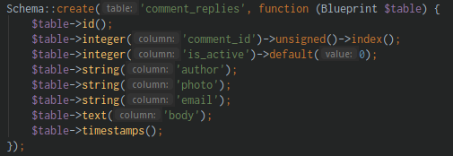

php artisan make:migration add_slug_posts_table –table=posts ()

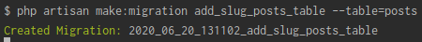

@dated_add_slug_posts_table.php:

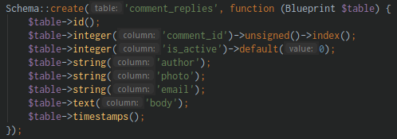

php artisan migrate (do the migration)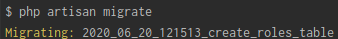

php artisan migrate:refresh (rolling back the migration and migrate it again)

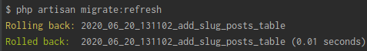

Let’s create a **Model** for it

php artisan make:model Category (create a Model for Category)

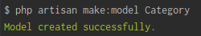

php artisan make:model Comment (create a Model for Comment)

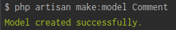

php artisan make:model CommentReply (create a Model for CommentReply)

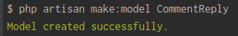

php artisan make:model Photo (create a Model for Photo)

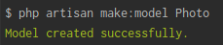

php artisan make:model Post (create a Model for Post)

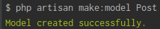

php artisan make:model Role (create a Model for Role)

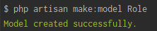

@database/seeds/**DatabaseSeeder.php:**

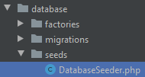

How to create a Seed class?

@CLI:

php artisan make:seeder UsersTableSeeder (create a seeder named UsersTableSeeder)

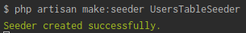

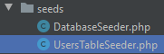

@database/seeds/**UsersTableSeeder.php**:

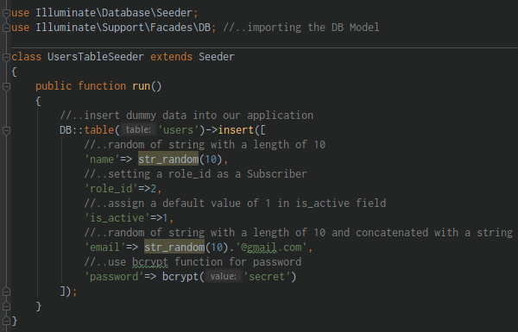

To run the Seeder:

php artisan db:seed (seed the database or input data on your database)

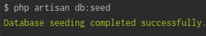

But this won’t work, unless you add the UsesTableSeeder::class in **DatabaseSeeder.php**

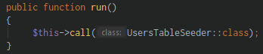

To run the Seeder again:

php artisan db:seed (seed the UsersTableSeeder)

1. Creating a more Advanced Seeder with Factories

Factories

@database/factories/**UserFactory.php**:

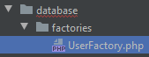

@UserFactory.php:

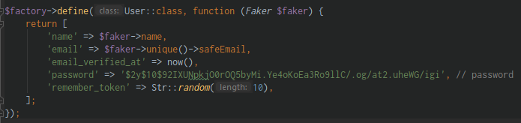

$**factor**y object call the **define()** method that has a **Class**, and a **function**, and the **$faker** object is a library that allows us to have a data have a really more human

@database/seeds/**DatabaseSeeder.php**:

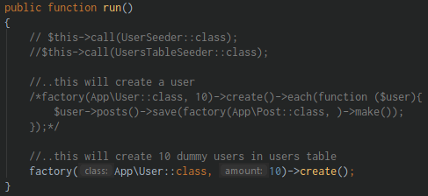

@CLI:

php artisan db:seed (seed the DatabaseSeeder.php)

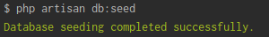

@localhost/phpmyadmin

* It will add new 10 dummy records that looks like a real information

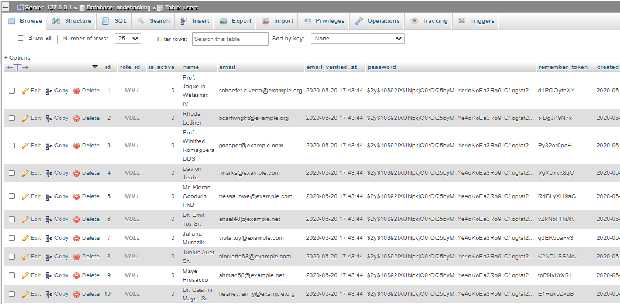

Creating your own factory:

@database/factories/**UserFactory.php:** (you can customize this part also)

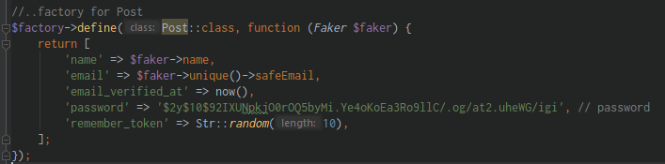

@database/seeds/**DatabaseSeeder.php:** (you can customize this part)

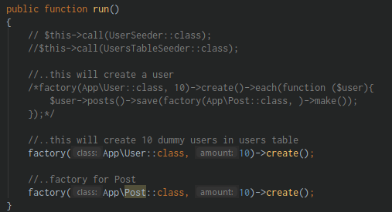

1. Let’s create Factories for all of Our Database Tables

User->posts (with a dummy data)

Let’s create a dummy data to create 10 Users and each users create a dummy data of posts

@database/seeds/DatabaseSeeder.php:

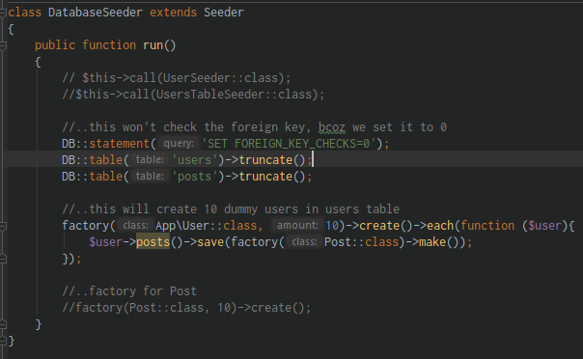

@User.php (Model)

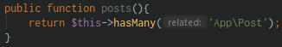

@database/factories/**UserFactory.php**:

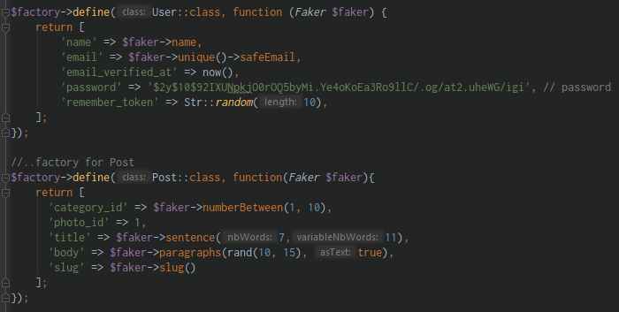

Run the Seeder:

@CLI:

php artisan db:seed (seed the Database)

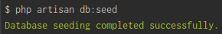

Now this will add **10 Users** and **10 posts**

@database/factories/**UserFactory.php**:

* Let’s Create a factory for (**Role**, **Category**, **Photo**)

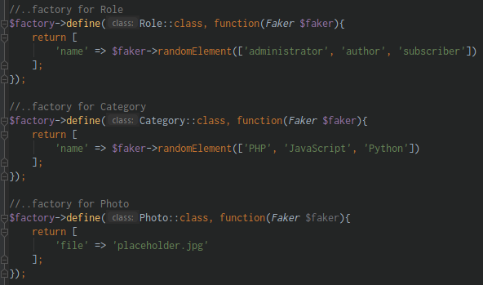

* Let’s Create a factory for (**Comment, CommentReply**)

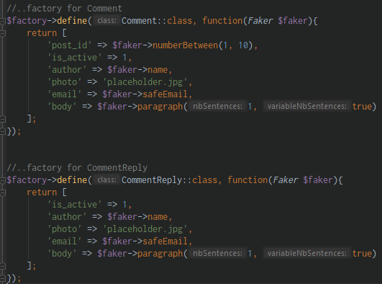

Review this part

@database/factories/UserFactory.php: (Part 1 of Page 1)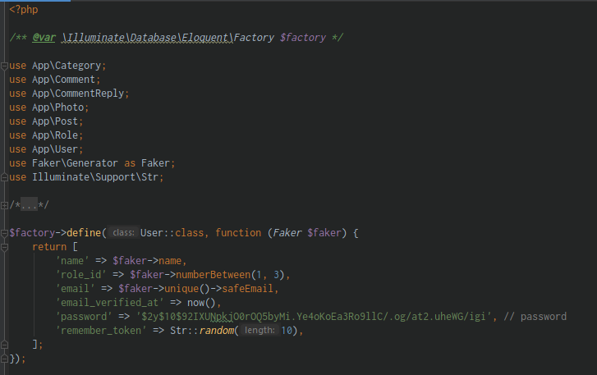

@database/factories/UserFactory.php: (Part 2 of Page 1)

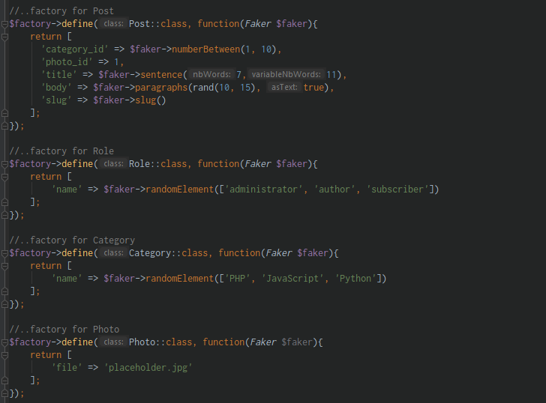

@database/factories/UserFactory.php: (Part 3 of Page 1)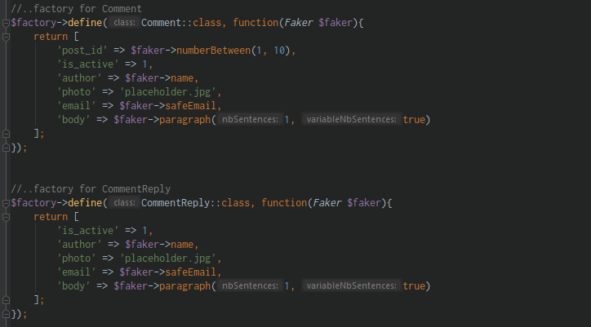

Check the following Models:

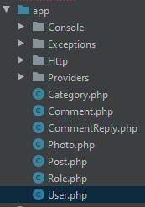

@database/seeds/DatabaseSeeder.php:

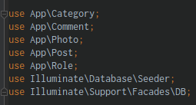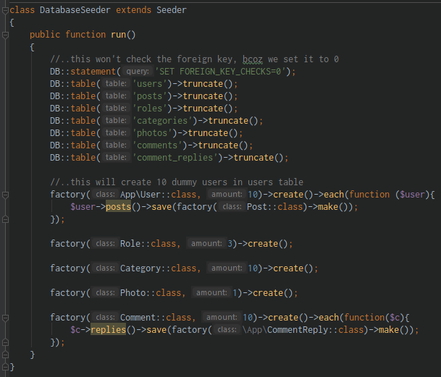

Run the Seeder again:

@CLI:

php artisan db:seed (seed the Database)



Section 29: New – Laravel Components

1. Creating Components part 1

Take a part of HTML file and divided into Components

They are similar with Layouts

Create a new Laravel project named: **components**

@CLI:

composer global require laravel/installer (create a Laravel installer)



Create a Database named: **components**

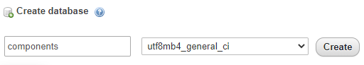

laravel new components (create a Laravel application named: **components**)

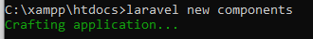

Open your project in PHPStormIDE

Click Run ‘**npm install**’

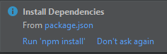

**@.env** file (modify the **DB_DATABASE** variable)



php artisan serve (serving your application)

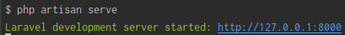

php artisan migrate (do the migration of your table)

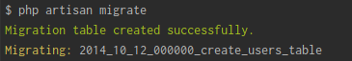

Take advantage of using the Factory

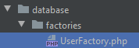

@database/seeds/**DatabaseSeeder.php** file:

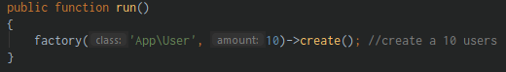

php artisan db:seed (run the seed/factory to create 10 users)

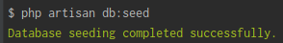

Download the Composer ui package

composer require laravel/ui (download a UI package like bootstrap, Vue, React)

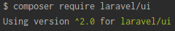

And will be using the Bootstrap, and we divide those templates into a many component

php artisan ui bootstrap --auth (downloading the bootstrap auth)

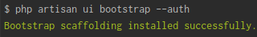

npm install && npm run dev (run npm install and run npm run dev)

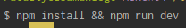

Now the **Login** and **Register** will come out to your page

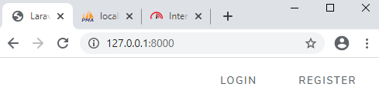

Create a **Component** directly into **resources/views,** and a **master** blade inside

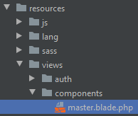

Cut the content of **welcome.blade.php** and paste it into **master.blade.php**

Then put it inside the **welcome.blade.php** file:

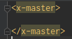

Copy a Blog-Template from Bootstrap, put all **js, css, vendor** in **public** folder

Paste the **index.html** in **master.blade.php**

Then start customizing the page using the

* Use the **{{ asset(‘path’) }}** method on source and link

Your page may somehow look like this:

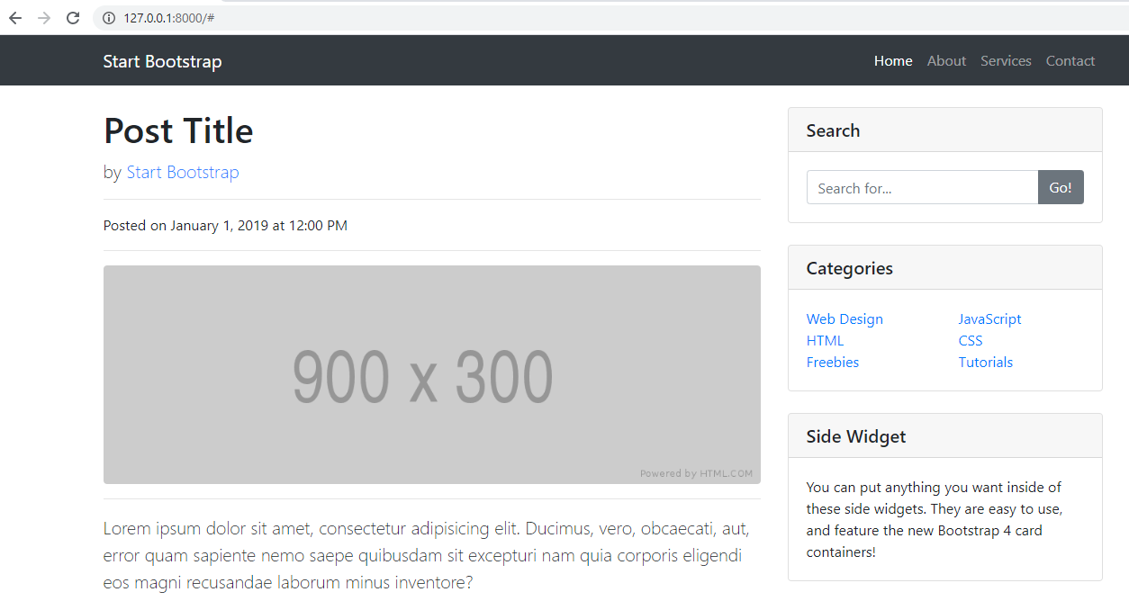

1. Creating Components part 2

Keep on how to using component

Components start with **x-**

Example: **x-home-search**, **x-categories**, **x-side-widget**

Then later on create a file name for it:

* **home-search.blade.php (home-search component),**
* **categories.php (categories component),**
* **side-widget.php (side-widget component)**

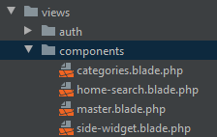

@master.blade.php

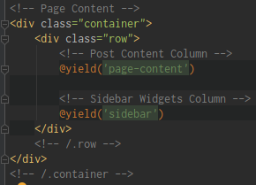

@welcome.blade.php

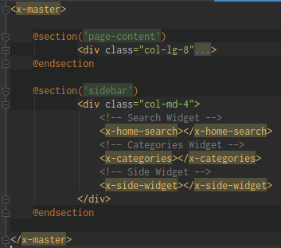

And on the next we’ll learn **how to pass data into these components**

1. Creating Components part 3

Let’s pass data into these components

@HomeController.php file:

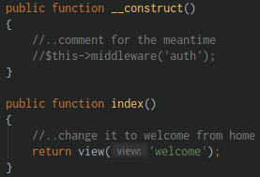

@routes/web.php file:



Now let’s pass data into one of our **components**

**@welcome.blade.php** file:

* Add the $users variable this are came from HomeController.php

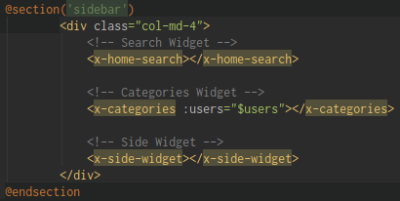

**@HomeController.php** file:

* Use/Import the **User** model
* Then create a **$users** variable that will be pass into **welcome.blade.php** file

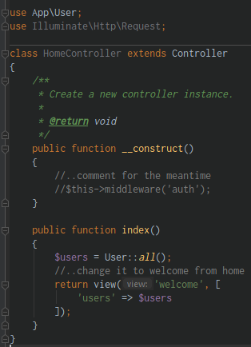

**@categories.blade.php** (acomponent we create)

* Create a foreach to display all of the users

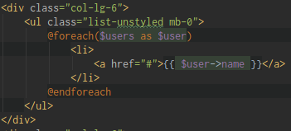

Section 30: New Application – Laravel 7

1. Setting p Views part 1

Let’s make sure that you download the **project-assets** folder



Open Git Bash Terminal

To go to directory:

1. Type **cd**
2. Drag the folder xampp/htdocs on Git Bash Terminal

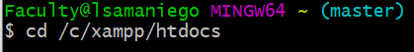

Create a new Laravel project named: **new-cms-system**

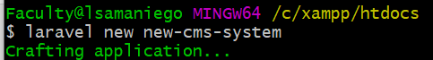

Create a Database named: **new_cms_system_db**

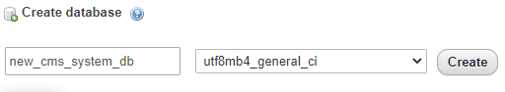

**@env** file: (modify the **DB_DATABASE** variable)



php artisan migrate (do the migration)

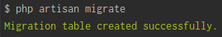

Click Run ‘npm install’

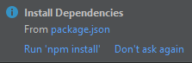

Start serving up your application

@CLI:

php artisan serve (start serving up your application)



Copy the **vendor** folder and paste into **public** directory of your app

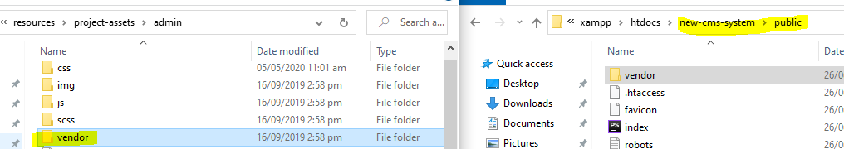

Install a Larave ui package

composer require laravel/ui (installing an UI package

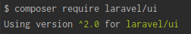

Install Bootstrap UI and the Authentication

php artisan ui bootstrap -- auth (installing the Bootstrap UI and Authentication)

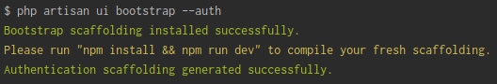

Run npm install and npm run dev

npm install && npm run dev (this will install the JS side of the project)

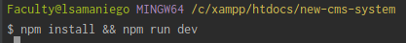

Drag the **blog-home.css, blog-post.css** and **sb-admin-2.css** into **public/css** folder

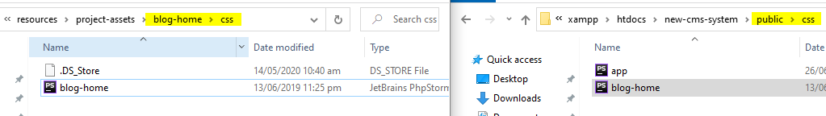

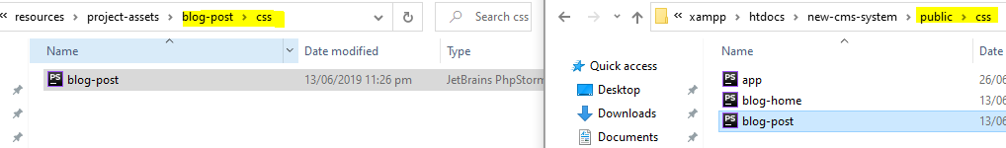 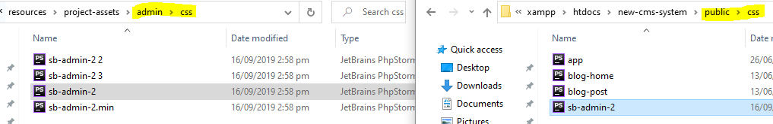

Drag the **sb-admin-2.js** into **public/js** folder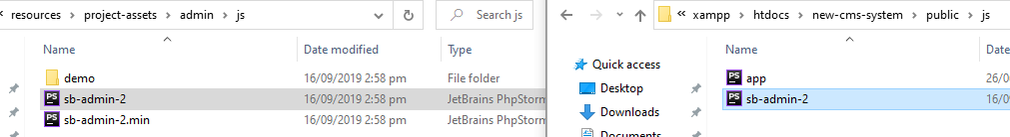

1. Setting p Views part 2

Start linking the files

Create components

Create a **components/master.blade.php** inside the **views** folder

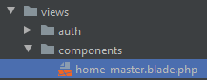

Copy the content of project-assets\blog-home\**index.html** and paste in **home-master.blade.php**

Delete the **welcome.blade.php** file

Clean up the **web.php** file

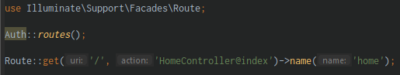

**@HomeController.php** file

* Comment the authentication process

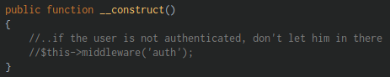

**@home-master-blade.php** file:

* Create a link for **css/app.css** this is created when you installing the ui

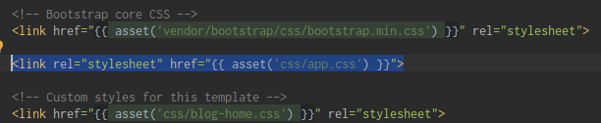

**@home.blade.php** file:

* **"X-“** this means you are using the component in components folder

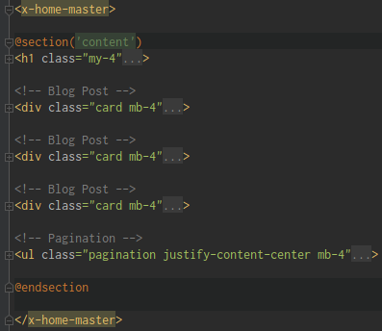

1. Admin View Creation Setup

Create new folder and file in views: **admin/index.blade.php**

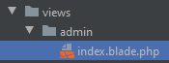

Create a new component-file inside **views/components: admin-master.blade.php**

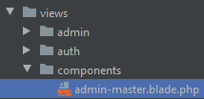

Copy the content of project-assets\admin\**blank.html** into **components/admin-master.html**

**@routes/web.php** file:

* Create a new route



@CLI:

php artisan make:controller AdminsController (create an AdminsController)

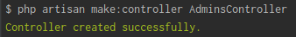

**@AdminsController.php** file:

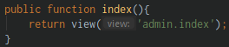

**@admin/index.blade.php** file:

* Extends the admin-master components

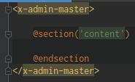

**@views/components/admin-master.blade.php** file:

* Fix the links like css, source like js, remove the **.min**

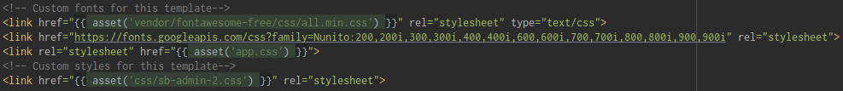

1. Menu Links and Migration

From **index.html**

Use the **route()** helper function

 change into 

* This is from this route with name **home**



**@app/Providers/RouteServiceProvider.php** file:

* Modify the redirection page after the Login
* Redirect the User to Admin page



**@views/components/home-master.blade.php** file:

* Create an if else statement using the Auth **check()** method

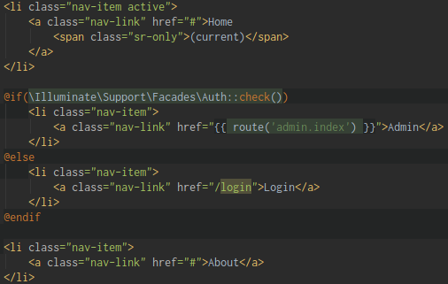

1. Blog Post View

Create a blog-post.blade.php inside **resources/views** folder

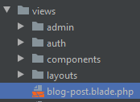

Copy the main content part only of project-assets\blog-post\**index.html** file into views/**blog-post.blade.php**

@CLI:

php artisan make:model Post -mc (make a Post model, create a Migration and Controller)

* - mc (this stands for migration and controller)

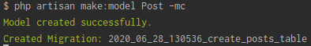

Create new route for the post



**@PostController.php** file:

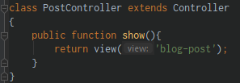

1. Posts Migration

Relate the post with the User

@home-master.blade.php file:

* Fix some href using routes() method



@create_posts_table.php file:

* Relate the Posts with the User
* Use a foreignId() method, to say that the Post table is going to have a user_id table column that’s going to relate with the user
* Constrain this table and use this foreignId to
* This constraint do not do anything, constraint these user_id on the post or constraint the table the whole table through this user_id
* Constraint means hold and do something onDelete
* So, when we delete our users we can delete our post table
* So, everytime we delete a user that owns a post is going to leave its post with it or the users post



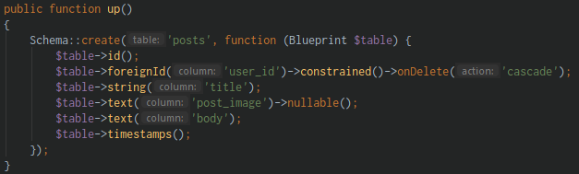

php artisan migrate (do the migration)

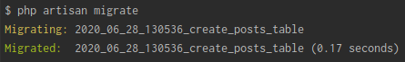

1. Creating Dummy Data with Relationships – Users with Posts

We already created a Migration and we want to create a Dummy data

Make the Post page dynamic, and the data comes from the Database

**@Post.php** (Model) file: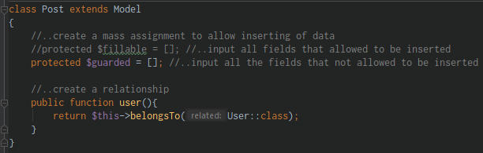

**@User.php** (Model) file:

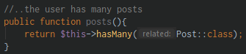

Use Factories to create a lot of Data

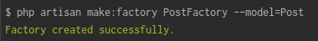

@CLI:

php artisan make:factory PostFactory (create a PostFactory in a model of Post)

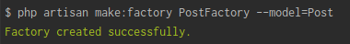

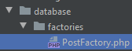

**@database/factories/PostFactory.php** file:

To view more samples in $faker go to this website: <https://github.com/fzaninotto/Faker>

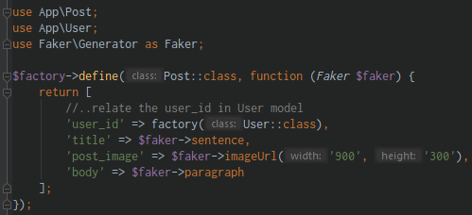

**@DatabaseSeeder.php** file:

* Create a 10 users

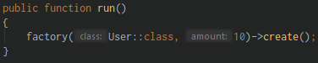

@CLI:

php artisan db:seed (seed the DatabaseSeeder)

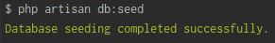

* A 10 new users added in **users** table

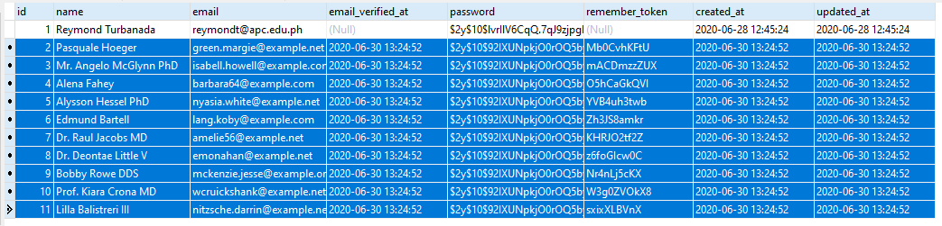

But you have to delete that

We create a 10 users and at the same time create 10 post

**@DatabaseSeeder.php** file:

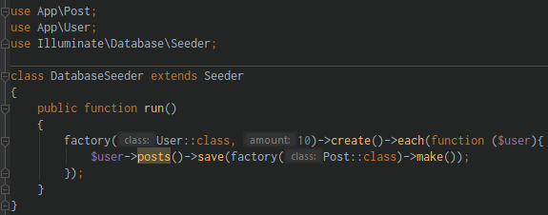

Run the DatabaseSeeder:

php artisan db:seed (seed the DatabaseSeeder)

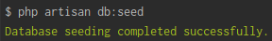

It will create a users

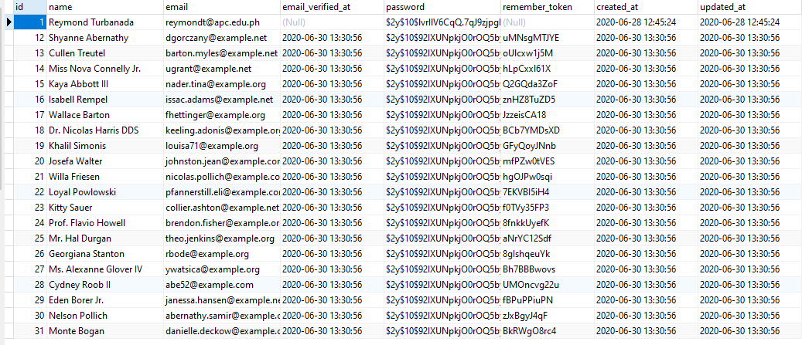

And it Creates a post for each user

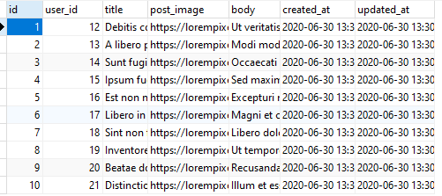

1. Displaying Posts on Home Page

Let’s start displaying the Dynamic Post

**@HomeController.php** file:

* Use the Post Model to get all of the Post and place it inside a variable

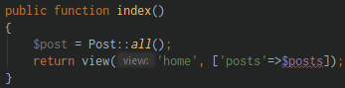

**@resources/views/home.blade.php** file:

* Modify the Blog html

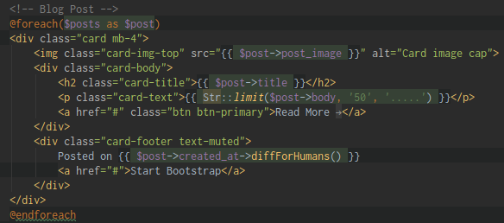

It may look like this:

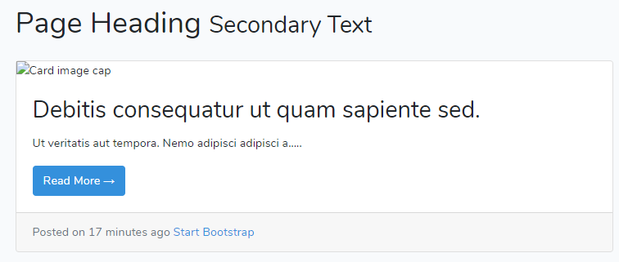

1. Displaying Individual Posts

Create a link here to display the individual post



**@PostController.php** file:

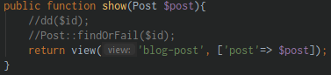

**@routes/web.php** file:



**!! NOTE: !!**

In **route** you see the **{post}** it is **get/based** on the **show(Post $post)**

**@resources/views/blog-post.blade.php** file:

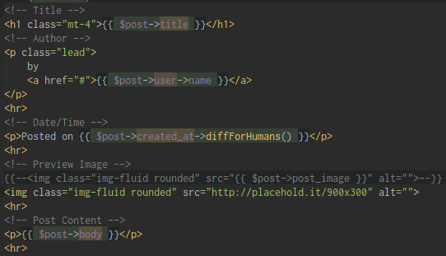

1. Creating a Post from Admin – Part 1

Don’t allow to view the Admin in the Public by placing some routes in **middleware**

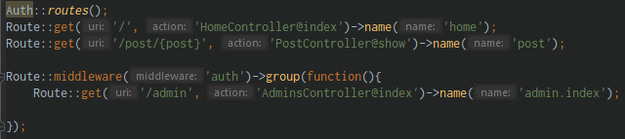

Create a new route for Posts creation

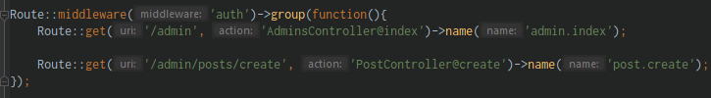

Create a new file inside **views/admin** folder

* This inherit the views/components/**admin-master.blade.php**

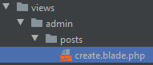

**@admin/posts/create.blade.php** file:

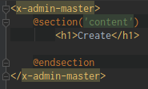

Create a new components:

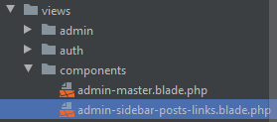

@views/components/**admin-master.blade.php** file:

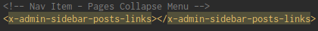

Paste the crop html part in **admin-sidebar-posts-links.blade.php** file:

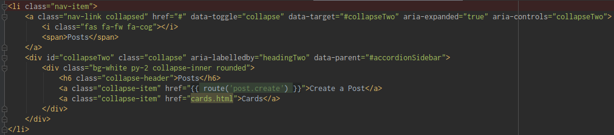

**@PostController.php** file:

* Create a **create()** method

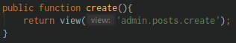

@views/admin/posts/**create.blade.php** file:

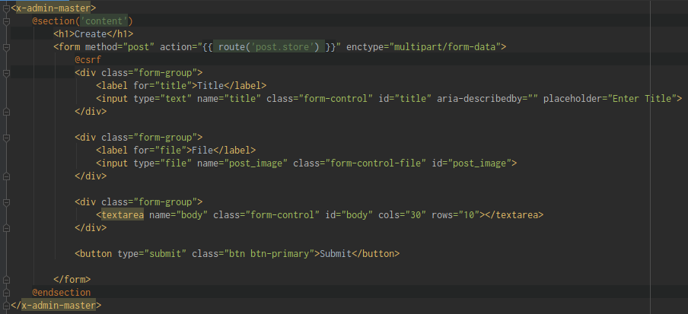

**@web.php** file:

* Create a Route for **post.store**

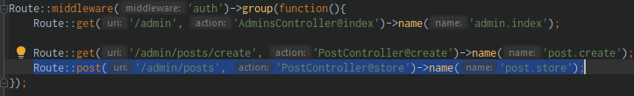

**@PostController.php** file:

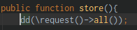

Run the Create and click submit:

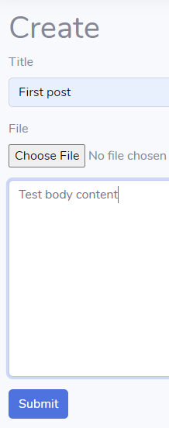 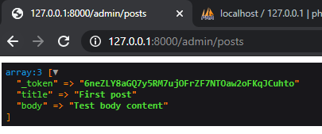

1. Creating a Post from Admin – Part 2

Creating a validation class in store() method

**@PostController.php** file:

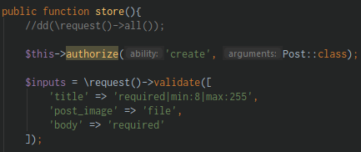

1. Creating a Post from Admin – Part 3

Continue working on the store() method and learn to upload the image

**@config/filesystems.php** file:

* You can view here where it will store the image
* You can post it in: **local | server | amazon web services**

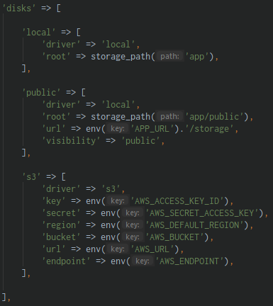

To override that:



**@.env** file:

* Add this variable and its value “public”



@CLI:

php artisan storage:link (linking into storage)



**@PostController.php** file:

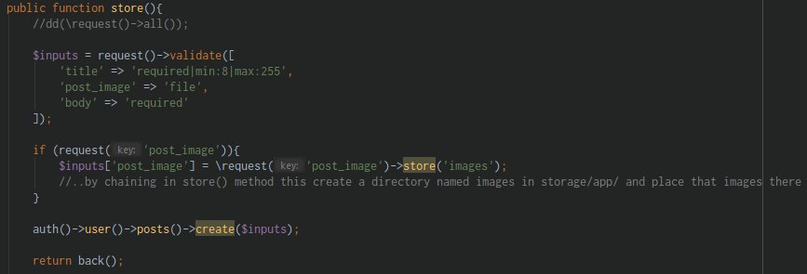

The image place in:

* @public/storage/**images** folder:

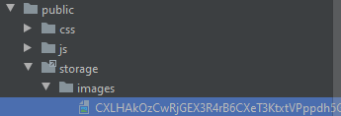

* @storage/app/public/**images** folder:

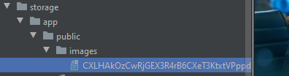

1. Displaying a Post from Admin – Part 1

@views/components/**admin-sidebar-posts-links.blade.php** file:

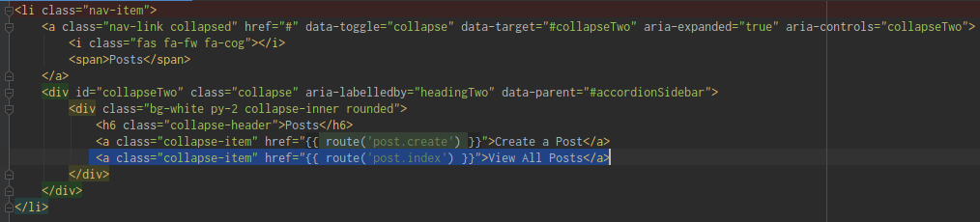

@routes/**web.php** file:

* Add a new Route for post.index

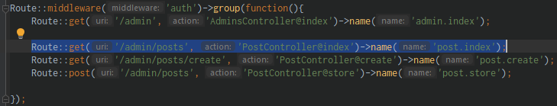

Create a new file in: views/admin/**posts** folder named “**index.blade.php**”

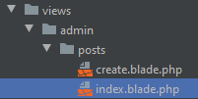

@views/admin/posts/**index.blade.php** file:

* Use the components

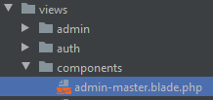 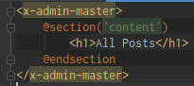

**@PostController.php** file:

* Return the view in admin/posts/**index.blade.php**

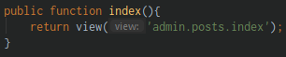

1. Displaying a Post from Admin – Part 2

@resources/views/components/**admin-master.blade.php:**

* Add a **@yield(‘scripts’)**

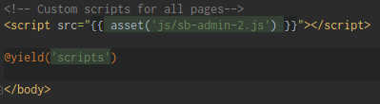

@resources/views/admin/posts/**index.blade.php:**

* Place the scripts

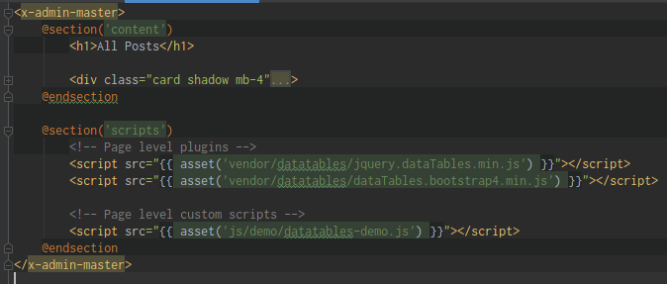

**!! NOTE !!**

To view the missing the files: Always inspect element->**Network**

1. Displaying a Post from Admin – Part 3

@ app/Http/Controllers/**PostController.php:**

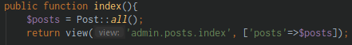

@ resources/views/admin/posts/**index.blade.php:**

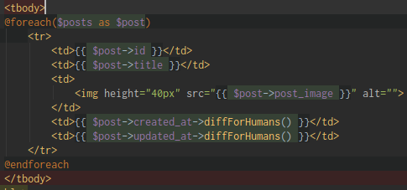

1. Displaying the Owner of the Post

Displaying who is the Owner of the Post

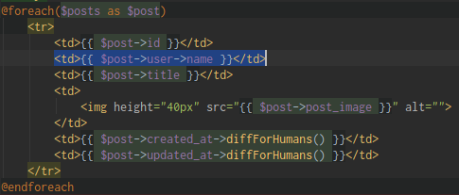

1. Example of Mutators and Accessors with an Image path

Display the missing image

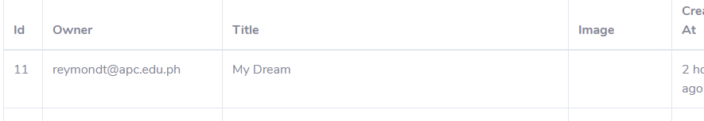

@ resources/views/admin/posts/**index.blade.php:**



@ app/**Post.php:**

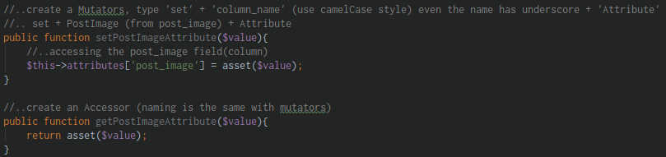

1. Flash Messaging and Deleting

Let’s do some deletion

@ resources/views/admin/posts/**index.blade.php:**

* Sending the $post->id

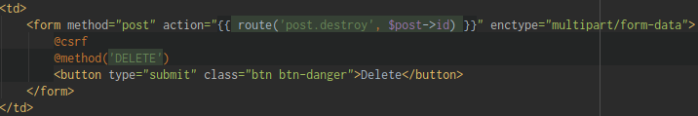

@routes/**web.php:**



@ app/Http/Controllers/**PostController.php:**

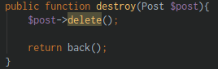

Then create some feedback

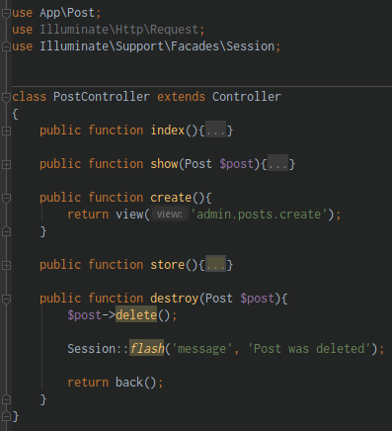

@ resources/views/admin/posts/**index.blade.php:**

* Place in the upper part of Datatable the message

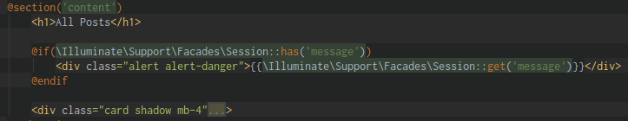

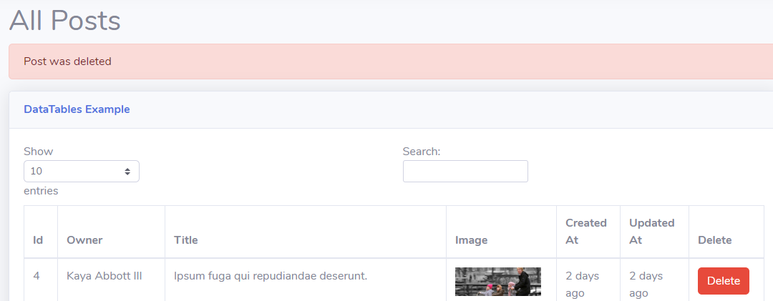

@ app/Http/Controllers/**PostController.php:**

* Other way for flash messaging is using the **Request $request**

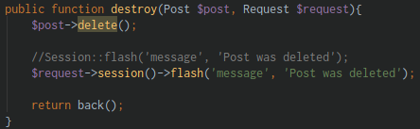

@ resources/views/admin/posts/**index.blade.php:**

* Place in the upper part of Datatable the message

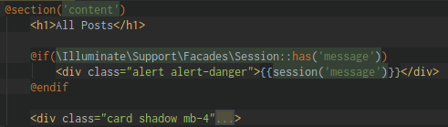

After Creating a Post redirect it to view all Post

@app/Http/Controllers/**PostController.php:**

* Instead of using back() method, use the route() function to return to route name

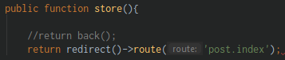

After Creation of Post create an Alert message:

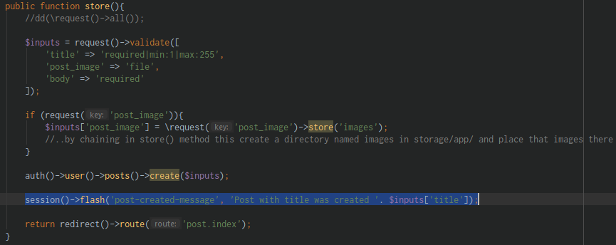

@resources/views/admin/posts/**index.blade.php:**

* Create an **if elseif statement** on the upper part of the table

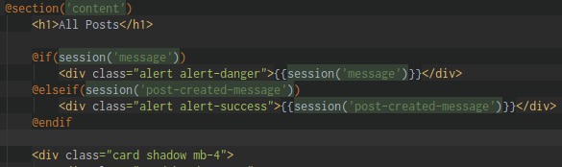

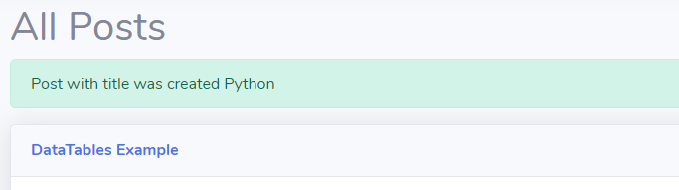

1. Updating a Post - part 1

Let’s start updating our Post

@routes/**web.php:**

* Create a Route for Editing/Updating of Post



@resources/views/admin/**posts/** folder create a new file name “**edit.blade.php**”

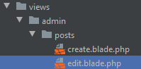

@app/Http/Controllers/**PostController.php:**

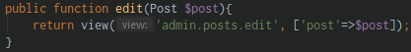

@resources/views/admin/posts/**index.blade.php:**

* Include the title in href

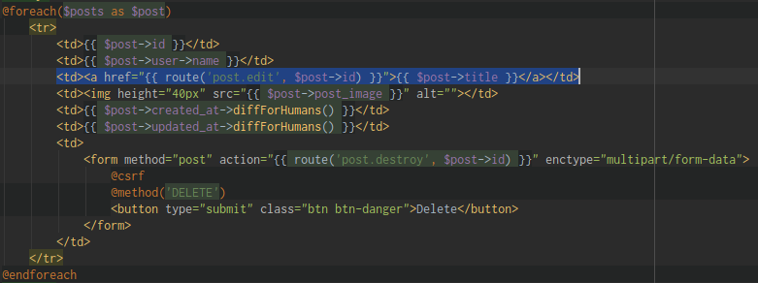

@resources/views/admin/posts/**edit.blade.php:**

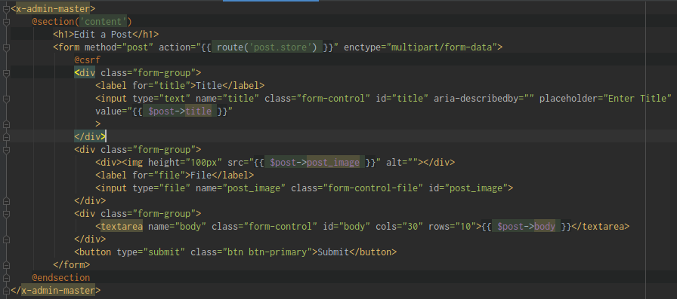

The form will look like this:

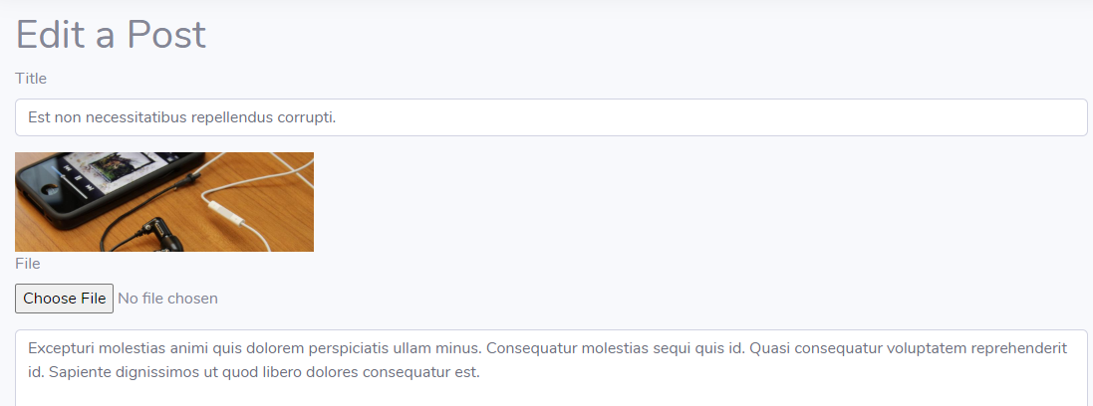

1. Updating a Post – part 2

@resources/views/admin/posts/**edit.blade.php:**

* Modify the action to **update** and add an **@method(‘PATCH’)**

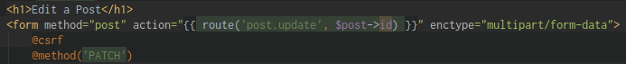

@routes/**web.php:**

* Create a new Route for PATCH (update)



@app/Http/Controllers/**PostController.php:**

* Create an **update(Post $post)** method

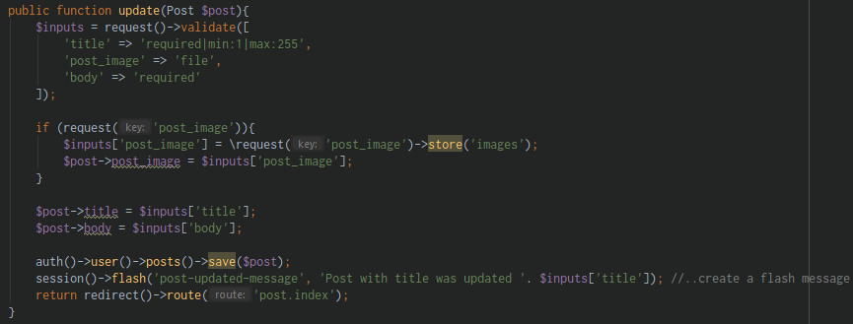

@resources/views/admin/posts/**index.blade.php:**

* Create a Flash message after the Update

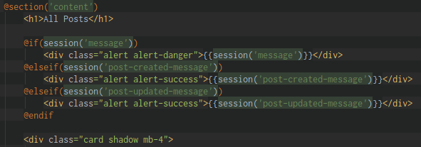

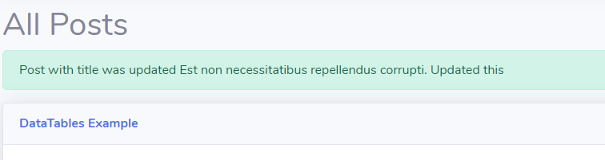

Next is, you are not allowed to Edit someone else Post

@app/Http/Controllers/**PostController.php: In update(Post $post)** method

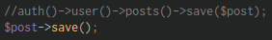

1. Creating Authorization Policies – part 1

The login user won’t allow to see and delete the other users post

@app/Http/Controllers/**PostController.php:**

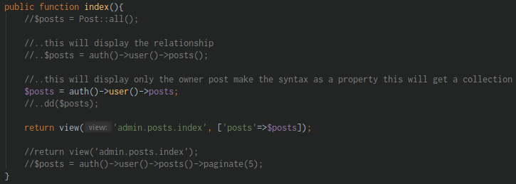

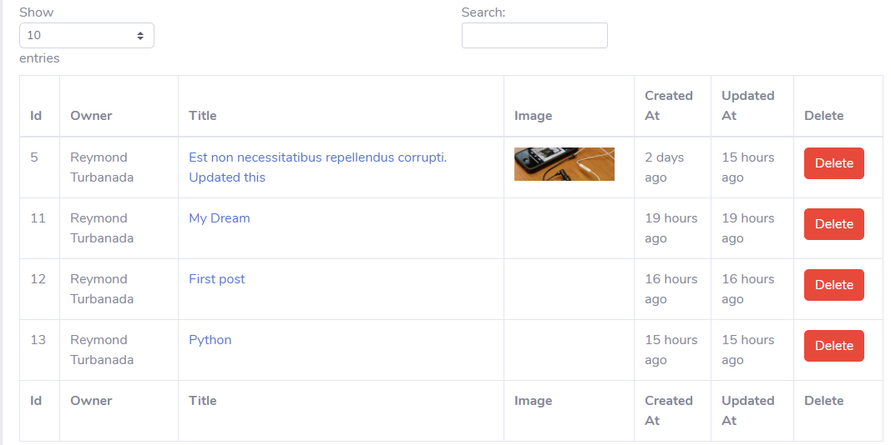

@app/Http/Controllers/**PostController.php:**

* This way only the owner of the Post can delete the Post

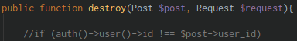

1. Creating Authorization Policies – Part 2

Using the middleware for authorization

@CLI:

php artisan make:policy PostPolicy –model=Post (create a Post Policy)

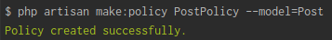

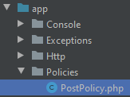

@app/Policies/**PostPolicy.php:**

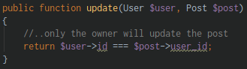

@app/Http/Controllers/**PostController.php:**

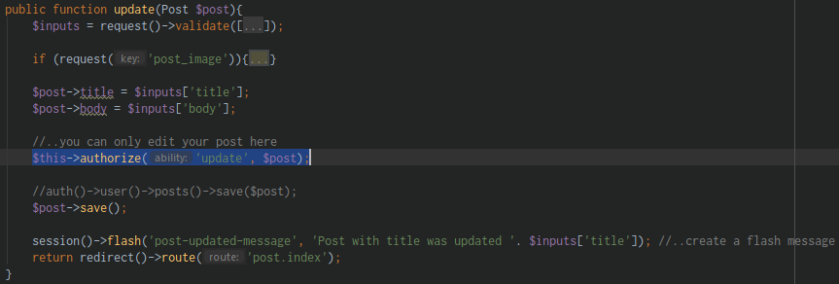

This way you are not be able to see someone else post:

@app/Policies/**PostPolicy.php:**

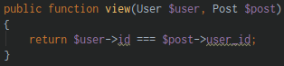

@app/Http/Controllers/**PostController.php:**

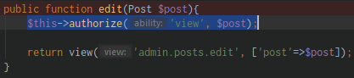

Do not allow the other to view the Post page and hide the Delete button

@resources/views/admin/posts/**index.blade.php:**

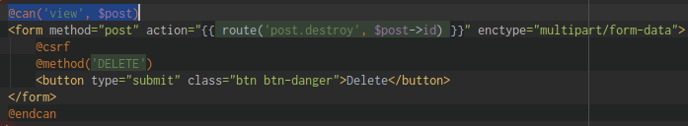

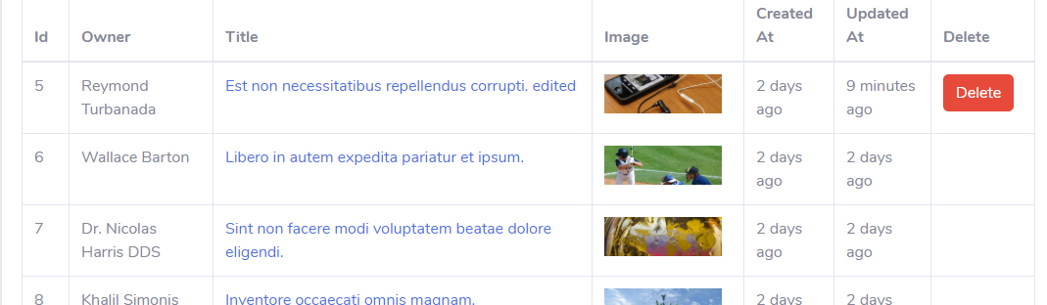

Doing the Policy in routes/**web.php:**

* Crop the **post.edit** Route and apply the Policy on it

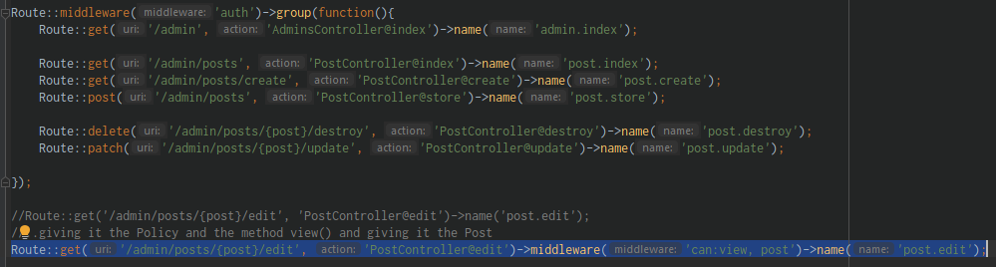

@app/Http/Controllers/**PostController.php:**

* Doing the Policy inside the Controller

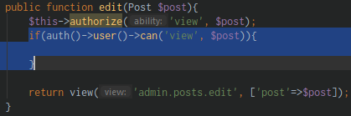

1. Creating Authorization Policies – Part 3 and Refactoring

@app/Policies/**PostPolicy.php:**

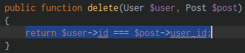

@app/Http/Controllers/**PostController.php:**

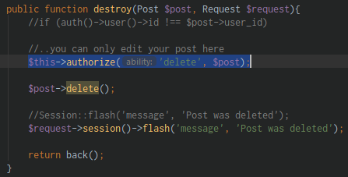

@app/Policies/**PostPolicy.php:**

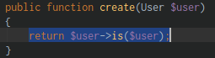

@app/Http/Controllers/**PostController.php:**

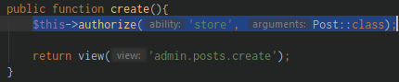

1. Laravel Pagination

Let’s do some pagination

On this part of this lesson, let’s come back the **post.edit** Route inside the Middleware

@routes/**web.php:**

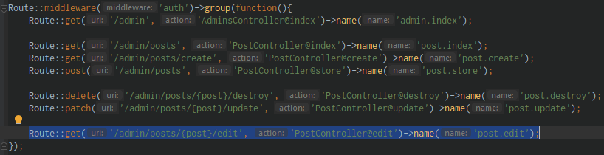

@app/Http/Controllers/**PostController.php:**

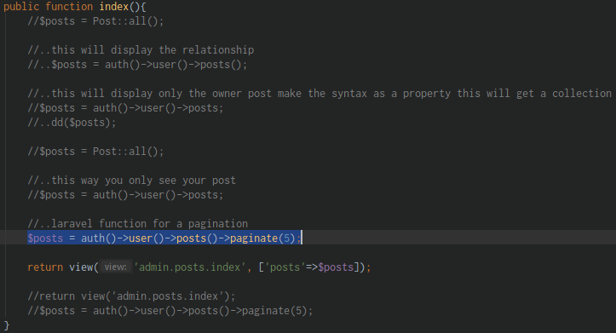

@resources/views/admin/posts/**index.blade.php:**

* Commented out the js used



@resources/views/admin/posts/**index.blade.php:**

* At the footer part of the section put the **{{ $post->links }}** to display the pagination again

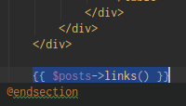 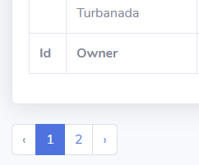

@CLI:

php artisan vendor:publish (select Tag you wanted to use)

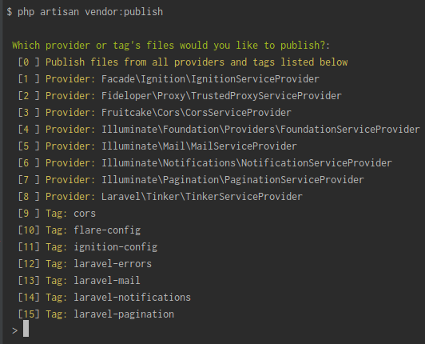

Let’s say you select #15

Type **15** then hit **Enter**

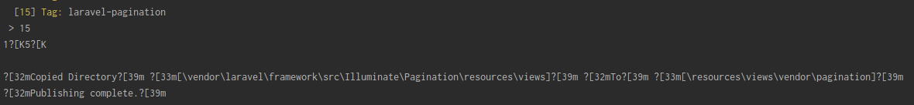

Then the **vendor folder** with a **pagination folder** added to you **views/ folder**

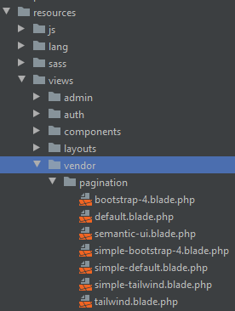

And you can edit and experiment on that file inside that vendor folder inside views folder

@resources/views/admin/posts/**index.blade.php:**

* This will **center** the pagination

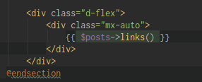



Section 31: Laravel 7 – Roles & Permissions – Migrations & Relationships

1. Creating Migrations part 1

Let’s create a user, create an Admin, and different roles and permissions

Create a couple of migrations

@CLI:

php artisan make:model Permission -mc (make a Permission **Model** & **Controller**)

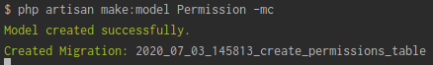

php artisan make:model Role -mc (make a Role **Model** & **Controller**)

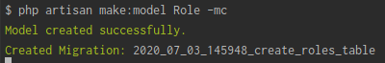

Now create a **Pivot table**

php artisan make:migration create_users_permissions_table -–create=permission_user (create a pivot table between user and permission)



php artisan make:migration create_users_roles_table -–create=role_user (create a pivot table between user and role)



php artisan make:migration create_roles_permissions_table -–create=permission_role (create a pivot table between role and permission)



1. Creating Migrations part 2

Let’s start customizing the tables created

@ database/migrations/_**create_permissions_table.php:**

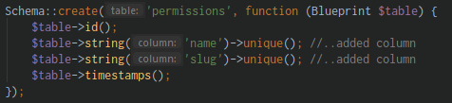

@ database/migrations/_**create_roles_table.php:**

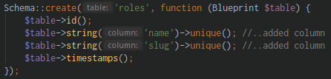

@ database/migrations/_**create_users_permissions_table.php:**

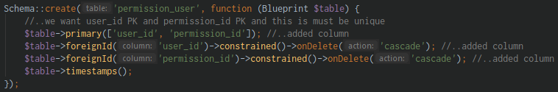

@database/migrations/_**create_users_roles_table.php:**

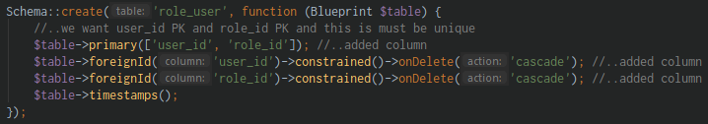

@database/migrations/_**create_roles_permissions_table.php:**

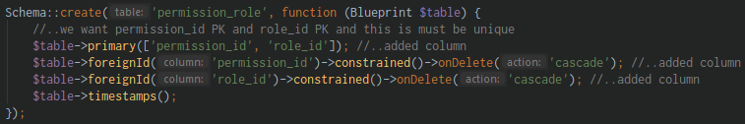

@CLI:

php artisan migrate (run the migration)

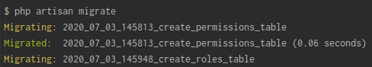

1. Setting Up Relationships

@ app/**Role.php:**

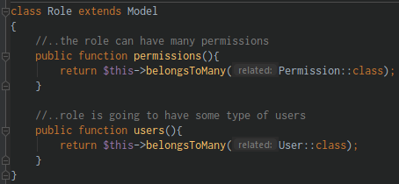

@ app/**Permission.php:**

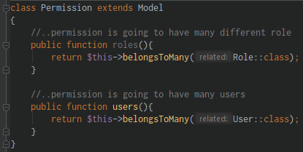

@ app/**User.php:**

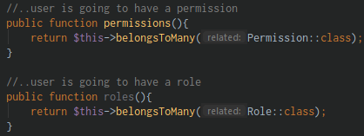

1. Using Tinker to Insert Roles and Permissions

@ app/**Permission.php:**



@ app/**Role.php:**



Let’s go around and play some data using PHP artisan tinker

@CLI:

php artisan tinker (run the tinker)

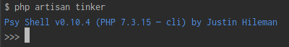

$user = App\User::find(1) (find the user with id = 1)

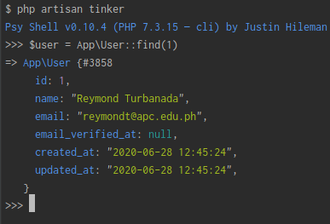

$admin = App\Role::create([

‘name’ => ‘Admin’

‘slug’ => ‘slug’

]) (create a role)

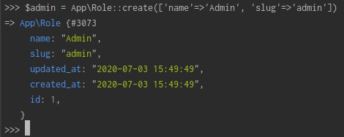

**@roles** table:

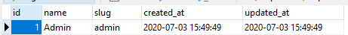

$user->roles()->attach($admin) (grab the user, and grab relationship called roles, access a method and I want to attach an admin role)

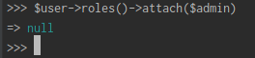

**@role_user** table:

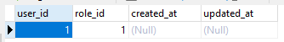

$view_dashboard = App\Permission::create([

‘name’ => ‘View Dashboard’,

‘slug’ => ‘view-dashboard’

]) (let’s create a permission)

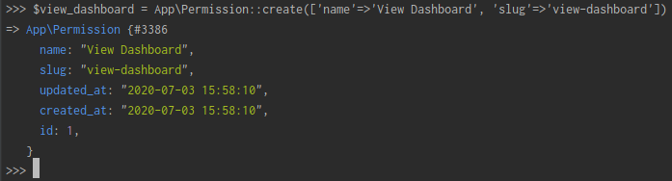

**@permissions** table:



$admin->permissions()->attach($view_dashboard) (let’s grab the admin role, and we know that we a permissions relationship, so we grab the method and we use this attach again and we attach this permission the $view_dashboard)

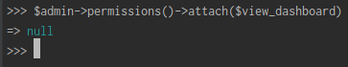

**@permission_role** table:

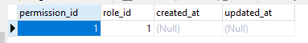

And now we know that our relationship is working

$admin->users (grab the $admin users)

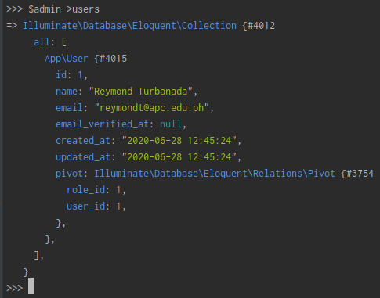

$admin->permissions (view the Admin Permission)

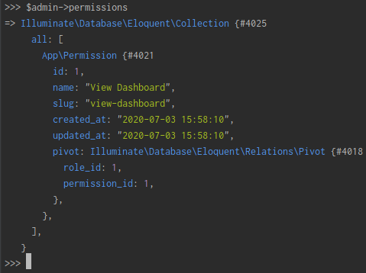

1. Using Permission on Dashboard example

Let’s start implementing it

@ app/**User.php:**

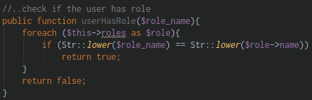

@ resources/views/admin/**index.blade.php:**

* If the user is ‘Admin’ he can view the Dashboard page

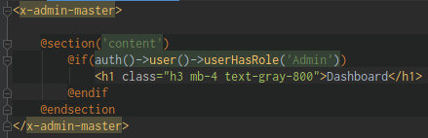

Section 32: Laravel 7 – Creating a User Profile

1. Creating a User Profile part 1

Let’s create a Profile page to allow the user update a user profile password and many more

@resources/views/components/**admin-master.blade.php:**

* Create a component



Create **admin-top-navbar-user-information.blade.php** in resources/views/components/ folder

* Paste on it the crop part from **admin-master.blade.php**

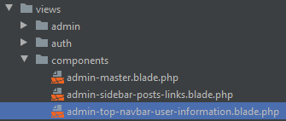

Create a **profile.blade.php** in resources/views/admin/users/ folder

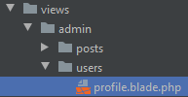

@ resources/views/admin/users/**profile.blade.php:**

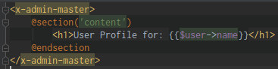

@CLI:

php artisan make:controller UserController (create a UserController)

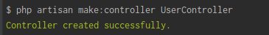

@routes/**web.php:**



@app/Http/Controllers/**UserController.php:**

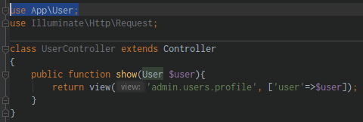

Run in web:

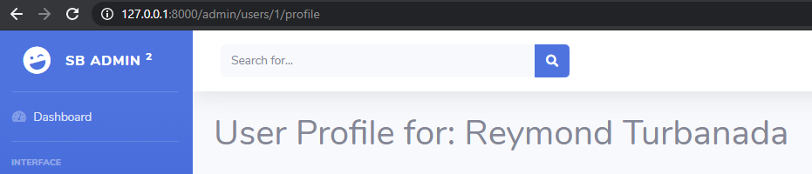

1. Creating a User Profile part 2

When the User photo click it will directly go to the User profile page instead of manually type it in the address bar

@resources/views/components/**admin-top-navbar-user-information.blade.php:**

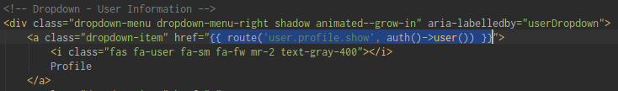

@resources/views/admin/users/**profile.blade.php:**

* Modify this form to become look like this

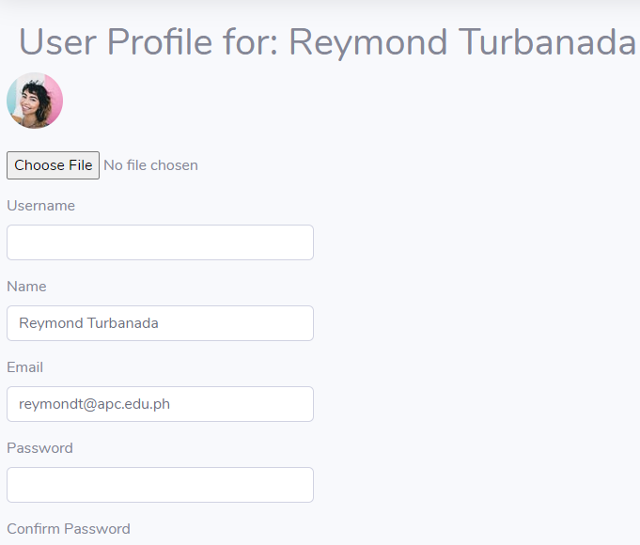

1. Adding a Username

Let’s add a username

@resources/views/admin/users/**profile.blade.php:**

* Modify this form

Add a **username** column in **users** table

@database/migrations/_**create_users_table.php:**

* Edit the code by adding a new column **usernamem** and **avatar**

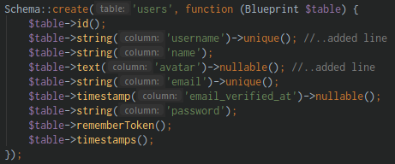

@resources/views/auth/**register.blade.php:**

* Add this field **username** in the Register form

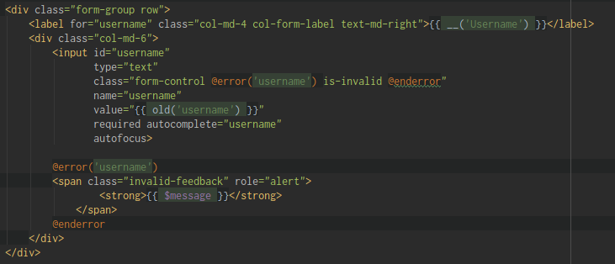

@resources/views/components/**home-master.blade.php:**

* Add this line of code **register**

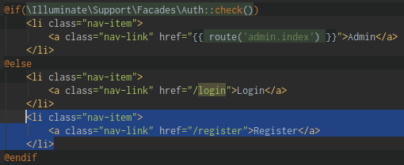

@app/Http/Controllers/Auth/**RegisterController.php:**

* Update this validator

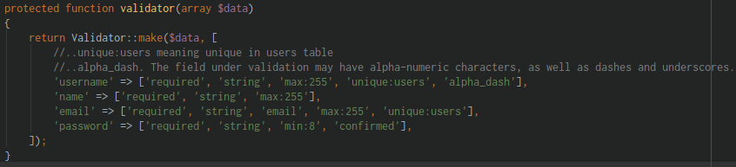

* Modify the **function create**

From:

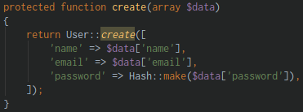

To: add **username,** remove **the Hash::make** method in **password**

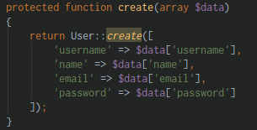

@app/**User.php:**

* Add the **username** in the fillable field

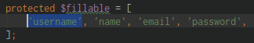

Now use **Mutators** for the Password because we don’t **encrypting** our password

@ app/**User.php:**

* Everytime we add or update our password in our models. We gonna get the password and we’re gonna **bcrypt()** it.

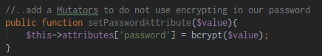

@CLI:

php artisan migrate:refresh (reroll all the migration, be careful this will delete all of your records)

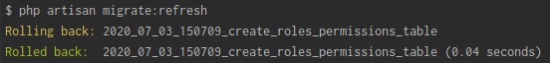

1. Updating the Profile

Let’s update our profile and also our Profile image

@ resources/views/admin/users/**profile.blade.php:**

* Add a **name=”avatar”** in input file

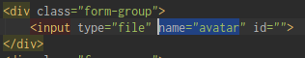

* Add a **PUT method** and the **route()**



@ routes/**web.php:**

* Add this link to update the user profile



@ app/Http/Controllers/**UserController.php:**

* Add the **update(User $user)** method

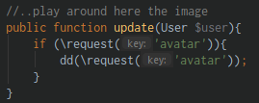

Run in browser:

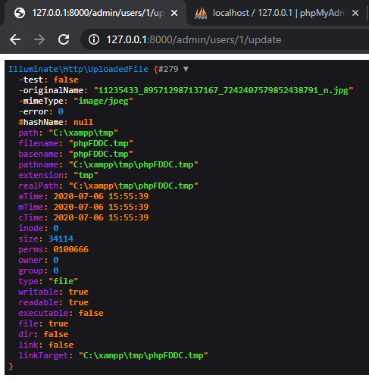

@ app/Http/Controllers/**UserController.php:**

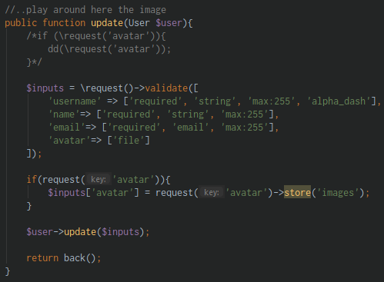

@ resources/views/admin/users/**profile.blade.php:**

* Add some error message

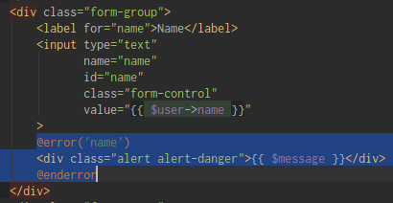

* And also you can add **@error** after the form-control in class

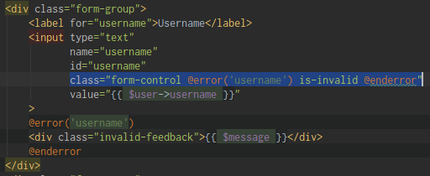

Run in browser:

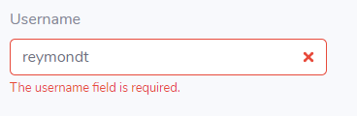

Let’s update the Avatar:

@ resources/views/admin/users/**profile.blade.php:**

* Modify the src of image

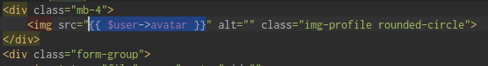

@ app/**User.php:**

* Add the **avatar** field in the fillable

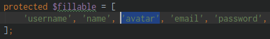

@ app/**User.php:**

* Add an **Accessor** to view the image

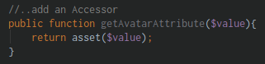

Always Reload All from Disk in PHPStorm

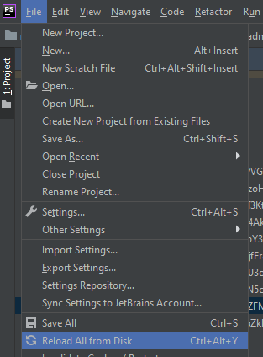

Section 33: Laravel 7 – Admin Users

1. Displaying all Users part 1

Let’s create a Middleware and how to use them like authorization

Create a new **components:**

* resources/views/components/**admin-sidebar-users-links.blade.php:**

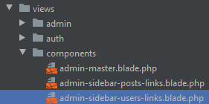

@resources/views/components/**admin-sidebar-users-links.blade.php:**

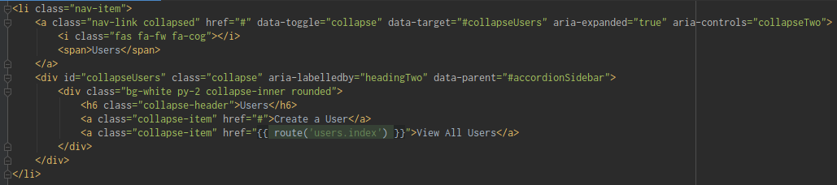

@routes/**web.php:**



@app/Http/Controllers/**UserController.php:**

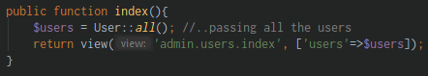

@resources/views/admin/users/**index.blade.php:**

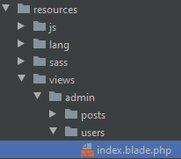

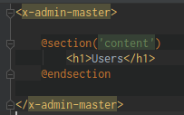

Then insert it in our components:

@resources/views/components/**admin-master.blade.php:**

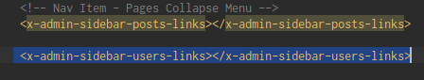

1. Displaying all Users part 2

@resources/views/admin/users/**index.blade.php:**

* Add the Datatable
* Paste the scripts for Datatable

@database/factories/**UserFactory.php:**

* Modify the DatabaseSeeder to create 100 users with a post

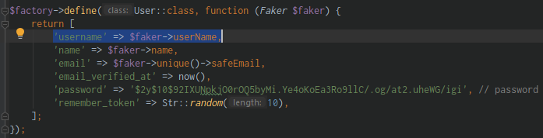

@CLI:

php artisan db:seed (run the seeder)

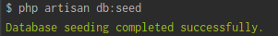

@resources/views/components/**admin-top-navbar-user-information.blade.php:**

1. Deleting Users

Delete a users

@resources/views/admin/users/**index.blade.php:**

* Add this line of code

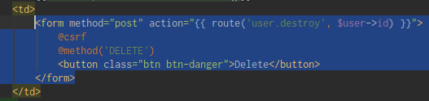

* Add this on the upper part of the Table for the flash message

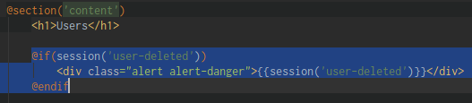

@routes/**web.php:**



@app/Http/Controllers/**UserController.php:**

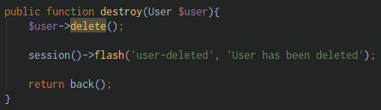

Run in the browser:

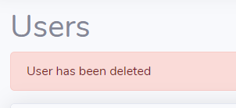

1. Creating some Roles again

The Users which is not admin won’t see the Users form

@CLI:

php artisan tinker (run Tinker)

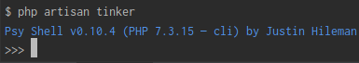

$admin = App\Role::create([‘name’=>’Admin’, ‘slug’=>’admin’]) (create an Admin role)

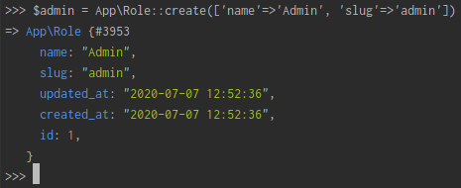

**@roles** table

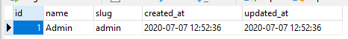

$view_dashboard = App\Permission::create([‘name’=>’View Dashboard’, ‘slug’=>’view-dashboard’]) (create a permission to view dashboard)

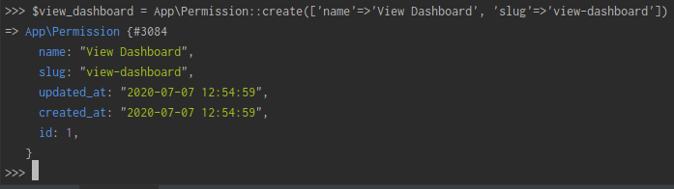

**@permissions** table



App\User::where(‘name’, ‘Reymond Turbanada’)->get(); (finding the user using Tinker)

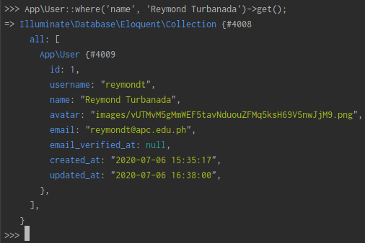

$admin->permissions()->attach($view_dashboard) (let’s assign a permission to role

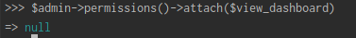

**@permission_role** table:

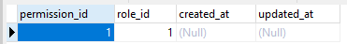

App\User::where(‘name’, ‘Reymond Turbanada’)->get(); (this method get() will return a collection)



So that we need an instance, we use the **first()** method

App\User::where(‘name’, ‘Reymond Turbanada’)->first(); (this return an instance that’s what we want)

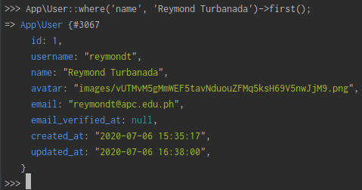

$user->roles()->attach($admin (add roles to the user)



**@role_user** table:

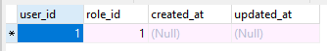

1. Creating and using Middlewares for Route Authorization

The user form will only be visible by us (Admin)

[reymondt@pc.edu.ph](mailto:reymondt@pc.edu.ph) / password (Admin)

[ciaremi@gmail.com](mailto:ciaremi@gmail.com) / password (Normal User)

@ resources/views/components/**admin-master.blade.php:**

* The normal User won’t see the User in Sidebar

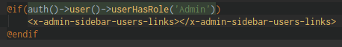

@CLI:

php artisan make:middleware (create a RoleMiddleWare and this is where we register our logic staff)

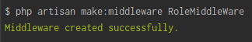

But we must first Register this Middleware inside the **Http/Kernel.php**:

@ app/Http/**Kernel.php:**

* Register it in **$routeMiddleware**

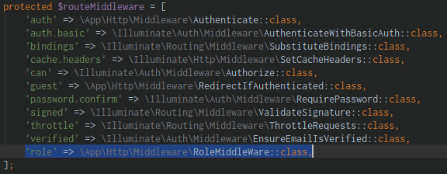

@ app/Http/Middleware/**RoleMiddleWare.php:**

* Add the **$role** in the parameter

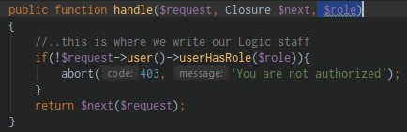

@ routes/**web.php:**

* Use the role middleware, and assign admin role
* You may pass the permission here also and an authentication



@ app/**User.php:**

* Refrain to all lower_case the role

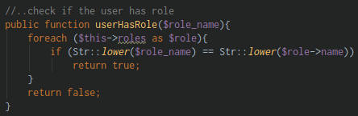

Run in the browser: (login other user who is not admin)

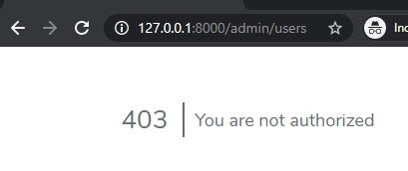

1. A Little recap

Let’s do some Recap

Re watch this video for more explanation

1. Admin and Model Owner Same Access

@ routes/**web.php:**

* Create a new Route::middleware



@CLI:

php artisan make:policy UserPolicy –model=Users (create a User Policy)

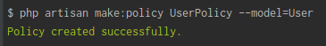

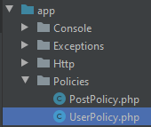

@ app/Policies/**UserPolicy.php:**

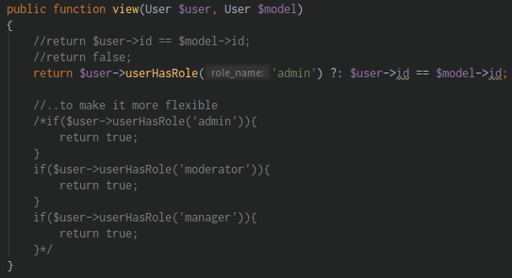

And go to **web.php** and pass in this **view()** method from **UserPolicy**

@ routes/**web.php:**

* This way only the Admin and the owner can do update their profile



1. Routes for Large Applications

Prepare us for a Large Applications

How to organize large applications

@routes/ folder:

* Create an **api** folder and move here the **api.php**
* Create a **web** folder and move here the **web.php**

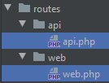

@ app/Providers/**RouteServiceProvider.php:**

* Update the function **mapWebRoutes()**

FROM:

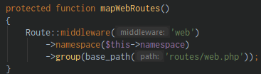

TO:

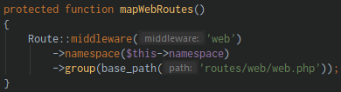

* Update the function **mapApiRoutes()**

FROM:

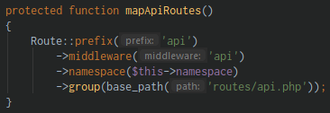

TO:

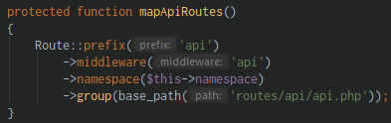

Create a new file inside **routes/web/** folder named “**posts.php**”

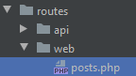

@ routes/web/**posts.php:**

* Paste in the Routes for Post
* Include also the Route model

FROM:

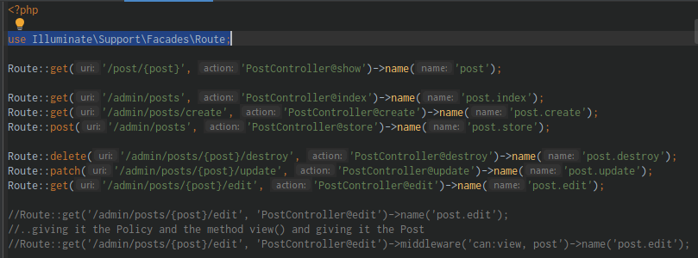

TO: (remove the **/admin** to prevent error)

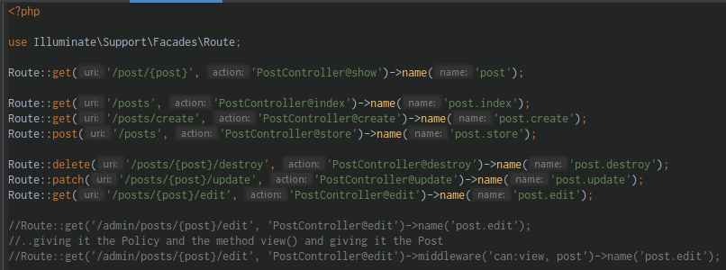

@ app/Providers/**RouteServiceProvider.php:**

* Create a new **protected function mapPostsRoutes()**

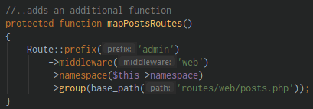

* Then register it on **public function map()**

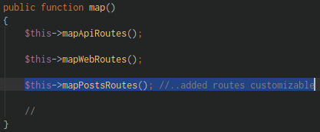

Let’s create for the **users** too:

Create a new file inside **routes/web/** folder named “**users.php**”

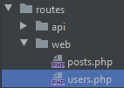

@ routes/web/**users.php:**

* Paste in the Routes for **User**
* Include also the **Route** model

FROM:

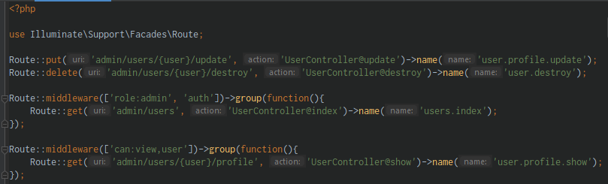

TO: (remove the **/admin** to prevent error)

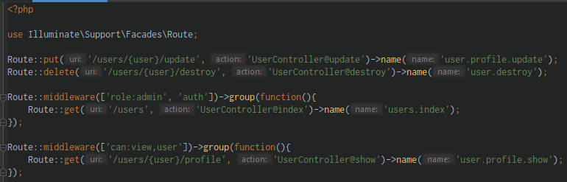

@ app/Providers/**RouteServiceProvider.php:**

* Create a new **protected function mapUsersRoutes()**

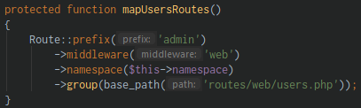

* Then register it on **public function map()**

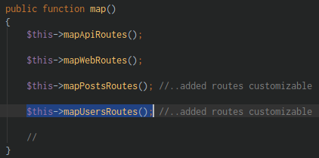

1. Component Nesting

Organizing our components

Create an **admin folder** inside **components/** folder

Create a **sidebar folder** inside that **admin/** folder

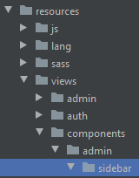

Place all related to sidebar file inside this directory:

resources/views/components/admin/**sidebar/** folder

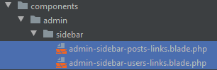

@ resources/views/components/**admin-master.blade.php:**

* Modify the following:

FROM:



TO: (we add the **admin.sidebar.** this is a reference for a location folder)



And also the:

FROM:



TO: (we add the **admin.sidebar.** this is a reference for a location folder)



And also:

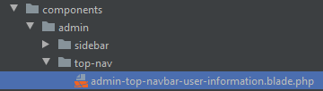

FROM:



TO: (we add the **admin.top-nav.** this is a reference for a location folder)



Section 34: Laravel 7 – User Profile Roles

1. Displaying Roles in User Profile

Create a functionality where we can assign the user a Role

@resources/views/admin/users/**profile.blade.php:**

* Add this Datatable for Roles

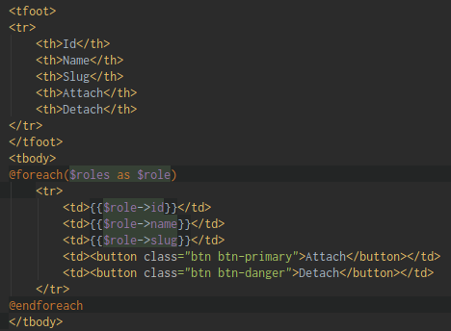

@app/Http/Controllers/**UserController.php:**

* Modify the **show()** method

FROM:

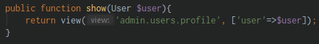

TO: (add the Role in array, make sure that you import the Class at Top)

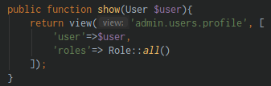

Run in the URL:

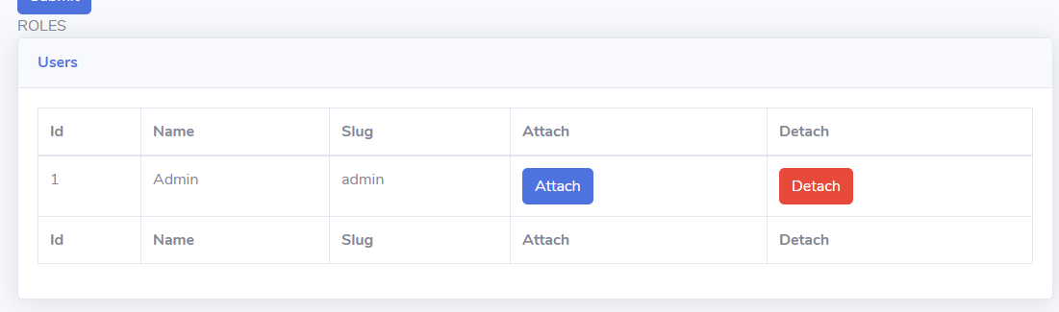

1. Detecting Roles for the User

Let’s a Create a Role using Tinker

@CLI:

php artisan tinker (run Tinker)

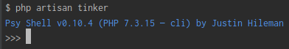

App\Role::create([‘name’=>’Manager’, ‘slug’=>’manager’]) (create a Manager Role)

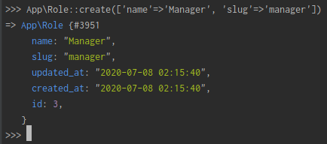

App\Role::create([‘name’=>’Author’, ‘slug’=>’author’]) (create an Author Role)

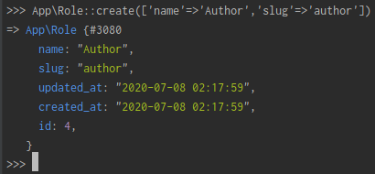

App\Role::create([‘name’=>’Subscriber’, ‘slug’=>subscriber’]) (create a Subscriber Role)

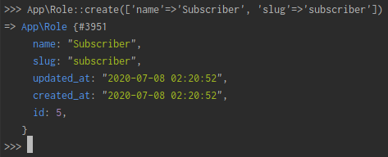

**@roles** table:

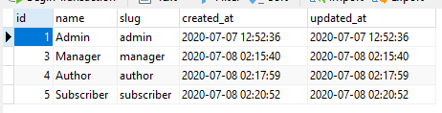

Let’s create a feature of which of these is a **Role** related to the **User**

@ resources/views/admin/users/**profile.blade.php:**

* Check only those Roles related to the Users
* This will check if the User role is same with the list of user_role then marked it **Checked,** meaning if they have the same slug(role) it will marked C**hecked**

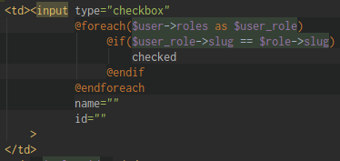

Run in the URL:

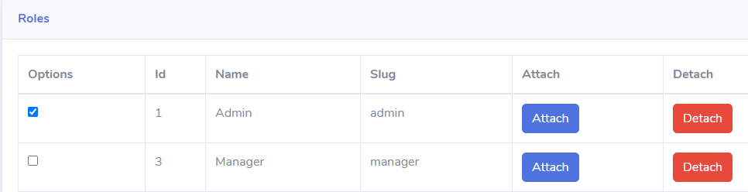

1. Attaching Roles part 1

Let’s attach a Role to the User

@ routes/web/**users.php:**

* Create a new Route for attaching



@ resources/views/admin/users/**profile.blade.php:**

* Include the button inside the form

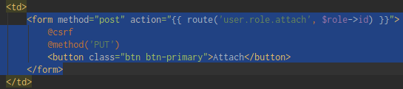

@ app/Http/Controllers/**UserController.php:**

* Create a function **attach(Role $role)**
* Try to **dd($role)** (diedump) it first

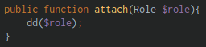

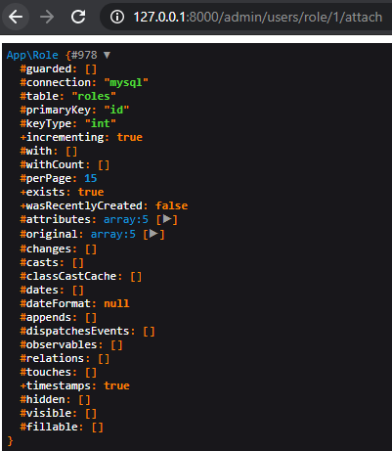

1. Attaching Roles part 2

@ routes/web/**users.php:**

FROM:



TO:



@ resources/views/admin/users/**profile.blade.php:**

FROM:



TO:



@ resources/views/admin/users/**profile.blade.php:**

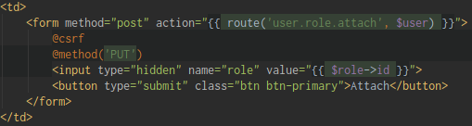

@ app/Http/Controllers/**UserController.php:**

FROM:

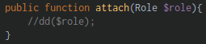

TO: (change from Role to **User**)

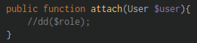

@ app/Http/Controllers/**UserController.php:**

* In here we can now attach a role to the User

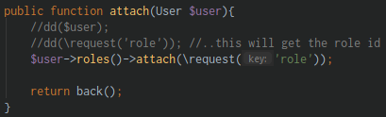

Now let’s create for **Detaching** a role

@routes/web/**users.php:**

* Create a Route for detach



@app/Http/Controllers/**UserController.php:**

* Create a function **detach(User $user)** (don’t forget the request())

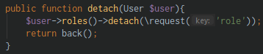

@ resources/views/admin/users/**profile.blade.php:**

* Create a form for **Detach** button

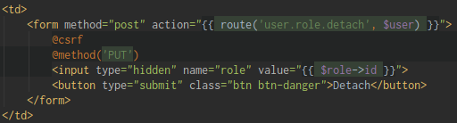

Build a Feature that will detect that won’t allow the user to check the checkbox

@resources/views/admin/users/**profile.blade.php:**

* If the user has that Role, make that button disabled and not clickable

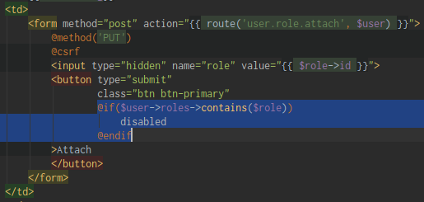

Run in the URL: (the Attach button is **not clickable** at all meaning it is **Disabled**)

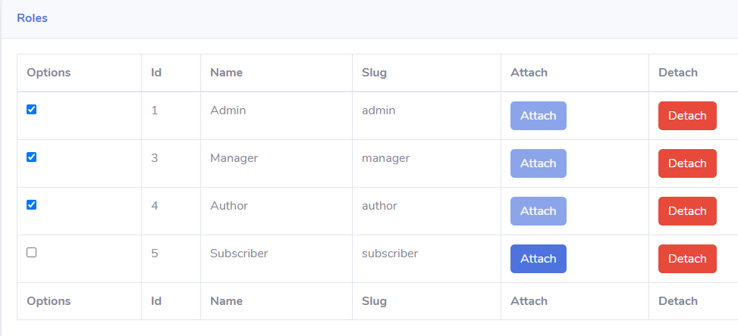

Also do the same with the Detach button:

@resources/views/admin/users/**profile.blade.php:**

* If the user doesn’t have that Role, make that button disabled

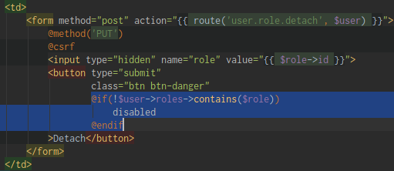

Run in the URL: (the Detach button is **not clickable** if it contains the Role)

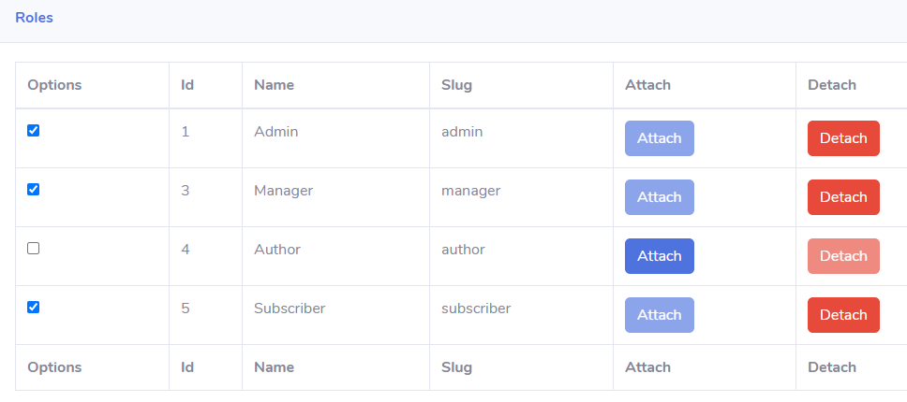

Section 35: Laravel 7 – Permissions & Roles - CRUD

1. CRUD – Create & Read part 1

Let’s create a CRUD for Permissions and Roles

@resources/views/components/admin/sidebar/**admin-sidebar-users-links.blade.php:**

* Copy the content of this file

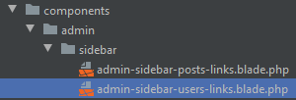

Create a new file named “**authorization-links.blade.php**” inside resources/views/components/admin/**sidebar/** folder

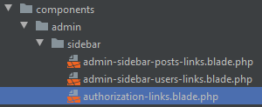

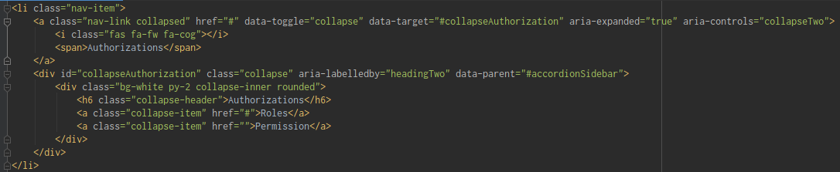

@ resources/views/components/**admin-master.blade.php:**

* Include it to display in sidebar



@ resources/views/admin/roles/**index.blade.php:**

* Create a new folder inside views/admin/ named “**roles/index.blade.php”**

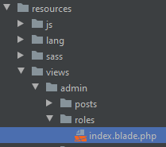

@ resources/views/admin/permissions/**index.blade.php:**

* Create a new folder inside views/admin/ named “**permissions/index.blade.php”**

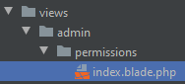

@ resources/views/admin/roles/**index.blade.php:**

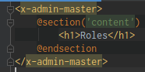

@ resources/views/admin/permissions/**index.blade.php:**

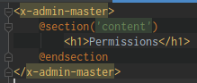

@routes/web/**roles.php:**

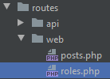

@routes/web/**permissions.php:**

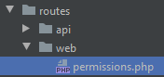

Let’s build a Routes for it

**Role Flow:**

1. resources/views/admin/roles/**index.blade.php:**
   1. create an html view of the page
2. routes/web/**roles.php:**
   1. create a new route file
3. app/Http/Controllers/**RoleController.php:**
   1. add an **index()** method
4. resources/views/components/admin/sidebar/**authorization-links.blade.php:**
   1. add the name of the route in href element
5. app/Providers/**RouteServiceProvider.php:**
   1. create a **protected function mapRolesRoute()**
   2. then register it in **public function map()**

*Explanation:*

1. resources/views/admin/roles/**index.blade.php:**

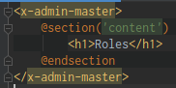

1. routes/web/**roles.php:**

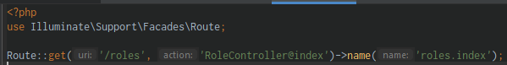

1. app/Http/Controllers/**RoleController.php:**

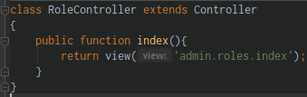

1. resources/views/components/admin/sidebar/**authorization-links.blade.php:**



1. app/Providers/**RouteServiceProvider.php:**

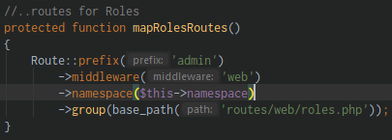

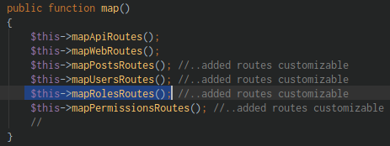

**Permission Flow:**

1. resources/views/admin/permissions/**index.blade.php:**
   1. create an html view of the page
2. routes/web/**permissions.php:**
   1. create a new route file
3. app/Http/Controllers/**PermissionController.php:**
   1. add an **index()** method
4. resources/views/components/admin/sidebar/**authorization-links.blade.php:**
   1. add the name of the route in href element
5. app/Providers/**RouteServiceProvider.php:**
   1. create a **protected function mapPermissionsRoute()**
   2. then register it in **public function map()**

*Explanation:*

1. resources/views/admin/permissions/**index.blade.php:**

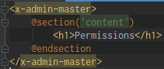

1. routes/web/**permissions.php:**

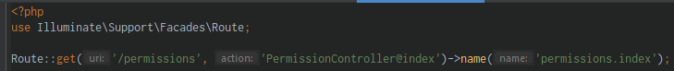

1. app/Http/Controllers/**PermissionController.php:**

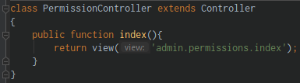

1. resources/views/components/admin/sidebar/**authorization-links.blade.php:**



1. app/Providers/**RouteServiceProvider.php:**

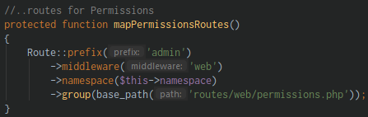

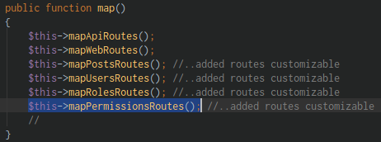

1. CRUD – Create & Read part 2

@resources/views/admin/roles/**index.blade.php:**

* Create an Input form and a Datatables

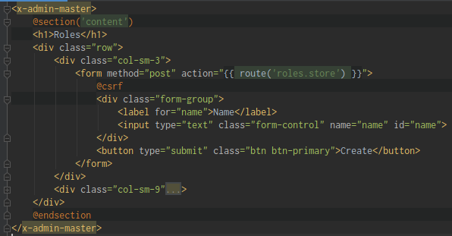

@routes/web/**roles.php:**

* Create a new Routes

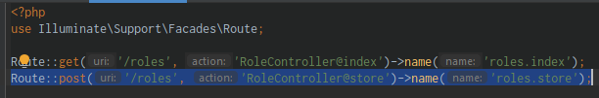

@app/Http/Controllers/**RoleController.php:**

* Create a **store()** method and **dd()** diedump to see the send value

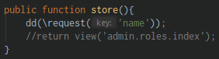

1. CRUD – Create & Read – Validation part 3

@resources/views/admin/roles/**index.blade.php:**

* Create an error message

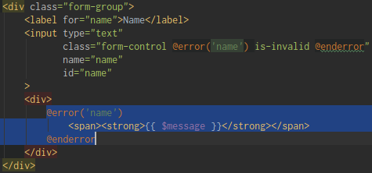

@app/Http/Controllers/**RoleController.php:**

* Modify the **store()** method
* Add a validation

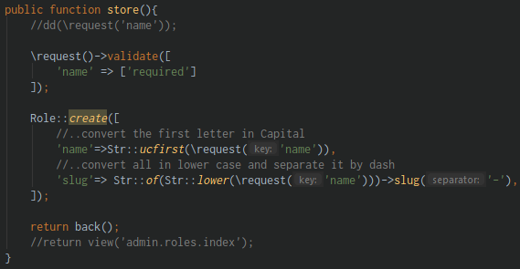

1. CRUD – Deleting

Let’s delete the Role

@resources/views/admin/roles/**index.blade.php:**

* Add a validation error message on top
* Add a Delete form

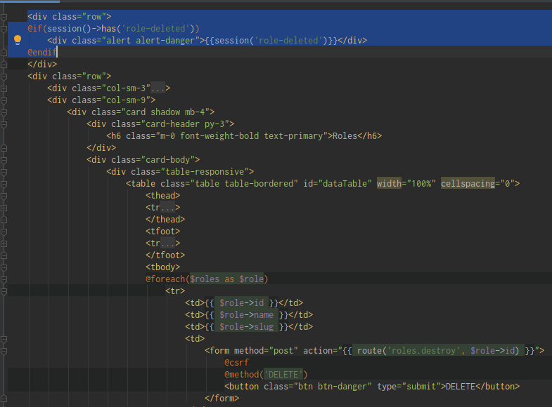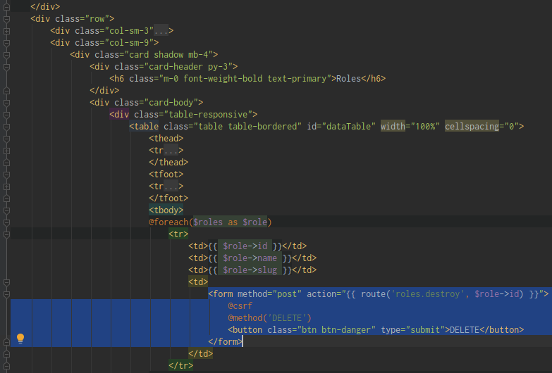

@routes/web/**roles.php:**

* Add a new Route



@app/Http/Controllers/**RoleController.php:**

* Add a **destroy()** method

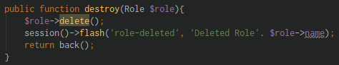

1. CRUD – Updating part 1

Let’s update our data

@resources/views/admin/roles/**index.blade.php:**

* Create an href element



@routes/web/**roles.php:**

* Create a new Route for edit



@app/Http/Controllers/**RoleController.php:**

* Create a public function edit(Role $role)

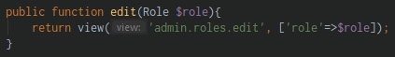

@resources/views/admin/roles/**edit.blade.php:**

* Modify the blade file

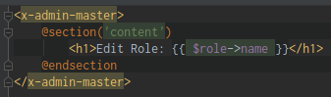

1. CRUD – Updating part 2

@resources/views/admin/roles/**edit.blade.php:**

* Modify the blade file

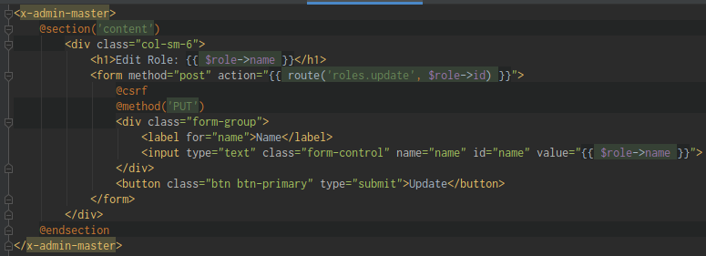

@routes/web/**roles.php:**

* Create a new Route for update



@app/Http/Controllers/**RoleController.php:**

* Create a public function update(Role $role) and dd() diedump the result

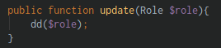

1. CRUD – Updating part 3

@resources/views/admin/roles/**edit.blade.php:**

* Add an Alert message on top

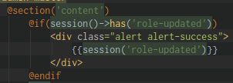

@app/Http/Controllers/**RoleController.php:**

* Modify the **update()** method
* Use **isDirty()** methods to check if there is changes you made

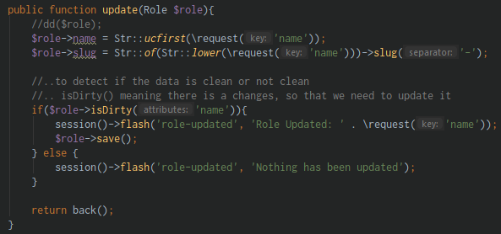

1. Displaying Role Permissions

@resources/views/admin/roles/**edit.blade.php:**

* Create a DataTable for Permission, use **isNotEmpty()** method to check if the permissions is not empty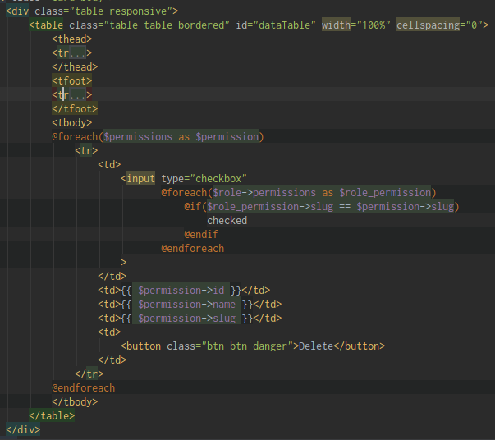

@app/Http/Controllers/**RoleController.php:**

* Modify the edit() method by adding the **Permission** model

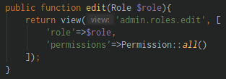

1. Attaching and Detaching Role Permissions

@CLI:

php artisan tinker (run tinker)

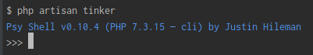

App\Permission::create([‘name’=>’Edit Post’, ‘slug’=>’edit-post’]) (add a new Permission **Edit Post**)

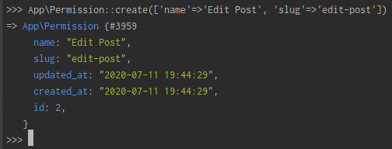

App\Permission::create([‘name’=>’Edit Post’, ‘slug’=>’edit-post’]) (add a new Permission **Update Users**)

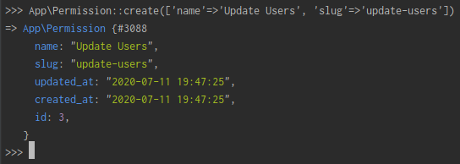

@ resources/views/admin/roles/**edit.blade.php:**

* Add the **Attach** and **Detach**

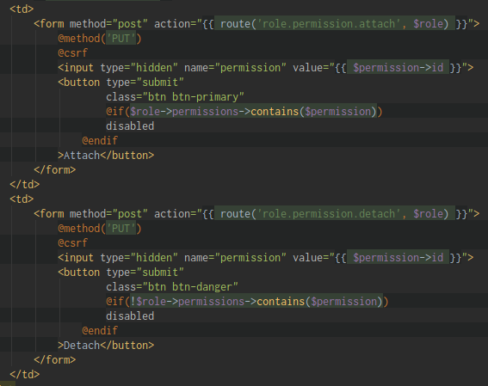

@ routes/web/**roles.php:**

* Add a new Route for **Attach** and **Detach**



@ app/Http/Controllers/**RoleController.php:**

* Add a new method: **attach_permission** and **detach_permission**

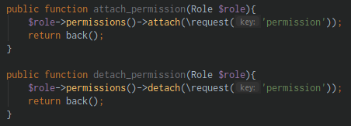

1. Displaying and Deleting Permissions

Lorem Ipsum Dolor sit amet

@CLI:

php artisan serve (run app)

1. Updating Permissions

Lorem Ipsum Dolor sit amet

@CLI:

php artisan serve (run app)

1. Protecting Routes Globally & Locally

Lorem Ipsum Dolor sit amet

@CLI:

php artisan serve (run app)

Section 36: Lorem Ipsum Dolor sit amet

1. Lorem

Lorem Ipsum Dolor sit amet

@CLI:

php artisan serve (run app)